


DAEN 690
Project Report
Adarsh Gorremuchu
Anu Yadav
Krishna Sai Pendem
Sathwik Masipeddi
Vishal Orsu

Fall 2024
Airline Financial Dashboard

About the Cover
James Baldo is an associate professor and serves as the Director of the George Mason University (GMU), College of Engineering and Computing (CEC), Volgenau School of Engineering (VSE), MS Data Analytics Engineering (DAEN) program. Dr. Baldo has served in this position since Fall 2018 and recently returned this past May after a 2-year sabbatical applying state-of-the-art data analytics engineering concepts and technologies to solve real-world problems.
Prior to becoming director of the DAEN program he served 19 years as a CEC adjunct professor while working as a practicing engineer. His career has over 45 years of industry and government experience with roles as a data analytics engineer and software engineer.
His interest in large-scale data, data management, analytics, and tools has provided him with opportunities to engage in assessing and applying new technologies across a diverse range of problems. The adoption of new technologies is exciting; however, the adoption of new technologies requires careful planning and in addition to the technology, taking special care in planning how to successfully address both organizational and cultural factors of the enterprise. This requires not only engineering knowledge and skills, but the ability to work on teams that interact with different corporate stakeholders.
Dr. Baldo continues to consult part-time with industry and leverages this knowledge and experience as feedback to the DAEN program. With technology moving at a lightning pace and technology adoption rates increasing, Dr. Baldo closely monitors the industry's skillset needs and how the DAEN program can provide graduates to fulfill these needs.
Dr. Baldo is currently researching applications of data mesh and data fabric for data management and exploring how analytics will be integrated into agentic systems.

Contents
Table of Contents
Abstract 1
Section 1: Introduction 3
1.1 Report Purpose 3
1.2 Report Readership 3
1.3 Report Structure 3
Section 2: Problem Definition 3
2.1 Problem Space 3
2.2 Research 6
2.3 Solution Space 8
2.4 Project Objectives 10
2.5 Primary User Stories 12
2.6 Product Vision 13
2.6.1 Scenario #1Equipping Financial Analysts and Investors 13
2.6.2 Scenario #2 Enhancing Research and Policy Development 13
Section 3: Datasets 14
3.1 Overview 14
3.2 Field Descriptions 15
3.3 Data Context 50
3.6 Other Data Sources 54
3.7 Storage Medium 54
3.8 Storage Security 54
3.9 Storage Costs 55
Section 4: Machine Learning Model Exploration and Selection 56
4.1 Model Exploration 56
Section 5: Machine Learning Model Training, Evaluation, and Validation 60
5.1 Visualizations 60
5.1.1 Visualizations and Interpretations 60
5.2 Machine Learning Model Training, Evaluation, and Validation 70
5.2.1 Model Training 70
5.2.2 Model Evaluation 71
5.2.3 Model Validation 72
Section 6: Findings 73
6.1 Final Product 73
6.2 Overall Findings 79
Section 7: Summary 80
Section 8: Future Work 80
Appendix A: Domain Background 83
Appendix B: Glossary 85
Appendix C: GitHub Repository 87
Overview 87
Appendix D: Risks 88
Sprint 1 Risks 88
Sprint 2 Risks 89
Sprint 3 Risks 90
Sprint 4 Risks 91
Sprint 5 Risks 92
Appendix E: Agile Development 93
Sprint 1 Lessons Learned 94
Sprint 2 Lessons Learned 96
Sprint 3 Lessons Learned 96
Sprint 4 Lessons Learned 97
Sprint 5 Lessons Learned 97
Works Cited 98

Table of Figures
Figure 1: American Airline. 5
Figure 2: Data Analytics Engineering has the power to be transformative for an organization. 6
Figure 3: Difference between LSTM, GRU, and ARIMA Predictions for JetBlue Airways 60
Figure 4: JetBlue Airways Stock Price Prediction 61
Figure 5: Difference between LSTM, GRU, and ARIMA Predictions for Alaskan Airlines 62
Figure 6: Alaskan Airlines Stock Price Prediction 62
Figure 7: Difference between LSTM, GRU, and ARIMA Predictions for Delta Airlines 63
Figure 8: Delta Airlines Stock Price Prediction 63
Figure 9: Difference between LSTM, GRU, and ARIMA Predictions for United Airlines 64
Figure 10: United Airlines Stock Price Prediction 64
Figure 11: Form 41 Financial Dashboard 66
Figure 12: Operating Expenses Dashboard 67
Figure 13: Aircraft & Passenger Service Dashboard 68
Figure 14: Fuel and Cost Consumption Dashboard 69
Figure 15: Air Capacity & Efficiency Dashboard 70
Figure 16: Home Page Overview 74
Figure 17: Airline Comparison Overview 75
Figure 18: Airline Financials page 76
Figure 19: Airline Forecast Page 77
Figure 20: Forecast Tab 78
Figure 21: Data Tab Dashboards 79

Table of Tables
Table 1: Glossary Table 18
Table 2: Sprint 1 Risks 20
Table 3: Sprint 2 Risks 21
Table 4: Sprint 3 Risks 21
Table 5: Sprint 4 Risks 22
Table 6: Sprint 5 Risks 22

This page intentionally left blank

Abstract
Abstract
The airline industry is inherently complex and data-intensive, necessitating the continuous analysis of financial and operational data to support efficient decision-making. This project aims to address limitations in existing platforms, such as the MIT Airline Data Project (ADP), which suffers from manual data updates, lack of stock price integration, and limited analytical capabilities. These shortcomings restrict effective analysis and decision-making for stakeholders, including investors, policymakers, and airline operators. To overcome these challenges, this project developed an advanced platform that integrates financial, operational, and stock price data, featuring interactive dashboards and predictive analytics. Key dashboards were created in Tableau, providing stakeholders with a comprehensive view of the airline industry. These include dashboards for financial metrics (revenue, profitability, and costs), operational expenses (fuel costs and maintenance), and fleet management. The dashboards are designed to be user-friendly and enable real-time exploration of Key Performance Indicators (KPIs) like operational efficiency and profitability. In addition to visualization, machine learning models such as LSTM, GRU, and ARIMA were used to predict airline stock prices for the next three quarters. Although predictions were limited by data constraints, the models established a foundation for future improvement with richer datasets. The comparative analysis of these models highlighted their strengths and limitations, offering valuable insights into airline stock price forecasting. A user-friendly website was developed to host the dashboards and prediction models, making the platform accessible to stakeholders with varying technical expertise. By integrating predictive analytics with interactive dashboards, this platform delivers actionable insights, enabling informed decisions, improved profitability, and enhanced operational strategies for airlines. This project addresses critical gaps in the industry, offering an innovative, accessible, and integrated solution to support decision-making in the competitive airline sector.

This page intentionally left blank

Report

Introduction

Report Purpose
The main objective of analyzing Form 41 operational and financial data from the airline industry is to evaluate the performance of the entire industry and its members in important segments of the aviation markets. It also helps to identify trends in airline stock prices and to provide actionable insights to the stakeholders to address any operational challenges effectively and efficiently.

Report Readership
This report is aimed at leaders and managers responsible for creating strategies that drive growth. Managers can use the information provided to conduct a comprehensive financial analysis, identify areas where improvement is required, and implement corrective measures to enhance the airline’s profitability and efficiency.
Financial analysts can utilize the data to identify patterns in revenue, profits, stock performance, and net income, helping them with more information to make future predictions. Operational managers can leverage the insights related to fuel costs (measured in $/OPT) and staffing expenses (measured in hours worked) to drive improvements in airline operations.
Additionally, investors and oversight agencies can use the report to evaluate the airline's financial health and industry position, providing them with a clearer understanding of economic and market trends.

Report Structure
This report is organized as follows:
- Introduction: Outlines the purpose of the report and its intended readership.
- Problem Definition: Describes the problems the report is aiming to address.
- Datasets: Provide a general description of the fields, explain the data sources, and assess the data quality.

Problem Definition

Problem Space
The airline industry is one of the most complex and data-driven sectors, requiring continuous analysis of both financial and operational performance to maintain efficiency and profitability. As airlines operate in a highly competitive and dynamic environment, there is a critical need for accurate, timely, and comprehensive data to make informed decisions.
Although the U.S. Department of Transportation's Form 41 provides detailed financial and operational data on airlines, effectively analyzing and utilizing this data remains challenging. The MIT Airline Data Project (ADP) was designed to address this gap by offering a consolidated platform for accessing and analyzing airline data. The information provided by ADP was useful. However, the data in ADP is now obsolete with no recent data, and it has significant limitations, these issues have created a growing need for a more sophisticated and automated platform.
Scope and Complexity of the Problem
The main issue is that the MIT ADP is outdated and no longer meets the needs of its diverse users, including academics, industry professionals, investors, and policymakers. The ADP's core functions are hindered by several issues, limiting its ability to provide meaningful insights into the U.S. airline industry's performance. These limitations can be grouped into the following categories:
- Manual Data Updates:
One of the key limitations of the current ADP is its manual update process. Form 41 data, while comprehensive, is not automatically refreshed in the ADP. This introduces delays in accessing the most up-to-date information, making the tool less useful for users who need real-time data to make time-sensitive decisions. The manual process not only slows down data availability but also increases the potential for human error, making it unreliable in the fast-paced airline industry, where decisions often need to be made based on the most current and accurate data.
- Lack of Stock Price Integration:
Another significant limitation is the absence of stock market data in the ADP. Stock prices are a crucial metric for investors and financial analysts who seek to understand how airline performance affects market valuation. Without the ability to analyze stock prices alongside operational and financial metrics, users are forced to rely on separate platforms or manually integrate stock price data themselves. This creates inefficiencies and reduces the ADP’s value as a comprehensive analysis tool.
- Absence of Data Visualization Tools:
The ADP primarily presents data in tabular format, which can be challenging for users to interpret. While tables are useful for detailed data analysis, they do not provide the immediate insights that visual tools like charts, graphs, and dashboards offer. In the current ADP, users have to manually export data into external software to create visualizations, making it cumbersome to quickly identify trends, anomalies, or correlations. This lack of visualization tools limits the usability of the platform, particularly for stakeholders who may not have the time or technical skills to conduct detailed manual analysis.
- Limited Analytical Capabilities:
The current ADP lacks advanced analytical capabilities such as machine learning or predictive modeling. In today’s data-driven environment, basic reporting and analysis are no longer sufficient for understanding complex systems like the airline industry. Machine learning techniques can help uncover hidden patterns, predict future trends, and identify correlations between different data points—such as how changes in operational efficiency may affect stock prices. Without these advanced tools, the ADP falls short of its potential as a modern decision-making platform.
- Stakeholder Frustration with Usability:
Given the limitations outlined above, stakeholders who rely on the ADP for research or decision-making face frustration due to the platform’s outdated design and functionality. The inability to access real-time data, the absence of stock price integration, and the lack of visualization tools contribute to a poor user experience. Users are often required to piece together data from multiple sources, which is not only time-consuming but increases the risk of errors in analysis. This limits the ADP’s relevance to its intended audience and reduces its potential for widespread use in the industry.

Figure 1: American Airlines.
Understanding the Full Problem Space
The challenges with the MIT ADP extend beyond any one feature but span across multiple areas related to data accessibility, integration, and analysis. To fully understand the breadth of the problem, it can be categorized into the following areas:
- Data Acquisition and Processing:
Form 41 data is updated regularly by the U.S. Department of Transportation, but the current ADP does not have a mechanism for automatically pulling in this data. The absence of automated data pipelines means that data is often stale by the time it is made available to users. These inefficiencies could be resolved by integrating modern tools like APIs to enable real-time data collection and updates, improving the platform’s accuracy and timeliness.
- Data Integration:
Stock price data, a key metric for financial analysis, is not currently integrated into the ADP. This missing data point significantly hampers the ability to perform a comprehensive financial analysis of airlines, especially for investors who want to understand how stock performance correlates with operational and financial health. The challenge lies in seamlessly integrating stock price data with Form 41 data in a way that allows for meaningful analysis.
- Data Visualization:
Without built-in visualization tools, the ADP’s current tabular format makes it difficult for users to quickly interpret data. Visualization tools such as interactive charts, graphs, and dashboards would allow users to better understand trends and patterns. Furthermore, visualization tools make the information more accessible to non-technical users, who may not have the expertise to analyze raw data. The absence of these tools limits the ADP’s appeal to a broader audience.
- Advanced Analytics and Machine Learning:
In today’s data-driven environment, machine learning and predictive analytics are critical for generating actionable insights. While the current ADP provides historical data, it does not have the capability to predict future trends or identify hidden patterns in the data. This gap limits the ADP’s utility in a world where stakeholders increasingly demand forward-looking insights to stay competitive.
- User Experience and Accessibility:
Finally, the overall user experience of the ADP is outdated and does not align with modern web-based platforms. The platform’s layout, functionality, and ease of use are suboptimal, especially for users who are accustomed to the fluid and intuitive interfaces of modern software. Moreover, the ADP lacks customizable features that allow users to tailor their analysis based on specific needs, further limiting its versatility.

Figure 2: Data Analytics Engineering has the power to be transformative for an organization.

Research
The research phase for this project involved a comprehensive exploration of various topics related to data management, visualization, and advanced analytics to address the limitations of the existing MIT Airline Data Project (ADP). This section summarizes the key research activities, including literature reviews and internet searches.
Data Automation and Integration
To address the need for automated data updates, extensive research was conducted on data automation techniques and tools. The literature review included:
- Data Integration Platforms: Research into data integration platforms such as Apache NiFi, Talend, and Microsoft Power BI revealed that these tools offer robust capabilities for automating data workflows and integrating disparate data sources. Key considerations included their ability to handle real-time data ingestion and their compatibility with various data formats and APIs.
- API Utilization: A review of academic papers and industry articles on API integration provided insights into how APIs can be used to automate the retrieval and updating of data. Studies such as those by Choi et al. (2019) and Smith and Jones (2020) highlighted the importance of designing APIs that can handle large volumes of data and ensure data consistency.
Data Visualization
Research into data visualization focused on identifying effective tools and techniques for presenting complex datasets. Key findings included:
- Visualization Tools: The evaluation of tools like Tableau, Power BI, and D3.js demonstrated their capabilities in creating interactive and dynamic visualizations. For instance, Wexler et al. (Wexler, 2021) emphasized the effectiveness of interactive dashboards in enabling users to explore data and identify trends without extensive technical expertise.
- Best Practices in Visualization: Literature on best practices in data visualization, such as (Cleveland, 1985) provided guidelines for designing intuitive and informative visualizations. Key principles include the use of clear and concise labels, appropriate chart types for different data types, and the importance of avoiding chart junk.
Advanced Analytics and Machine Learning
Research into advanced analytics and machine learning techniques focused on their application to financial and operational data. Notable studies and resources include:
- Predictive Modeling: Papers by (Hastie, 2009) and (James, 2013)on predictive modeling and machine learning algorithms provided insights into how models like regression analysis, decision trees, and neural networks can be used to forecast trends and identify correlations in airline performance data.
- Correlation Analysis: Research on correlation analysis and feature importance techniques, including works by (Breiman, 2001) and (Kuhn, 2013) highlighted methods for uncovering relationships between different metrics, such as stock prices and operational efficiency.
Internet Searches and Resources
In addition to academic research, extensive internet searches were conducted to gather practical insights and current best practices related to the project’s needs. Key findings included:
- Real-Time Data Processing: The exploration of articles and tutorials on real-time data processing revealed best practices for setting up data pipelines that can handle continuous data feeds. Resources from AWS and Google Cloud offered practical guides on implementing real-time data streaming solutions using services like Amazon Kinesis and Google Cloud Pub/Sub.
- Stock Price Data Integration: Searches for sources of stock price data and integration methods led to the discovery of several financial data providers, such as Alpha Vantage and Yahoo Finance. These providers offer APIs that can be used to integrate stock price data into applications and analyzes.
- Data Visualization Best Practices: Articles and case studies on data visualization best practices were reviewed to understand how to effectively present complex datasets. The Data Visualization Society and resources from Flowing Data provided examples and recommendations for creating effective visualizations.

Solution Space
The solution space for the MIT Airline Data Project (ADP) focuses on addressing the limitations of the existing platform by incorporating advanced technologies and methodologies. This section outlines the potential solutions to the identified problems, detailing how each component of the proposed system will address specific issues and improve the overall functionality and usability of the platform.
Automated Data Updates
Problem: The current ADP relies on manual updates, which results in outdated data and inefficiencies.
Solution: Implement an automated data update mechanism using real-time data pipelines and APIs.
- Data Pipelines: Utilize cloud-based data pipeline services such as Amazon Kinesis or Google Cloud Pub/Sub to automatically ingest and process data from Form 41 submissions. These services support real-time data streaming, ensuring that the platform receives the most current data without manual intervention.
- APIs: Develop and integrate APIs that connect directly to the U.S. Department of Transportation's data sources. These APIs will automate the retrieval of new data, ensuring timely updates to the platform. For example, APIs can be used to pull data from Form 41 and integrate it into the database on a scheduled basis.
- Data Storage: Use cloud storage solutions like Amazon S3 or Google Cloud Storage to securely store and manage large volumes of data. Implement version control to track changes and maintain historical records.
Integration of Stock Price Data
Problem: The existing ADP lacks integration with stock price data, limiting financial analysis capabilities.
Solution: Incorporate stock price data through integration with financial data providers.
- Data Providers: Leverage APIs from financial data providers such as Alpha Vantage, Yahoo Finance, or IEX Cloud to obtain real-time and historical stock price data. These APIs offer comprehensive financial information, including stock prices, trading volumes, and other relevant metrics.
- Data Integration: Develop a robust data integration framework that combines Form 41 data with stock price data. This will involve mapping stock price data to the corresponding airline performance metrics, allowing users to analyze correlations between financial and operational data.
- Data Syncing: Implement mechanisms to synchronize stock price data with Form 41 data updates. Ensure that stock prices are updated concurrently with operational data to provide a cohesive view of airline performance.
Data Visualization and User Interface
Problem: The current ADP lacks data visualization tools, making it difficult for users to interpret complex data.
Solution: Develop an intuitive and interactive data visualization platform.
- Visualization Tools: Utilize tools such as Tableau, Power BI, or D3.js to create interactive charts, graphs, and dashboards. These tools will enable users to visualize trends, anomalies, and correlations in the data.
- Dashboard Design: Design user-friendly dashboards that allow users to customize their views based on specific metrics and data points. Features should include filters, drill-down options, and real-time updates to enhance the user experience.
- Accessibility: Ensure that the platform is accessible across various devices and browsers. Implement responsive design principles to provide a seamless experience on desktop, tablet, and mobile devices.
Advanced Analytics and Machine Learning
Problem: The current ADP lacks advanced analytical capabilities, limiting its ability to provide predictive insights.
Solution: Incorporate machine learning and advanced analytics to uncover trends and correlations.
- Machine Learning Models: Develop and deploy machine learning models to analyze historical data and predict future trends. Techniques such as regression analysis, time-series forecasting, and clustering will be used to identify patterns and correlations between operational metrics and stock prices.
- Analytics Platform: Integrate machine learning models with the data visualization platform to provide users with advanced analytical insights. For instance, users can view predictive models alongside historical data to understand how future trends may impact airline performance.
- Feature Engineering: Conduct feature engineering to identify and select relevant variables for analysis. This includes creating new features from existing data, such as combining fuel costs with operational efficiency metrics to assess their impact on profitability.
User Experience and Accessibility
Problem: The existing ADP has a dated user interface and limited functionality, impacting user satisfaction.
Solution: Redesign the platform to enhance usability and accessibility.
- User Interface Design: Implement a modern user interface design that emphasizes usability and ease of navigation. Conduct user experience (UX) research to understand user needs and preferences and incorporate feedback into the design process.
- Customization Options: Provide users with the ability to customize their dashboards and reports. This includes options to select specific metrics, set up alerts, and save personalized views.
- Support and Documentation: Develop comprehensive support resources and documentation to assist users in navigating the platform and utilizing its features. This includes user guides, tutorials, and a knowledge base.
Implementation Phases
- Phase 1: Requirements Gathering and Planning
Define detailed project requirements, establish technical specifications, and create a project plan. Engage with stakeholders to ensure that the solution aligns with their needs.
- Phase 2: System Design and Development
Design the architecture of the automated data pipeline, stock price integration, and data visualization components. Develop the necessary code, integrate APIs, and build machine learning models.
- Phase 3: Testing and Validation
Conduct thorough testing of the platform to ensure that it meets performance, reliability, and accuracy standards. Validate the integration of data sources and the functionality of visualization and analytics features.
- Phase 4: Deployment and Training
Deploy the platform to a production environment and provide training to users. Offer ongoing support and maintenance to address any issues that arise post-launch.
- Phase 5: Monitoring and Optimization
Monitor the performance of the platform and gather user feedback to identify areas for improvement. Implement optimizations based on feedback and evolving requirements.

Project Objectives
The objectives of the project are designed to guide the development of the new platform for the MIT Airline Data Project (ADP) and ensure it effectively addresses the limitations of the existing system. This section outlines the key assumptions and expected outcomes of the project based on the provided questions.
Learning Outcomes
- What does the team assume it will learn after finishing this project?
The team assumes that by completing this project, it will gain a deeper understanding of:
- Real-Time Data Integration: Understand the challenges of automating real-time updates and establish best practices for managing data pipelines. This includes learning about the technical requirements for setting up data pipelines and managing continuous data flows.
- Stock Price Data Integration: The complexities involved in integrating stock price data with operational metrics, including the selection of appropriate financial data providers and the synchronization of disparate data sources.
- Advanced Data Analytics: The application of machine learning techniques to financial and operational data. This includes understanding how to build and validate predictive models, as well as identifying meaningful trends and correlations.
- User Experience Design: Effective approaches to designing and implementing user-friendly data visualization tools and interactive dashboards that meet the needs of various stakeholders.
Achievements as a Solution
- What does the team assume they will achieve as a solution when they finish this project?
Upon completing the project, the team assumes that the following achievements will be realized:
- Automated Data Updates: A system that automates the retrieval and updating of Form 41 data, reducing manual effort and ensuring that users have access to the most current information available.
- Integrated Stock Price Data: The ability to integrate real-time stock price data with operational performance metrics, enabling users to analyze the financial health of airlines in conjunction with their operational performance.
- Interactive Data Visualizations: A suite of interactive and intuitive data visualizations that allow users to explore and interpret complex datasets effectively. This includes customizable dashboards, charts, and graphs that provide insights into airline performance and trends.
- Advanced Analytics Capabilities: Implementation of machine learning models and advanced analytics tools that uncover trends, forecast future performance, and reveal correlations between stock prices and operational data.
Understanding the Problem
- What does the team assume it will achieve in terms of understanding the problem after they finish this project?
The team assumes that by completing this project, it will achieve a comprehensive understanding of:
- Data Management Challenges: The practical difficulties and solutions related to managing large volumes of financial and operational data, including issues related to data accuracy, consistency, and integration.
- User Needs and Preferences: Insights into the specific needs and preferences of users who interact with airline industry data, including academics, financial analysts, and media professionals. This understanding will guide the design and functionality of the platform to better meet user requirements.
- Technical Integration: A deeper appreciation of the technical complexities involved in integrating multiple data sources and implementing advanced analytical tools. This includes understanding the limitations and potential issues that may arise during the integration process.
Value to the Targeted Group
- What does the team assume it will provide in value as a product of this project work to the world, targeted group, etc.?
The team assumes that the project will provide significant value in the following ways:
- Enhanced Decision-Making: By providing up-to-date and integrated data, the platform will enable users to make more informed decisions based on a comprehensive view of both financial and operational performance. This will benefit stakeholders such as academics, financial analysts, and media professionals.
- Improved Transparency: The platform will enhance transparency in the airline industry by offering detailed and accessible data on financial and operational metrics. This transparency will support regulatory oversight and public understanding of industry performance.
- Advanced Insights: The incorporation of machine learning and predictive analytics will offer users advanced insights into industry trends and correlations, allowing them to identify opportunities and challenges that may not be apparent from basic data analysis.
- User-Friendly Interface: The development of interactive and customizable data visualizations will improve the accessibility and usability of complex data, making it easier for users to explore and interpret information.
Overall, the project aims to modernize the MIT ADP, making it a more valuable resource for analyzing and understanding the U.S. airline industry.

Primary User Stories
As a financial analyst, I want a consolidated dashboard that provides real-time, integrated data on airline financials and operations so that I can perform in-depth market analysis and make informed investment recommendations without delays.
As a researcher in academia, I want access to a rich dataset paired with advanced tools for analysis and visualization so that I can conduct detailed research on airline industry trends and develop new insights into market behavior.
As a regulatory authority, I want a streamlined platform that offers comprehensive and updated metrics on airline performance and efficiency so that I can evaluate industry health more efficiently and craft well-informed regulatory policies.
As a data scientist, I want a platform that merges machine learning capabilities with both airline and financial market data. So that I can uncover hidden patterns, forecast future trends, and provide more predictive power in my analyzes.

Product Vision
The product vision defines the target users, their needs, the solution offered, and how it differentiates itself from existing alternatives.
This version focuses on describing the product's value and differentiating features freshly and originally. It avoids similarity by using unique phrasing, emphasizing distinct benefits, and crafting scenarios to appeal specifically to different user groups.

Scenario #1: Equipping Financial Analysts and Investors

- For: Financial analysts and investors

- Who: Need real-time, comprehensive data on airline financial and operational performance to make
informed investment decisions

- The: Airline’s Financial Economics Dashboard

- Is a: Data integration and analytics platform

- That: Provides up-to-date airline performance data, integrated with stock market trends, and features advanced visualization tools for insightful analysis.

- Unlike: The current MIT Airline Data Project, which relies on outdated, manually updated data and lacks interactive analytics capabilities

- Our product: Offers automated data updates, real-time stock price integration, and customizable dashboards, empowering users to make faster, more accurate decisions.

- Caveats: Requires a stable internet connection and familiarity with data analytics tools for optimal use.

Scenario #2: Enhancing Research and Policy Development

- For: Academic researchers and policymakers

- Who: Need a versatile, interactive platform to analyze complex airline industry data and develop evidence-based policies

- The: Airline’s Financial Economics Dashboard

- Is a: Research and analysis tool

- That: Allows users to explore multi-dimensional datasets, apply advanced machine learning models, and visualize complex trends and patterns in the airline industry.

- Unlike: Traditional static data repositories that require manual processing and lack depth in analytical options

- Our product: Delivers a dynamic, user-friendly interface that supports predictive modeling and comprehensive data exploration, enhancing research quality and policy formulation speed.

- Caveats: Users must have a foundational understanding of data analysis and machine learning to fully utilize the platform's advanced features.

Datasets

Overview
The main source of the dataset used in this project is Form 41, an in-depth report that airlines submit to the U.S. Department of Transportation (DOT). The dataset concentrates on the U.S. airline business. Form 41 offers complete financial and operational data on U.S.-based carriers, including information on revenues, costs, fleet utilization, operational metrics, and other key performance indicators. External data sources such as stock prices, market performance metrics, fleet composition, and traffic statistics (T-100) are added to this main data set to improve it. A comprehensive and multi-dimensional examination of the financial health, operational effectiveness, and market dynamics of the aviation industry is made possible by the integration of these separate datasets.
1. Form 41 Financial & Operational data
Source: Bureau of Transportation Statistics (BTS)
Data Structure: Form 41 Financial Schedule consists of financial information on large U.S. certified air carriers--including balance sheet, cash flow, employment, income statement, fuel cost and consumption, aircraft operating expenses, and operating expenses.
2. Air Carrier Statistics (Form 41 Traffic) U.S. Carriers
Source: Bureau of Transportation Statistics (BTS)
Data Structure: Monthly data reported by certificated U.S. air carriers on passengers, freight, and mail transported. Also includes aircraft type, service class, available capacity and seats, and aircraft hours ramp-to-ramp and airborne
3. Airline On-Time Performance Data
Source: Bureau of Transportation Statistics (BTS)
Data Structure: Monthly data reported by US-certified air carriers that account for at least one percent of domestic scheduled passenger revenues--includes scheduled and actual arrival and departure times for flights.
4. Stock Price Data
Source: Financial APIs (e.g., Yahoo Finance)
Data Structure: Time-series information on airline stock prices, including volume traded, high, low, and opening and closing prices each day.

Field Descriptions
1. Air Carrier Financial Reports (Form 41 Financial Data):
Schedule B-1: U.S. Air Carrier Quarterly Operating Balance Sheet Statements.
This dataset includes quarterly balance sheet data for large, certificated U.S. air carriers with annual operating revenues of $20 million or more. It covers various financial metrics such as cash reserves, investments, liabilities, stockholder equity, and more. This data adheres to a common financial reporting format consistent with public financial documents, making it useful for time-series analysis and benchmarking across airlines. It has 8099 rows and is as large as 3.8 MB.
Cash (Type: float) – The total amount of cash on hand or in the bank, representing a carrier’s liquid assets. It is an essential measure of an airline’s financial health and liquidity.
ShortTermInv (Type: float) – Short-term investments, which include any financial instruments or assets that can be easily converted to cash within one year.
NotesReceivable (Type: float) – The total value of notes receivable, representing amounts owed to the airline from customers or other entities, typically for credit sales.
AcctsReceivable (Type: float) – Total accounts receivable, which includes amounts that are owed to the airline by its customers for services already delivered.
AcctsNotCollect (Type: float) – An allowance for uncollectible accounts used to offset the accounts receivable with anticipated bad debts.
NotesAccRecNet (Type: float) – The net value of notes and accounts receivable after allowances for doubtful accounts are deducted.
PartsSuppliesNet (Type: float) – The total value of spare parts and supplies, net of depreciation, used for airline operations.
PrepaidItems (Type: float) – Represents payments made in advance for goods or services that the airline will receive in the future.
CurrAssetsOth (Type: float) – Other miscellaneous current assets that do not fall into other categories but contribute to the airline’s total current assets.
CurrAssets (Type: float) – Total current assets, which include cash, receivables, prepaid items, and other short-term resources
InvestAssocComp (Type: float) – Investments in associated companies, representing the airline's share of ownership in affiliated entities.
InvestRecOth (Type: float) – Any other long-term investments or receivables not associated with core airline operations.
SpecialFunds (Type: float) – Special funds reserved for specific purposes, such as debt repayment or major acquisitions.
InvestSpecFunds (Type: float) – Total of all investments and special funds combined, showing long-term financial investments.
FlightEquip (Type: float) – The value of flight equipment, such as aircraft, net of depreciation.
PropEquipGround (Type: float) – Value of ground property and equipment, including buildings, vehicles, and other facilities.
DeprPrEqGround (Type: float) – Accumulated depreciation for ground equipment and property, used to reduce its book value.
PropEquipNet (Type: float) – Total net value of operating property and equipment after depreciation.
Land (Type: float) – The value of land owned by the airline, often used for facilities, maintenance areas, or terminals.
EquipDepAdvPay (Type: float) – Advance payments made for future equipment purchases or deposits.
Construction (Type: float) – Costs associated with construction work in progress, including ongoing projects to build or enhance airline facilities.
LeasedPropCap (Type: float) – Property under capital leases, including aircraft and other equipment the airline leases.
LeasedPropAcc (Type: float) – Accumulated amortization for leased property, reducing its book value over time.
PropEquip (Type: float) – Total value of all operating property and equipment used by the airline.
PropEquipNonOp (Type: float) – Value of non-operating property and equipment that the airline owns but does not use in current operations.
DeprPrEqNonOp (Type: float) – Accumulated depreciation for non-operating equipment, reducing its book value.
PropEquipNOTot (Type: float) – Total value of all non-operating property and equipment after depreciation.
PrePayLongTerm (Type: float) – Long-term prepayments for future goods or services.
NonAmortDev (Type: float) – Unamortized development costs associated with airline expansion or other business ventures.
AssetsOthDef (Type: float) – Deferred charges and other miscellaneous long-term assets.
AssetsOther (Type: float) – Total value of all other assets not categorized elsewhere.
Assets (Type: float) – Total value of the airline's assets, including cash, investments, property, equipment, and other assets.

Schedule B-1.1: U.S. Air Carrier Quarterly Operating Balance Sheet Statements.
This dataset contains semi-annual operating balance sheet data for U.S. air carriers with annual operating revenues of less than $20 million. It includes key financial items such as cash reserves, notes, accounts receivable, liabilities, and stockholders' equity. The financial reporting follows a format consistent with public financial statements like those filed with the Securities and Exchange Commission (SEC). This ensures uniformity in financial analysis and makes historical comparisons easier for time-series research. It has 872 rows and is as large as 199 KB.

Cash (Type: float) – The total amount of cash and cash equivalents available to the airline. This represents liquid assets that can be used to cover short-term obligations.
NotesAccRecNet (Type: float) – The net value of notes and accounts receivable, representing amounts owed to the airline from customers or other entities, minus allowances for doubtful accounts.
CurrAssetsOth (Type: float) – Other current assets, which include any miscellaneous short-term assets not categorized elsewhere but still contributing to the airline's liquidity.
CurrAssets (Type: float) – The total value of current assets, combining cash, receivables, and other short-term resources, reflecting the airline’s immediate financial strength.
PropEquipOwned (Type: float) – The value of property and equipment owned by the airline, including aircraft and other operational assets.
DeprPropEquip (Type: float) – Accumulated depreciation for owned property and equipment, reducing its book value over time due to wear and tear.
PropEquipCapLs (Type: float) – The value of property and equipment obtained under capital leases, including leased aircraft and facilities.
AmortPrEqCapLs (Type: float) – Accumulated amortization for property and equipment under capital leases, reducing its book value.
PropEquip (Type: float) – The total net value of operating property and equipment after accounting for depreciation and amortization.
AssetsOther (Type: float) – The value of other assets, which may include long-term investments, deferred charges, or other assets not directly tied to core airline operations.
Assets (Type: float) – The total value of the airline's assets, combining current assets, property, equipment, and other assets.
NotesAccPayable (Type: float) – The total value of notes and accounts payable, representing amounts the airline owes to creditors, suppliers, or other entities.
AccruedTaxes (Type: float) – The amount of taxes accrued but not yet paid by the airline, representing a current liability.
CurrLiabOther (Type: float) – Other current liabilities, which include any short-term obligations that do not fall under other specific categories.
CurrLiabilities (Type: float) – Total current liabilities, reflecting the airline's immediate obligations that must be settled within one year.
LongTermDebt (Type: float) – The total value of long-term debt obligations, including bonds and loans that extend beyond one year.
OthLiabilities (Type: float) – Other non-current liabilities representing any long-term obligations not categorized elsewhere.
DeferredCredits (Type: float) – The total value of deferred credits, which include liabilities that will be recognized in future periods, such as deferred revenue or tax liabilities.
PfEquity (Type: float) – The value of preferred stock equity, representing the portion of stockholders' equity allocated to preferred shareholders.
PfSharesNum (Type: float) – The total number of preferred shares outstanding, reflecting the ownership structure of the airline.
ComEquity (Type: float) – The value of common stock equity, representing the portion of stockholders' equity allocated to common shareholders.
ComSharesNum (Type: float) – The total number of common shares outstanding, reflecting the equity ownership of the airline.
PaidInCapital (Type: float) – Additional capital invested by shareholders beyond the par value of issued stock.
RetEarnings (Type: float) – Retained earnings, which represent the portion of the airline’s net income that has been reinvested in the company rather than distributed to shareholders.
ShHldEquity (Type: float) – Total stockholders' equity, reflecting the combined value of common and preferred equity, paid-in capital, and retained earnings.
TreasStock (Type: float) – The value of treasury stock, representing shares that the airline has repurchased from shareholders, which are deducted from total equity.
ShHldEquityNet (Type: float) – Net stockholders' equity, calculated by subtracting treasury stock from total stockholders' equity.
LiabShHldEquity (Type: float) – The total value of liabilities and stockholders' equity, showing the overall financial position of the airline, including obligations and ownership equity.
AirlineID (Type: integer) – A unique identification number assigned by the U.S. Department of Transportation (DOT) to each airline carrier, used for tracking and analysis.
UniqueCarrier (Type: string) – A unique carrier code used to identify the airline. If the same code has been used by multiple carriers over time, a numeric suffix is added.
UniqueCarrierName (Type: string) – The full name of the airline carrier, including numeric suffixes to differentiate between carriers with similar names used historically.
Carrier (Type: string) – The carrier code assigned by IATA, which may not be unique across all time periods. For analysis, the unique carrier code should be used.
CarrierName (Type: string) – The full name of the airline carrier.
UniqCarrierEntity (Type: string) – A unique identifier for a carrier’s operation region.
CarrierRegion (Type: string) – The geographical region where the carrier operates.
CarrierGroupNew (Type: integer) – A new carrier group classification used for distinguishing airlines based on their operational characteristics.
CarrierGroup (Type: integer) – The legacy carrier group classification used in historical analysis.
Year (Type: integer) – The calendar year during which the data was recorded, crucial for time-series analysis and identifying long-term trends.
Quarter (Type: integer) – The semi-annual reporting period (quarters 1-2 and 3-4), used to categorize data and assess financial performance over shorter intervals.
Schedule B-43: Inventory Annual Inventory of Airframe and Aircraft Engines.
This dataset contains the annual inventory of airframes and aircraft engines for U.S. air carriers. It provides detailed information about aircraft in service, including manufacturer details, capacity, and operational status. This inventory allows for in-depth analysis of the carrier's fleet composition, capacity, and aircraft lifecycle. It has 132314 rows and is as large as 1.5 MB.

Year (Type: integer) – The calendar year during which the inventory data was reported is important for tracking the aircraft fleet over time.
Carrier (Type: string) – The code assigned by IATA to identify the airline carrier. This code may not always be unique across all years, so for accurate analysis, the Unique Carrier Code should be used.
CarrierName (Type: string) – The name of the reporting airline carrier.
ManufactureYear (Type: integer) – The year in which the aircraft was manufactured, reflecting the age of the airframe or engine.
UniqueCarrierName (Type: string) – The unique name assigned to the airline carrier. If multiple carriers have used the same name over time, a numeric suffix is applied for distinction (e.g., Air Caribbean, Air Caribbean (1)).
SerialNumber (Type: string) – The serial number assigned to the aircraft serving as a unique identifier for tracking specific airframes or engines.
TailNumber (Type: string) – The tail number of the aircraft, another unique identifier used by regulatory agencies for registration and tracking.
AircraftStatus (Type: string) – The current status of the aircraft (e.g., active, retired, in storage), used for analyzing fleet utilization and aircraft lifecycle.
OperatingStatus (Type: string) – The operational status of the aircraft (e.g., in service, maintenance, grounded), useful for fleet management analysis.
NumberOfSeats (Type: integer) – The total number of passenger seats available on the aircraft, providing insight into the airline's seating capacity and service range.
Manufacturer (Type: string) – The name of the aircraft manufacturer (e.g., Boeing, Airbus), useful for analyzing fleet composition based on manufacturer preferences.
AircraftType (Type: string) – The type of aircraft (e.g., narrow-body, wide-body), giving details about the airline's fleet configuration.
Model (Type: string) – The specific model and cabin design of the aircraft, reflecting its design and interior configuration.
CapacityInPounds (Type: integer) – The available payload capacity of the aircraft in pounds, which represents the total weight the aircraft can carry in passengers, cargo, and fuel.
AcquisitionDate (Type: string) – The date on which the aircraft was acquired or placed into service by the airline, useful for assessing fleet growth and replacement cycles.
AirlineID (Type: integer) – A unique identification number assigned by the U.S. Department of Transportation (DOT) to the airline carrier, used for regulatory and tracking purposes.
UniqueCarrier (Type: string) – A unique carrier code used to identify the airline across different time periods. If the same code has been used by multiple carriers, a numeric suffix is added for historical differentiation (e.g., PA, PA(1), PA(2)).

Schedule P-1(a): Monthly Interim Operations Report of Air Carrier Employment
This dataset contains monthly employment data for U.S. air carriers, including both full-time and part-time employees. It provides insights into workforce size and composition for airlines, facilitating analysis of employment trends and staffing levels across the air transportation industry. It has 29599 rows and large as 2.5 MB.

Year (Type: integer) – The calendar year during which the employment data was reported.
Month (Type: integer) – The month corresponding to the employment data, allowing for monthly trend analysis of airline employment levels.
AirlineID (Type: integer) – A unique identification number assigned by the U.S. Department of Transportation (DOT) to identify a specific airline carrier.
UniqueCarrier (Type: string) – The unique carrier code used for distinguishing airlines over time. If multiple carriers have used the same code, a numeric suffix (e.g., PA, PA(1), PA(2)) is added for historical differentiation.
UniqueCarrierName (Type: string) – The unique name of the airline carrier. If the same name has been used by multiple carriers over time, a numeric suffix is applied (e.g., Air Caribbean, Air Caribbean (1)).
Carrier (Type: string) – The IATA code assigned to identify the carrier. Since this code might not always be unique across all years, the Unique Carrier Code is recommended for longitudinal analysis.
CarrierName (Type: string) – The name of the reporting airline carrier.
CarrierGroup (Type: string) – A legacy carrier group code, used for historical analysis and classification of airlines by group.
CarrierGroupNew (Type: string) – The new carrier group code, reflecting the most recent classification of airlines based on size and operational scope.
FullTimeEmployees (Type: integer) – The monthly number of full-time employees working for the airline. For yearly data analysis (using 'Sum' filter statistics), the result is an average of the monthly full-time employee numbers.
PartTimeEmployees (Type: integer) – The monthly number of part-time employees. When summed over a year, the value reflects a monthly average of part-time employees.
TotalEmployees (Type: integer) – The total monthly number of both full-time and part-time employees working for the airline. For yearly data, the sum represents the monthly average of the total number of employees.
FTEEmployees (Type: integer) – The monthly number of Full-Time Equivalent (FTE) employees, which counts two part-time employees as one full-time employee. This value is useful for understanding the airline's staffing levels in full-time terms. For yearly data, the sum gives the monthly average FTE count.
Schedule P-1.1: Semi-Annual Profit and Loss Statements for Carriers with Annual Operating Revenues of $20 Million or Less
This table provides detailed semi-annual profit and loss (P&L) data for U.S. air carriers with annual operating revenues of $20 million or less. It includes operating revenues, expenses, depreciation, income tax, net income, and other financial metrics. The format aligns with common public financial documents such as those filed with the SEC, with reversed signs post-2006 to align with conventional financial reporting standards. Historical data should be re-downloaded for accurate comparisons and time-series research. It has 873 rows and large as 153 KB.

NetIncome (Type: integer) – Net income, profit, or loss of the airline, reported in thousands (000). Represents the final financial result after all expenses, taxes, and other adjustments have been applied.
OpProfit (Type: integer) – Operating profit or loss in thousands (000), calculated as operating revenues minus operating expenses before taxes and other adjustments.
OpRevenueSchPax (Type: integer) – Revenue from scheduled passenger services, reported in thousands (000).
OpRevenueSchOth (Type: integer) – Revenue from other scheduled services (excluding passengers), reported in thousands (000).
OpRevenueNonSch (Type: integer) – Revenue from non-scheduled services, reported in thousands (000).
OpRevenuePubSvc (Type: integer) – Revenue from transport-related public service operations, reported in thousands (000).
OpRevenueOther (Type: integer) – Revenue from other transport-related activities, reported in thousands (000).
OpRevenue (Type: integer) – Total operating revenue, combining all revenue sources (scheduled, non-scheduled, public service, and others), reported in thousands (000).
OpExpenseFlying (Type: integer) – Expenses related to flying operations, reported in thousands (000).
OpExpenseMaint (Type: integer) – Maintenance expenses, reported in thousands (000).
OpExpenseAdmin (Type: integer) – General and administrative expenses, reported in thousands (000).
DeprPrEqOwned (Type: integer) – Depreciation and amortization expenses for owned property and equipment, reported in thousands (000).
DeprPrEqLeased (Type: integer) – Depreciation and amortization expenses for leased property and equipment, reported in thousands (000).
TransExpense (Type: integer) – Transport-related expenses, reported in thousands (000).
OpExpense (Type: integer) – Total operating expenses, combining all the expense categories, reported in thousands (000).
NonOpIntExp (Type: integer) – Non-operating interest expense (net), reported in thousands (000). Includes any interest-related income or expenses.
NonOpExpOth (Type: integer) – Other non-operating income or expenses (net), reported in thousands (000).
Tax (Type: integer) – Income taxes for the current reporting period, reported in thousands (000).
ExtraItems (Type: integer) – Discontinued operations, extraordinary items, and accounting changes (net), reported in thousands (000).
AirlineID (Type: integer) – A unique identification number assigned by the U.S. DOT to identify a specific airline carrier.
UniqueCarrier (Type: string) – The unique carrier code for longitudinal analysis. If multiple carriers have used the same code, a numeric suffix (e.g., PA, PA(1), PA(2)) is added.
UniqueCarrierName (Type: string) – The unique name of the airline carrier. If the same name has been used by multiple carriers, a numeric suffix is applied (e.g., Air Caribbean, Air Caribbean (1)).
Carrier (Type: string) – The IATA code assigned to identify the carrier. Since this code might not always be unique across all years, the Unique Carrier Code is recommended for longitudinal analysis.
CarrierName (Type: string) – The name of the reporting airline carrier.
UniqCarrierEntity (Type: string) – Unique entity for a carrier’s operation region.
CarrierRegion (Type: string) – The carrier’s operational region. Airlines report data based on their operation region.
CarrierGroup (Type: string) – A legacy carrier group code used for historical analysis and classification of airlines.
CarrierGroupNew (Type: string) – The new carrier group code reflects the most recent classification of airlines.
Year (Type: integer) – The calendar year of the reporting period.
Quarter (Type: integer) – The quarter of the reporting period (1-4).

Schedule P-1.2: Quarterly Profit and Loss Statements for Carriers with Annual Operating Revenues of $20 Million or More
This table provides quarterly profit and loss (P&L) data for U.S. air carriers with annual operating revenues of $20 million or more. It includes operating revenues, expenses, depreciation, income tax, net income, and other financial metrics. The format aligns with common public financial documents, such as those filed with the SEC. Post-2006, the signs for financial data follow the standard format used in public financial statements, with historical data requiring re-downloads for proper time-series research. It has 14879 rows and is as huge as 4.4 MB.

NetIncome (Type: integer) – Net income, profit, or loss of the airline, reported in thousands (000). This represents the final financial result after all operating and non-operating expenses and taxes.
OpProfitLoss (Type: integer) – Operating profit or loss in thousands (000). This is calculated as total operating revenues minus operating expenses before tax.
TransRevPax (Type: integer) – Transport revenues from scheduled passenger services, reported in thousands (000).
Mail (Type: integer) – Revenue from mail services, reported in thousands (000).
TotalProperty (Type: integer) – Combined revenue from freight and passenger baggage, reported in thousands (000).
PropFreight (Type: integer) – Revenue from freight, reported in thousands (000).
PropBag (Type: integer) – Revenue from passenger baggage fees, reported in thousands (000).
TotalCharter (Type: integer) – Combined charter revenue from passenger and property transport, reported in thousands (000).
CharterPax (Type: integer) – Charter revenue from passenger services, reported in thousands (000).
CharterProp (Type: integer) – Charter revenue from property transport, reported in thousands (000).
TotalMiscRev (Type: integer) – Miscellaneous operating revenues, reported in thousands (000).
ResCancelFees (Type: integer) – Revenue from reservation cancellation fees, reported in thousands (000).
MiscOpRev (Type: integer) – Other miscellaneous operating revenues, reported in thousands (000).
PubSvcRevenue (Type: integer) – Public service revenues (subsidy), reported in thousands (000).
TransRevenue (Type: integer) – Total transport-related revenues, reported in thousands (000).
OpRevenues (Type: integer) – Total operating revenues from all sources, reported in thousands (000).
FlyingOps (Type: integer) – Expenses related to flying operations, reported in thousands (000).
Maintenance (Type: integer) – Expenses for aircraft maintenance, reported in thousands (000).
PaxService (Type: integer) – Passenger service expenses, reported in thousands (000).
AircftServices (Type: integer) – Aircraft and traffic servicing expenses, reported in thousands (000).
PromotionSales (Type: integer) – Expenses related to promotion and sales activities, reported in thousands (000).
GeneralAdmin (Type: integer) – General and administrative expenses, reported in thousands (000).
GeneralServices (Type: integer) – General administrative services expenses, reported in thousands (000).
DeprecAmort (Type: integer) – Depreciation and amortization expenses, reported in thousands (000).
TransExpenses (Type: integer) – Transport-related expenses, reported in thousands (000).
OpExpenses (Type: integer) – Total operating expenses from all categories, reported in thousands (000).
InterestLongDebt (Type: integer) – Interest expenses on long-term debt and capital leases, reported in thousands (000).
InterestExpOth (Type: integer) – Other interest expenses, reported in thousands (000).
ForeignExGains (Type: integer) – Foreign exchange gains and losses, reported in thousands (000).
CapGainsProp (Type: integer) – Capital gains and losses from property, reported in thousands (000).
CapGainsOther (Type: integer) – Other capital gains and losses, reported in thousands (000).
OtherIncomeNet (Type: integer) – Net other income and expenses, reported in thousands (000).
NonOpIncome (Type: integer) – Total non-operating income and expenses, reported in thousands (000).
IncomePreTax (Type: integer) – Income before taxes, reported in thousands (000).
IncomeTax (Type: integer) – Income taxes for the current period, reported in thousands (000).
IncomeBeforeOth (Type: integer) – Income before accounting adjustments for discontinued operations and extraordinary items, reported in thousands (000).
DiscontOps (Type: integer) – Discontinued operations, reported in thousands (000).
ExtraItems (Type: integer) – Extraordinary items, reported in thousands (000).
IncomeTaxExtra (Type: integer) – Income taxes related to extraordinary items, reported in thousands (000).
IncomeTaxCredits (Type: integer) – Income before accounting changes, reported in thousands (000).
AcctgChanges (Type: integer) – Accounting changes, reported in thousands (000).
AirlineID (Type: integer) – Unique identification number assigned by U.S. DOT to identify the airline carrier.
UniqueCarrier (Type: string) – Unique carrier code for longitudinal analysis. If multiple carriers used the same code, a numeric suffix is applied (e.g., PA, PA(1), PA(2)).
UniqueCarrierName (Type: string) – Unique carrier name. If the same name was used by multiple carriers, a numeric suffix is added (e.g., Air Caribbean, Air Caribbean (1)).
Carrier (Type: string) – IATA code assigned to the carrier. Use the Unique Carrier Code for analysis over time.
CarrierName (Type: string) – Carrier name reported by the airline.
UniqCarrierEntity (Type: string) – Unique entity representing the carrier's operation region.
CarrierRegion (Type: string) – The carrier’s operation region (reporting by region).
CarrierGroup (Type: string) – Legacy carrier group code used for historical analysis and classification of airlines.
CarrierGroupNew (Type: string) – New carrier group code reflecting current classification.
Year (Type: integer) – Calendar year of the reporting period.
Quarter (Type: integer) – Quarter of the reporting period (1-4).

Schedule P-10: Annual Employee Statistics by Labor Category
This table provides annual statistics for U.S. air carriers, categorized by labor groups. It includes a breakdown of employees by various roles, making it useful for understanding airline labor distribution. This dataset has 3369 rows and is 373KB.

Year (Type: integer) – The calendar year of the reporting period.
AirlineID (Type: integer) – A unique identification number assigned by the U.S. DOT to each airline (carrier). It represents a distinct airline operating under a U.S. DOT certificate.
UniqueCarrier (Type: string) – Unique carrier code. For longitudinal analysis, if multiple carriers used the same code, a numeric suffix is applied (e.g., PA, PA(1), PA(2)).
UniqueCarrierName (Type: string) – The name of the airline. If the same name was used by multiple carriers, a numeric suffix is added.
CarrierCode (Type: string) – Code assigned by IATA and commonly used to identify a carrier (not always unique over time). For analysis, use the unique carrier code.
CarrierName (Type: string) – The official name of the reporting carrier.
Entity (Type: string) – The carrier's operation region. This identifies where the carrier conducts its operations.
GeneralManagers (Type: integer) – Number of general managers employed by the airline.
PilotsCopilots (Type: integer) – Number of pilots and copilots employed by the airline.
OtherFlightPersonnel (Type: integer) – Other flight-related personnel, excluding pilots and copilots.
PaxGSA (Type: integer) – Employees in passenger and general services administration roles.
Maintenance (Type: integer) – Employees in maintenance roles, handling aircraft upkeep and repairs.
AcftTrafficHandlingGrp1 (Type: integer) – Group 1 employees responsible for aircraft traffic handling.
GeneralAcftTrafficHandling (Type: integer) – General employees responsible for aircraft traffic handling.
AircraftControl (Type: integer) – Employees responsible for controlling aircraft operations.
PaxHandling (Type: integer) – Employees in passenger handling roles.
CargoHandling (Type: integer) – Employees in cargo handling roles.
TraineesInstructor (Type: integer) – Trainees and instructors employed by the airline.
Statistical (Type: integer) – Employees involved in statistical analysis and operations.
TrafficSoliciters (Type: integer) – Employees soliciting traffic, involved in marketing and route planning.
Other (Type: integer) – Employees not categorized in other groups.
TransportRelated (Type: integer) – Employees involved in transport-related roles.
Total (Type: integer) – Total number of employees in the airline.

Schedule P-12(a): Monthly Reported Fuel Costs and Consumption by Carrier and Fuel Use Category
This dataset includes monthly data on fuel costs and gallons of fuel consumed by U.S. air carriers, categorized by service type (scheduled/non-scheduled) and traffic region (domestic/international). The dataset captures fuel usage for both major and regional air carriers since 2000 and has historical data available for earlier periods. This dataset has 23608 rows and is 7.8 MB.

Year (Type: integer) – Calendar year of the reporting period.
Quarter (Type: integer) – Quarter of the reporting period (1-4).
Month (Type: integer) – Month of the reporting period.
AirlineID (Type: integer) – Unique identification number assigned by the U.S. DOT for each airline carrier.
UniqueCarrier (Type: string) – Unique carrier code for longitudinal analysis. Numeric suffixes differentiate carriers using the same code.
Carrier (Type: string) – IATA code assigned to the carrier (not always unique).
CarrierName (Type: string) – The official name of the reporting airline.
CarrierGroupNew (Type: string) – Carrier group classification for analysis.
SALAGallons (Type: integer) – Fuel consumption in gallons for scheduled domestic service within Alaska.
SDOMGallons (Type: integer) – Fuel consumption in gallons for scheduled domestic service outside Alaska.
STDOMGallons (Type: integer) – Total fuel consumption in gallons for all scheduled domestic services.
International Service:
SATLGallons (Type: integer) – Fuel consumption in gallons for scheduled service in the Atlantic region.
SPACGallons (Type: integer) – Fuel consumption in gallons for scheduled service in the Pacific region.
SLATGallons (Type: integer) – Fuel consumption in gallons for scheduled service in the Latin American region.
SINTGallons (Type: integer) – Total fuel consumption in gallons for all scheduled international services.
TSGallons (Type: integer) – Total fuel consumption in gallons for all scheduled services (domestic + international).
NALAGallons (Type: integer) – Fuel consumption in gallons for non-scheduled domestic service within Alaska.
NDOMGallons (Type: integer) – Fuel consumption in gallons for non-scheduled domestic service outside Alaska.
NTDOMGallons (Type: integer) – Total fuel consumption in gallons for all non-scheduled domestic services.
NATLGallons (Type: integer) – Fuel consumption in gallons for non-scheduled service in the Atlantic region.
NPACGallons (Type: integer) – Fuel consumption in gallons for non-scheduled service in the Pacific region.
NLATGallons (Type: integer) – Fuel consumption in gallons for non-scheduled service in the Latin American region.
MACGallons (Type: integer) – Fuel consumption in gallons for Military Airlift Command operations (MAC) flights.
NINTGallons (Type: integer) – Total fuel consumption in gallons for all non-scheduled international services.
TNGallons (Type: integer) – Total fuel consumption in gallons for all non-scheduled services (domestic + international).
TDOMTGallons (Type: integer) – Total domestic fuel consumption (gallons).
TINTGallons (Type: integer) – Total international fuel consumption (gallons).
TotalGallons (Type: integer) – Grand total fuel consumption in gallons (domestic + international).
SALACost (Type: integer) – Fuel cost in dollars for scheduled domestic service within Alaska.
SDOMCost (Type: integer) – Fuel cost in dollars for scheduled domestic service outside Alaska.
STDOMCost (Type: integer) – Total fuel cost in dollars for all scheduled domestic services.
International Service:
SATLCost (Type: integer) – Fuel cost in dollars for scheduled international service in the Atlantic region.
SPACCost (Type: integer) – Fuel cost in dollars for scheduled international service in the Pacific region.
SLATCost (Type: integer) – Fuel cost in dollars for scheduled international service in the Latin American region.
SINTCost (Type: integer) – Total fuel cost in dollars for all scheduled international services.
TSCost (Type: integer) – Total fuel cost in dollars for all scheduled services (domestic + international).
NALACost (Type: integer) – Fuel cost in dollars for non-scheduled domestic service within Alaska.
NDOMCost (Type: integer) – Fuel cost in dollars for non-scheduled domestic service outside Alaska.
NTDOMCost (Type: integer) – Total fuel cost in dollars for all non-scheduled domestic services.
NATLCost (Type: integer) – Fuel cost in dollars for non-scheduled international service in the Atlantic region.
NPACCost (Type: integer) – Fuel cost in dollars for non-scheduled international service in the Pacific region.
NLATCost (Type: integer) – Fuel cost in dollars for non-scheduled international service in the Latin American region.
MACCost (Type: integer) – Fuel cost in dollars for Military Airlift Command operations.
NINTCost (Type: integer) – Total fuel cost in dollars for all non-scheduled international services.
TNCost (Type: integer) – Total fuel cost in dollars for all non-scheduled services (domestic + international).
TDOMTCost (Type: integer) – Total domestic fuel cost (dollars).
TINTCost (Type: integer) – Total international fuel cost (dollars).
TotalCost (Type: integer) – Grand total fuel cost (domestic + international).

Schedule P-5.1: Aircraft Operating Expenses for Large and Medium Regional Air Carriers
This table provides data on the operating expenses incurred by large and medium regional air carriers. The data for large regional carriers is reported on a quarterly basis, while medium carriers provide semi-annual data. It includes detailed breakdowns of direct and indirect operating expenses, making it useful for analyzing the financial performance of air carriers. This dataset has 11221 rows and 1.7 MB.

Pilot Expense (Type: integer) – Costs associated with flying operations for pilots and copilots (in thousands).
Aircraft Fuel (Type: integer) – Costs for aircraft fuel and oil (in thousands).
Other Expenses (Type: integer) – Additional flying operations expenses not categorized elsewhere (in thousands).
Total Direct Less Rent (Type: integer) – Total flying operations expenses excluding rentals (in thousands).
Maintenance (Type: integer) – Costs related to flight equipment maintenance (in thousands).
Depreciation and Rental (Type: integer) – Costs related to the depreciation and rental of flight equipment (in thousands).
Total Direct (Type: integer) – Total direct expenses for aircraft operating expenses (in thousands).
Flight Attendant Expense (Type: integer) – Costs associated with flight attendants (in thousands).
Traffic Related Expense (Type: integer) – Expenses related to traffic management (in thousands).
Departure Related Expense (Type: integer) – Station-related expenses for departures (in thousands).
Capacity Related Expense (Type: integer) – Costs related to capacity management (in thousands).
Total Indirect (Type: integer) – Total indirect expenses (in thousands).
Total Operating Expense (Type: integer) – Total operating expenses (in thousands).
Total Air Hours (Type: integer) – Total airborne hours of the aircraft (in thousands) – from take-off to landing.
Aircraft Days Assigned (Type: integer) – Total days the aircraft is assigned for service (in thousands).
Aircraft Fuel Issued (Type: integer) – Total fuel issued in gallons during the reporting period for revenue and non-revenue flights (in thousands).
Aircraft Configuration (Type: string) – Details about the configuration of the aircraft.
Aircraft Group (Type: string) – Classification of the aircraft.
Aircraft Type (Type: string) – Specific type of aircraft being reported.
AirlineID (Type: integer) – Unique identification number assigned by the U.S. DOT to each airline carrier.
Unique Carrier (Type: string) – Unique carrier code for analysis (with numeric suffixes for carriers sharing codes).
Unique Carrier Name (Type: string) – Name of the airline (with numeric suffixes as necessary).
Carrier (Type: string) – IATA code assigned to the carrier (not always unique).
Carrier Name (Type: string) – Official name of the reporting carrier.
UniqCarrierEntity (Type: string) – Unique entity for the carrier's operation region.
Carrier Region (Type: string) – The operational region of the carrier.
Carrier Group New (Type: string) – New classification for carrier groups.
Carrier Group Code (Type: string) – Legacy analysis code for the carrier group.
10. Time Period Information:
Year (Type: integer) – Calendar year of the reporting period.
Quarter (Type: integer) – Quarter of the reporting period (1-4).

Schedule P-5.2: Quarterly Aircraft Operating Expenses for Large Certificated U.S. Air Carriers
This table contains detailed quarterly data on the aircraft operating expenses incurred by large certificated U.S. air carriers. It includes information on various flying expenses, maintenance costs, equipment depreciation, and total operating expenses. This dataset has 63479 rows and it is 17.2 MB.

Pilot Fly Ops (Type: integer) – Expenses for pilots and copilots (in thousands).
Other Flight Fly Ops (Type: integer) – Expenses for other flight personnel (in thousands).
Train Fly Ops (Type: integer) – Expenses for trainees and instructors (in thousands).
Personnel Expenses Fly Ops (Type: integer) – General personnel expenses (in thousands).
Professional Fly Ops (Type: integer) – Professional and technical fees and expenses (in thousands).
Interchange Fly Ops (Type: integer) – Aircraft interchange charges (in thousands).
Fuel Fly Ops (Type: integer) – Costs of aircraft fuel (in thousands).
Oil Fly Ops (Type: integer) – Costs of aircraft oil (in thousands).
Rental Fly Ops (Type: integer) – Rental expenses (in thousands).
Other Fly Ops (Type: integer) – Other supplies and expenses (in thousands).
Insurance Fly Ops (Type: integer) – Costs of purchased insurance (in thousands).
Benefits Fly Ops (Type: integer) – Employee benefits and pensions (in thousands).
Incident Fly Ops (Type: integer) – Expenses for injuries, loss, and damage (in thousands).
Payroll Taxes Fly Ops (Type: integer) – Payroll taxes (in thousands).
Other Taxes Fly Ops (Type: integer) – Taxes other than payroll (in thousands).
Other Expenses Fly Ops (Type: integer) – Other expenses (in thousands).
Total Fly Ops (Type: integer) – Total flying operations expenses (in thousands).
Airframe Labor (Type: integer) – Labor costs for airframes (in thousands).
Engine Labor (Type: integer) – Labor costs for aircraft engines (in thousands).
Airframe Repair (Type: integer) – Costs for airframe repairs (in thousands).
Engine Repairs (Type: integer) – Costs for aircraft engine repairs (in thousands).
Interchange Charges (Type: integer) – Aircraft interchange charges (in thousands).
Airframe Materials (Type: integer) – Costs for airframe materials (in thousands).
Engine Materials (Type: integer) – Costs for engine materials (in thousands).
Airframe Allowances (Type: integer) – Airworthiness allowance provisions for airframes (in thousands).
Airframe Overhauls (Type: integer) – Deferred airframe overhauls, credit (-) (in thousands).
Engine Allowances (Type: integer) – Airworthiness allowance provisions for aircraft engines (in thousands).
Engine Overhauls (Type: integer) – Deferred aircraft engine overhauls, credit (-) (in thousands).
Total Direct Maintenance (Type: integer) – Total direct maintenance expenses for flight equipment (in thousands).
Applied Maintenance Burden (Type: integer) – Applied maintenance burden for flight equipment (in thousands).
Total Flight Maintenance Memo (Type: integer) – Total maintenance expenses for flight equipment (in thousands).
Net Obsolescence Parts (Type: integer) – Net obsolescence and deterioration of expendable parts (in thousands).
Airframe Depreciation (Type: integer) – Depreciation costs for airframes (in thousands).
Engine Depreciation (Type: integer) – Depreciation costs for aircraft engines (in thousands).
Parts Depreciation (Type: integer) – Depreciation costs for airframe parts (in thousands).
Engine Parts Depreciation (Type: integer) – Depreciation costs for aircraft engine parts (in thousands).
Other Flight Equipment Depreciation (Type: integer) – Depreciation for other flight equipment (in thousands).
Total Depreciation (Type: integer) – Total depreciation across various categories (in thousands).
Flight Equipment Amortization Expense (Type: integer) – Amortization expense for capital leases related to flight equipment (in thousands).
Flying Operations Expense for Interchange Aircraft (Type: integer) – Expenses associated with interchange aircraft (in thousands).
Total Aircraft Operating Expense (Type: integer) – Total direct operating expenses (in thousands).
Developmental and Preoperative Expense Amortization (Type: integer) – Amortization of developmental and preoperative expenses (in thousands).
Other Intangibles Amortization (Type: integer) – Amortization for other intangible assets (in thousands).
Maintenance Equipment and Hangars Depreciation (Type: integer) – Depreciation for maintenance equipment and hangars (in thousands).
General Ground Property Depreciation (Type: integer) – Depreciation for general ground property (in thousands).
Capital Leases Amortization (Type: integer) – Amortization of capital leases (in thousands).
Total Air Hours (Type: integer) – Total airborne hours of the aircraft (in thousands) – from take-off to landing.
Aircraft Days Assigned (Type: integer) – Total days the aircraft is assigned for service (in thousands).
Aircraft Fuel Issued (Type: integer) – Total fuel issued in gallons during the reporting period for revenue and non-revenue flights (in thousands).
Aircraft Configuration (Type: string) – Configuration details of the aircraft.
Aircraft Group (Type: string) – Classification of the aircraft.
Aircraft Type (Type: string) – Specific type of aircraft being reported.
Airline ID (Type: integer) – Unique identification number assigned by the U.S. DOT to each airline carrier.
Unique Carrier (Type: string) – Unique carrier code for analysis (with numeric suffixes for carriers sharing codes).
Unique Carrier Name (Type: string) – Name of the airline (with numeric suffixes as necessary).
Carrier (Type: string) – IATA code assigned to the carrier (not always unique).
Carrier Name (Type: string) – Official name of the reporting carrier.
Unique Carrier Entity (Type: string) – Unique entity for the carrier's operation region.
Carrier Region (Type: string) – The operational region of the carrier.
Carrier Group New (Type: string) – New classification for carrier groups.
Carrier Group Code (Type: string) – Legacy analysis code for the carrier group.
Year (Type: integer) – Calendar year of the reporting period.
Quarter (Type: integer) – Quarter of the reporting period (1-4).

Schedule P-6: Quarterly Operating Expenses for Carriers with Annual Operating Revenues of $20 Million or More
This table presents quarterly operating expenses categorized by objective grouping for U.S. carriers with annual operating revenues of $20 million or more. It includes a variety of expenses such as salaries, benefits, materials purchased, services purchased, depreciation, amortization, food, and other operating expenses. This dataset has 14773 and is 4.3 MB.
Salaries Management (Type: integer) – General management personnel expenses (in thousands).
Salaries Flight (Type: integer) – Expenses for flight personnel (in thousands).
Salaries Maintenance (Type: integer) – Maintenance labor expenses (in thousands).
Salaries Traffic (Type: integer) – Expenses for aircraft and traffic handling personnel (in thousands).
Salaries Other (Type: integer) – Expenses for other personnel (in thousands).
Total Salaries (Type: integer) – Total salaries paid (in thousands).
Benefits Personnel (Type: integer) – Personnel expenses for fringe benefits (in thousands).
Benefits Pensions (Type: integer) – Employee benefits and pensions (in thousands).
Benefits Payroll (Type: integer) – Payroll taxes (in thousands).
Total Related Fringe Benefits (Type: integer) – Total fringe benefits related to salaries (in thousands).
Total Salaries and Related Fringe Benefits (Type: integer) – Combined total of salaries and related benefits (in thousands).
Aircraft Fuel (Type: integer) – Costs for aircraft fuel and oil (in thousands).
Maintenance Material (Type: integer) – Costs for maintenance materials (in thousands).
Food (Type: integer) – Expenses for passenger food (in thousands).
Other Materials (Type: integer) – Costs for other materials (in thousands).
Total Materials (Type: integer) – Total materials purchased (in thousands).
Advertising (Type: integer) – Advertising and promotional expenses (in thousands).
Communication (Type: integer) – Communication expenses (in thousands).
Insurance (Type: integer) – Insurance expenses (in thousands).
Outside Equipment (Type: integer) – Costs for outside flight equipment maintenance (in thousands).
Traffic Commissions - Passenger (Type: integer) – Passenger traffic commissions (in thousands).
Traffic Commissions - Cargo (Type: integer) – Cargo traffic commissions (in thousands).
Other Services (Type: integer) – Costs for other services (in thousands).
Total Services (Type: integer) – Total services purchased (in thousands).
Landing Fees (Type: integer) – Expenses for landing fees (in thousands).
Rentals (Type: integer) – Rental expenses (in thousands).
Depreciation (Type: integer) – Depreciation expenses (in thousands).
Amortization (Type: integer) – Amortization expenses (in thousands).
Other (Type: integer) – Other operating expenses (in thousands).
Transport Expense (Type: integer) – Transportation-related expenses (in thousands).
Total Operating Expenses (Type: integer) – Sum of all operating expenses (in thousands).
Airline ID (Type: integer) – Unique identification number assigned by the U.S. DOT to each airline carrier.
Unique Carrier (Type: string) – Unique carrier code for analysis (with numeric suffixes for carriers sharing codes).
Unique Carrier Name (Type: string) – Name of the airline (with numeric suffixes as necessary).
Carrier (Type: string) – IATA code assigned to the carrier (not always unique).
Carrier Name (Type: string) – Official name of the reporting carrier.
Unique Carrier Entity (Type: string) – Unique entity for the carrier's operation region.
Carrier Region (Type: string) – Operational region of the carrier.
Carrier Group New (Type: string) – New classification for carrier groups.
Year (Type: integer) – Calendar year of the reporting period.
Quarter (Type: integer) – Quarter of the reporting period (1-4).
Schedule P-7: Quarterly Operating Expense Statements for Large Certificated U.S. Air Carriers
This table provides quarterly operating expenses grouped by functional categories for large certificated U.S. air carriers. It includes details on various operating expenses such as aircraft operating expenses, passenger service expenses, advertising and publicity expenses, and total operating expenses. This dataset has 6444 rows and is 1.7 MB.

Total Aircraft Operating Expense (Type: integer) – Total direct operating expense related to aircraft (in thousands).
Flight Attendant Expense (Type: integer) – Expenses related to flight attendants (in thousands).
Food Expense (Type: integer) – Expenses for food provided to passengers (in thousands).
Other Inflight Expense (Type: integer) – Other inflight-related expenses (in thousands).
Total Passenger Service Expense (Type: integer) – Total expenses for passenger services (in thousands).
Line Servicing Expense (Type: integer) – Expenses for line servicing (in thousands).
Control Expense (Type: integer) – Control-related expenses (in thousands).
Landing Fees (Type: integer) – Expenses for landing fees (in thousands).
Total Aircraft Servicing Expense (Type: integer) – Total servicing expenses related to aircraft (in thousands).
Traffic Expense - Passenger (Type: integer) – Directly assignable expenses related to passenger traffic (in thousands).
Traffic Expense - Cargo (Type: integer) – Directly assignable expenses related to cargo traffic (in thousands).
Traffic Expense - Other (Type: integer) – Not directly assignable traffic expenses (in thousands).
Total Traffic Servicing Expense (Type: integer) – Total traffic servicing expenses (in thousands).
Reservation Expense - Passenger (Type: integer) – Directly assignable expenses for passenger reservations (in thousands).
Reservation Expense - Cargo (Type: integer) – Directly assignable expenses for cargo reservations (in thousands).
Reservation Expense - Other (Type: integer) – Not directly assignable reservation expenses (in thousands).
Total Reservation and Sales Expense (Type: integer) – Total reservation and sales expenses (in thousands).
Advertising Expense - Passenger (Type: integer) – Directly assignable advertising expenses for passenger services (in thousands).
Advertising Expense - Cargo (Type: integer) – Directly assignable advertising expenses for cargo services (in thousands).
Institutional Advertising Expense (Type: integer) – Institutional advertising expenses (in thousands).
Total Advertising and Publicity Expense (Type: integer) – Total advertising and publicity expenses (in thousands).
General and Administrative Expense (Type: integer) – General and administrative expenses (in thousands).
Depreciation Expense - Maintenance Equipment (Type: integer) – Depreciation expenses for maintenance equipment (in thousands).
Amortization (Type: integer) – Amortization expenses excluding flight equipment (in thousands).
Transport Related Expense (Type: integer) – Transport-related expenses (in thousands).
Total Operating Expense (Type: integer) – Total of all operating expenses (in thousands).
Maintenance - Ground Property and Equipment (Type: integer) – Maintenance expenses for ground property and equipment (in thousands).
Depreciation - Ground Property and Equipment (Type: integer) – Depreciation expenses for ground property and equipment (in thousands).
Total Maintenance and Depreciation - Ground (Type: integer) – Total maintenance and depreciation expenses for ground assets (in thousands).
Total Servicing, Sales, and General Operating Expenses (Type: integer) – Total expenses related to servicing, sales, and general operations (in thousands).
Airline ID (Type: integer) – Unique identification number assigned by the U.S. DOT to each airline carrier.
Unique Carrier (Type: string) – Unique carrier code (with numeric suffixes for shared codes).
Unique Carrier Name (Type: string) – Name of the airline (with numeric suffixes as necessary).
Carrier (Type: string) – IATA code for the carrier (not always unique).
Carrier Name (Type: string) – Official name of the reporting carrier.
Unique Carrier Entity (Type: string) – Unique entity for the carrier's operation region.
Carrier Region (Type: string) – Operational region of the carrier.
Carrier Group New (Type: string) – New classification for carrier groups.
Carrier Group Code (Type: string) – Legacy analysis code for the carrier group.
Year (Type: integer) – Calendar year of the reporting period.
Quarter (Type: integer) – Quarter of the reporting period (1-4).

2. Air Carrier Statistics (Form 41 Traffic)- U.S Carriers.
T-100 Domestic Market (U.S. Carriers)
This table contains data on domestic markets as reported by U.S. air carriers, focusing on the enplaned passengers, freight, and mail where both origin and destination airports are located within the U.S. and its territories.
Passengers (Type: integer) – Number of on-flight market passengers enplaned.
Freight (Type: integer) – On-flight market freight enplaned (in pounds).
Mail (Type: integer) – On-flight market mail enplaned (in pounds).
Distance (Type: integer) – Distance between origin and destination airports (in miles).
Unique Carrier (Type: string) – Unique carrier code; includes numeric suffixes for shared codes (e.g., PA, PA(1), PA(2)).
Airline ID (Type: integer) – Identification number assigned by the U.S. DOT to uniquely identify an airline carrier.
Unique Carrier Name (Type: string) – Unique name of the carrier, with numeric suffixes as necessary.
Unique Carrier Entity (Type: string) – Unique entity identifier for a carrier's operation region.
Carrier Region (Type: string) – Operational region of the carrier.
Carrier (Type: string) – Code assigned by IATA for identifying a carrier (not always unique).
Carrier Name (Type: string) – Official name of the carrier.
Carrier Group (Type: string) – Legacy code for the carrier group.
Carrier Group New (Type: string) – Updated classification for carrier groups.
Origin Airport ID (Type: integer) – Identification number assigned by the U.S. DOT for the origin airport.
Origin Airport Sequence ID (Type: integer) – Unique identifier for the origin airport at a specific point in time.
Origin City Market ID (Type: integer) – Identification number assigned by the U.S. DOT for the city market served by the origin airport.
Origin (Type: string) – Name of the origin airport.
Origin City Name (Type: string) – Name of the origin city.
Origin State (Type: string) – State code of the origin airport.
Origin State FIPS (Type: integer) – FIPS code for the origin state.
Origin State Name (Type: string) – Full name of the origin state.
Origin WAC (Type: string) – World Area Code for the origin airport.
Destination Airport ID (Type: integer) – Identification number assigned by the U.S. DOT for the destination airport.
Destination Airport Sequence ID (Type: integer) – Unique identifier for the destination airport at a specific point in time.
Destination City Market ID (Type: integer) – Identification number for the city market served by the destination airport.
Destination (Type: string) – Name of the destination airport.
Destination City Name (Type: string) – Name of the destination city.
Destination State (Type: string) – State code of the destination airport.
Destination State FIPS (Type: integer) – FIPS code for the destination state.
Destination State Name (Type: string) – Full name of the destination state.
Destination WAC (Type: string) – World Area Code for the destination airport.
Year (Type: integer) – Year of the data reporting.
Quarter (Type: integer) – Quarter of the year (1-4).
Month (Type: integer) – Month of the year (1-12).
Distance Group (Type: string) – Distance intervals in 500-mile increments for flight segments.
Class (Type: string) – Service class of the flights (e.g., economy, business).

T-100 Domestic Segment (U.S. Carriers)
This table contains domestic non-stop segment data reported by U.S. air carriers, focusing on the transportation of passengers, freight, and mail between U.S. airports, along with operational metrics such as capacity, departures, and load factors.
DepScheduled (Type: integer) – Number of scheduled departures for the segment.
DepPerformed (Type: integer) – Number of departures performed.
Payload (Type: integer) – Available payload capacity (in pounds).
Seats (Type: integer) – Total available seats on the flight.
Passengers (Type: integer) – Number of non-stop segment passengers transported.
Freight (Type: integer) – Non-stop segment freight transported (in pounds).
Mail (Type: integer) – Non-stop segment mail transported (in pounds).
Distance (Type: integer) – Distance between origin and destination airports (in miles).
Load Factor (Type: float) – Ratio of passenger miles to available seat miles, indicating efficiency.
Ramp Time (Type: integer) – Ramp-to-ramp time in minutes.
Air Time (Type: integer) – Airborne time in minutes.
Unique Carrier (Type: string) – Unique carrier code; includes numeric suffixes for shared codes (e.g., PA, PA(1), PA(2)).
Airline ID (Type: integer) – Identification number assigned by the U.S. DOT to uniquely identify an airline carrier.
Unique Carrier Name (Type: string) – Unique name of the carrier, with numeric suffixes as necessary.
Unique Carrier Entity (Type: string) – Unique entity identifier for a carrier's operation region.
Carrier Region (Type: string) – Operational region of the carrier.
Carrier (Type: string) – Code assigned by IATA for identifying a carrier (not always unique).
Carrier Name (Type: string) – Official name of the carrier.
Carrier Group (Type: string) – Legacy code for the carrier group.
Carrier Group New (Type: string) – Updated classification for carrier groups.
Origin Airport ID (Type: integer) – Identification number assigned by the U.S. DOT for the origin airport.
Origin Airport Sequence ID (Type: integer) – Unique identifier for the origin airport at a specific point in time.
Origin City Market ID (Type: integer) – Identification number for the city market served by the origin airport.
Origin (Type: string) – Name of the origin airport.
Origin City Name (Type: string) – Name of the origin city.
Origin State (Type: string) – State code of the origin airport.
Origin State FIPS (Type: integer) – FIPS code for the origin state.
Origin State Name (Type: string) – Full name of the origin state.
Origin WAC (Type: string) – World Area Code for the origin airport.
Destination Airport ID (Type: integer) – Identification number assigned by the U.S. DOT for the destination airport.
Destination Airport Sequence ID (Type: integer) – Unique identifier for the destination airport at a specific point in time.
Destination City Market ID (Type: integer) – Identification number for the city market served by the destination airport.
Destination (Type: string) – Name of the destination airport.
Destination City Name (Type: string) – Name of the destination city.
Destination State (Type: string) – State code of the destination airport.
Destination State FIPS (Type: integer) – FIPS code for the destination state.
Destination State Name (Type: string) – Full name of the destination state.
Destination WAC (Type: string) – World Area Code for the destination airport.
Aircraft Group (Type: string) – Classification of the aircraft type.
Aircraft Type (Type: string) – Specific type of aircraft used for the flight.
Aircraft Configuration (Type: string) – Configuration of the aircraft, including seating arrangements and amenities.
Year (Type: integer) – Year of the data reporting.
Quarter (Type: integer) – Quarter of the year (1-4).
Month (Type: integer) – Month of the year (1-12).
Distance Group (Type: string) – Distance intervals in 500-mile increments for flight segments.
Class (Type: string) – Service class of the flights (e.g., economy, business).

T-100 International Market (U.S. Carriers Only)
This table contains international market data reported by U.S. air carriers, detailing operations that involve transportation to and from the United States or its territories. The dataset excludes flights with both origin and destination in a foreign country and is released three months after domestic data.

Passengers (Type: integer) – Number of enplaned passengers in the international market.
Freight (Type: integer) – On-flight market freight enplaned (in pounds).
Mail (Type: integer) – On-flight market mail enplaned (in pounds).
Distance (Type: integer) – Distance between origin and destination airports (in miles).
Unique Carrier (Type: string) – Unique carrier code; includes numeric suffixes for shared codes (e.g., PA, PA(1), PA(2)).
Airline ID (Type: integer) – Identification number assigned by the U.S. DOT to uniquely identify an airline carrier.
Unique Carrier Name (Type: string) – Unique name of the carrier, with numeric suffixes as necessary.
Unique Carrier Entity (Type: string) – Unique entity identifier for a carrier's operation region.
Carrier Region (Type: string) – Operational region of the carrier.
Carrier (Type: string) – Code assigned by IATA for identifying a carrier (not always unique).
Carrier Name (Type: string) – Official name of the carrier.
Carrier Group (Type: string) – Legacy code for the carrier group.
Carrier Group New (Type: string) – Updated classification for carrier groups.
Origin Airport ID (Type: integer) – Identification number assigned by the U.S. DOT for the origin airport.
Origin Airport Sequence ID (Type: integer) – Unique identifier for the origin airport at a specific point in time.
Origin City Market ID (Type: integer) – Identification number for the city market served by the origin airport.
Origin (Type: string) – Name of the origin airport.
Origin City Name (Type: string) – Name of the origin city.
Origin Country (Type: string) – Country of the origin airport.
Origin Country Name (Type: string) – Full name of the country for the origin airport.
Origin WAC (Type: string) – World Area Code for the origin airport.
Destination Airport ID (Type: integer) – Identification number assigned by the U.S. DOT for the destination airport.
Destination Airport Sequence ID (Type: integer) – Unique identifier for the destination airport at a specific point in time.
Destination City Market ID (Type: integer) – Identification number for the city market served by the destination airport.
Destination (Type: string) – Name of the destination airport.
Destination City Name (Type: string) – Name of the destination city.
Destination Country (Type: string) – Country of the destination airport.
Destination Country Name (Type: string) – Full name of the country for the destination airport.
Destination WAC (Type: string) – World Area Code for the destination airport.
Year (Type: integer) – Year of the data reporting.
Quarter (Type: integer) – Quarter of the year (1-4).
Month (Type: integer) – Month of the year (1-12).
Distance Group (Type: string) – Distance intervals in 500-mile increments for flight segments.
Class (Type: string) – Service class of the flights (e.g., economy, business).
T-100 International Segment (U.S. Carriers Only)
This dataset includes international non-stop segment data reported by U.S. carriers. It encompasses various operational details such as carrier information, flight origin and destination, aircraft type, service class, and metrics for passengers, freight, and mail transported when at least one point of service is in the United States or its territories. This data is released three months after domestic data, and flights with both origin and destination in a foreign country are excluded.

DepScheduled (Type: integer) – Number of scheduled departures for the segment.
DepPerformed (Type: integer) – Number of departures performed.
Payload (Type: integer) – Available payload capacity (in pounds).
Seats (Type: integer) – Number of available seats.
Passengers (Type: integer) – Number of non-stop segment passengers transported.
Freight (Type: integer) – Non-stop segment freight transported (in pounds).
Mail (Type: integer) – Non-stop segment mail transported (in pounds).
Distance (Type: integer) – Distance between origin and destination airports (in miles).
LoadFactor (Type: float) – Load factor, calculated as the ratio of passenger miles to available seat miles.
RampTime (Type: integer) – Ramp-to-ramp time in minutes.
AirTime (Type: integer) – Airborne time in minutes.
UniqueCarrier (Type: string) – Unique carrier code, includes numeric suffixes for shared codes (e.g., PA, PA(1), PA(2)).
AirlineID (Type: integer) – Identification number assigned by the U.S. DOT for unique airline identification.
UniqueCarrierName (Type: string) – Name of the carrier, potentially with numeric suffixes for duplicates (e.g., Air Caribbean, Air Caribbean (1)).
UniqueCarrierEntity (Type: string) – Unique entity identifier for the carrier's operational region.
CarrierRegion (Type: string) – Operational region of the carrier.
Carrier (Type: string) – IATA code used to identify the carrier (not always unique).
CarrierName (Type: string) – Official name of the carrier.
CarrierGroup (Type: string) – Legacy carrier group code.
CarrierGroupNew (Type: string) – Updated classification for carrier groups.
OriginAirportID (Type: integer) – U.S. DOT assigned identification number for the origin airport.
OriginAirportSeqID (Type: integer) – Unique identifier for the origin airport at a specific time.
OriginCityMarketID (Type: integer) – Identification number for the city market served by the origin airport.
Origin (Type: string) – Name of the origin airport.
OriginCityName (Type: string) – Name of the city where the origin airport is located.
OriginCountry (Type: string) – Country where the origin airport is located.
OriginCountryName (Type: string) – Full name of the country for the origin airport.
OriginWAC (Type: string) – World Area Code for the origin airport.
DestAirportID (Type: integer) – U.S. DOT assigned identification number for the destination airport.
DestAirportSeqID (Type: integer) – Unique identifier for the destination airport at a specific time.
DestCityMarketID (Type: integer) – Identification number for the city market served by the destination airport.
Dest (Type: string) – Name of the destination airport.
DestCityName (Type: string) – Name of the city where the destination airport is located.
DestCountry (Type: string) – Country where the destination airport is located.
DestCountryName (Type: string) – Full name of the country for the destination airport.
DestWAC (Type: string) – World Area Code for the destination airport.
AircraftGroup (Type: string) – Group classification of the aircraft.
AircraftType (Type: string) – Type of aircraft used for the segment.
AircraftConfig (Type: string) – Configuration of the aircraft.
Year (Type: integer) – Year of the data reporting.
Quarter (Type: integer) – Quarter of the year (1-4).
Month (Type: integer) – Month of the year (1-12).
DistanceGroup (Type: string) – Distance intervals for flight segments, categorized in 500-mile increments.
Class (Type: string) – Service class of the flights (e.g., economy, business).

3. Air Carrier Summary Data (Form 41 and 298C Summary Data)
RAA: Commuter and Small Certificated Air Carrier Traffic and Capacity Statistics
This dataset provides a monthly summary of traffic data reported by RAA member carriers, which primarily operate aircraft with fewer than 100 seats on short to medium-range routes. The data includes available seat miles (ASMs), revenue passengers enrolled, revenue passenger miles (RPMs), departures performed, and load factors. This summary includes reported international flights and military service, which may not be available in other T100 tables.
Year (Type: integer) – Year of data reporting.
Month (Type: integer) – Month of the year (1-12).
Quarter (Type: integer) – Quarter of the year (1-4).
AirlineID (Type: integer) – Unique identification number assigned by the U.S. DOT to identify the airline.
UniqueCarrier (Type: string) – Unique carrier code, which may include numeric suffixes for shared codes (e.g., PA, PA(1), PA(2)).
UniqueCarrierName (Type: string) – Name of the carrier, with numeric suffixes if applicable (e.g., Air Caribbean, Air Caribbean (1)).
UniqCarrierEntity (Type: string) – Unique identifier for the carrier's operational region.
Carrier (Type: string) – IATA code commonly used to identify the carrier (not always unique).
CarrierName (Type: string) – Official name of the reporting carrier.
CarrierGroup (Type: string) – Legacy carrier group code.
SchRevPaxEnplaned (Type: integer) – Scheduled revenue passengers enplaned (K110).
NonSchRevPaxEnplaned (Type: integer) – Non-scheduled revenue passengers enplaned (V110).
RevPaxMiles (Type: integer) – Revenue passenger miles (Z140).
AvailSeatMiles (Type: integer) – Available seat miles (Z320).
RADPerformed (Type: integer) – Revenue aircraft departures performed (Z510).
RADScheduled (Type: integer) – Revenue aircraft departures scheduled (Z520).
LoadFactor (Type: float) – Load factor, calculated as the ratio of passenger miles to available seat miles.
DataSource (Type: string) – Source of data, indicating whether it is Domestic (D) or International (I).

T1: U.S. Air Carrier Traffic and Capacity Summary by Service Class
This dataset provides a monthly summary of traffic data reported by U.S. air carriers, compiled by carrier entities and service classes. It includes various metrics related to passenger and freight transportation, capturing available and revenue metrics, along with operational data.

Year (Type: integer) – Year of data reporting.
Quarter (Type: integer) – Quarter of the year (1-4).
Month (Type: integer) – Month of the year (1-12).
AirlineID (Type: integer) – Unique identification number assigned by the U.S. DOT to identify the airline.
UniqueCarrier (Type: string) – Unique carrier code, which may include numeric suffixes for shared codes (e.g., PA, PA(1), PA(2)).
UniqueCarrierName (Type: string) – Name of the carrier, with numeric suffixes if applicable (e.g., Air Caribbean, Air Caribbean (1)).
UniqCarrierEntity (Type: string) – Unique identifier for the carrier's operational region.
CarrierRegion (Type: string) – The operational region of the carrier, as reported by the carrier.
Carrier (Type: string) – IATA code commonly used to identify the carrier (not always unique).
CarrierName (Type: string) – Official name of the reporting carrier.
CarrierGroup (Type: string) – Legacy carrier group code.
CarrierGroupNew (Type: string) – New carrier group classification.
ServiceClass (Type: string) – Type of service provided (e.g., Scheduled, Non-Scheduled). Some service classes are sums of other detailed classes (e.g., K (F+G), V (L+N+P+R), and Z (K+V)).
RevPaxEnplaned (Type: integer) – Revenue passengers enplaned.
RevPaxMiles (Type: integer) – Revenue passenger miles.
RPMCoach (Type: integer) – Revenue passenger miles, Coach.
RPMFirstClass (Type: integer) – Revenue passenger miles, First Class.
NonRevPaxMiles (Type: integer) – Non-revenue passenger miles.
RevTonMiles (Type: integer) – Revenue ton miles.
RTMFreight (Type: integer) – Revenue ton miles, Freight.
RevPaxTonMiles (Type : Integer) – Revenue Passenger ton miles.
RTMUSPrMail (Type: integer) – Revenue ton miles, U.S. Priority Mail.
RTMUSNonPrMail (Type: integer) – Revenue ton miles, U.S. Non-Priority Mail.
RTMMail (Type: integer) – Revenue ton miles, Mail.
RTMForeignMail (Type: integer) – Revenue ton miles, Foreign Mail.
RTMExpress (Type: integer) – Revenue ton miles, Express Mail.
NonRevTonMiles (Type : integer) – Non-revenue ton miles.
AvailTonMiles (Type : integer) – Avalable ton miles.
AvailSeatMiles (Type: integer) – Available seat miles.
ASMFirstClass (Type: integer) – Available seat miles for First Class.
ASMCoach (Type: integer) – Available seat miles for Coach.
RevMilesFlown (Type: integer) – Revenue aircraft miles flown.
RevMilesSched (Type: integer) – Revenue aircraft miles scheduled.
SchRAMComp (Type: integer) – Scheduled revenue aircraft miles completed.
RADPerformed (Type: integer) – Revenue aircraft departures performed.
RevAirHours (Type: float) – Revenue aircraft hours (airborne).
AirHoursRampToRamp (Type: float) – Aircraft hours (ramp to ramp).

T2: U.S. Air Carrier TRAFFIC And Capacity Statistics by Aircraft Type
This dataset provides a quarterly summary of traffic data compiled by aircraft types/configurations, carrier entities, and service classes. It includes various metrics that reflect the operational performance of U.S. air carriers, encompassing both passenger and freight data.

Year (Type: integer) – Year of data reporting.
Quarter (Type: integer) – Quarter of the year (1-4).
AirlineID (Type: integer) – Unique identification number assigned by the U.S. DOT to identify the airline.
UniqueCarrier (Type: string) – Unique carrier code, which may include numeric suffixes for shared codes (e.g., PA, PA(1), PA(2)).
UniqueCarrierName (Type: string) – Name of the carrier, with numeric suffixes if applicable (e.g., Air Caribbean, Air Caribbean (1)).
UniqCarrierEntity (Type: string) – Unique identifier for the carrier's operational region.
CarrierRegion (Type: string) – The operational region of the carrier, as reported by the carrier.
Carrier (Type: string) – IATA code commonly used to identify the carrier (not always unique).
CarrierName (Type: string) – Official name of the reporting carrier.
CarrierGroup (Type: string) – Legacy carrier group code.
CarrierGroupNew (Type: string) – New carrier group classification.
AircraftGroup (Type: string) – Classification of aircraft types.
AircraftType (Type: string) – Specific type of aircraft.
AircraftConfig (Type: string) – Cabin configuration of the aircraft.
SvcClass (Type: string) – Type of service provided (e.g., Scheduled, Non-Scheduled). Some service classes are sums of other detailed classes (e.g., K (F+G), V (L+N+P+R), and Z (K+V)).
AvailSeatMiles (Type: integer) – Total available seat miles for all services.
RevPaxMiles (Type: integer) – Total revenue passenger miles for all services.
RevTonMiles (Type: integer) – Total revenue ton miles for all services.
RTMFreight (Type: integer) – Freight revenue ton miles for all services.
RTMMail (Type: integer) – Mail revenue ton miles for all services.
AvailTonMiles (Type: integer) – Total available ton miles for all services.
RevAirMiles (Type: integer) – Revenue aircraft miles flown for all services.
RevDepPerformed (Type: integer) – Revenue aircraft departures performed for all services.
RevAirHours (Type: float) – Revenue aircraft hours flown (airborne).
NonRevAirHours (Type: float) – Non-revenue aircraft hours flown (airborne; note: not collected after Q3 2002).
AirHoursRamp (Type: float) – Aircraft hours, ramp-to-ramp.
AirHours (Type: float) – Total aircraft hours flown (airborne).
AirDaysEquip (Type: integer) – Aircraft days assigned to carrier equipment.
AirDaysRoute (Type: integer) – Aircraft days assigned to carrier routes (note: not collected after Q3 2002).
AircraftFuel (Type: integer) – Total aircraft fuel issued in gallons.
NumMonths (Type: integer) – Number of months that the carrier reported in the quarter (1, 2, or 3).
T3: U.S. Air Carrier Airport Activity Statistics
This dataset provides a quarterly summary of traffic data compiled by origin airports, carrier entities, and service classes, highlighting various performance metrics related to airport activity.

Year (Type: integer) – Year of data reporting.
Quarter (Type: integer) – Quarter of the year (1-4).
AirlineID (Type: integer) – Unique identification number assigned by the U.S. DOT to identify the airline.
UniqueCarrier (Type: string) – Unique carrier code, which may include numeric suffixes for shared codes (e.g., PA, PA(1), PA(2)).
UniqueCarrierName (Type: string) – Name of the carrier, with numeric suffixes if applicable (e.g., Air Caribbean, Air Caribbean (1)).
UniqCarrierEntity (Type: string) – Unique identifier for the carrier's operational region (not available for three years for confidentiality).
CarrierRegion (Type: string) – The operational region of the carrier, as reported by the carrier (not available for three years for confidentiality).
Carrier (Type: string) – IATA code commonly used to identify the carrier (not always unique).
CarrierName (Type: string) – Official name of the reporting carrier.
CarrierGroup (Type: string) – Legacy carrier group code.
CarrierGroupNew (Type: string) – New carrier group classification.
OriginAirportID (Type: integer) – Unique identification number assigned by the U.S. DOT for each airport.
OriginAirportSeqID (Type: integer) – Sequence ID for identifying an airport at a specific point in time (attributes may change over time).
OriginCityMarketID (Type: integer) – City Market ID assigned by the U.S. DOT to identify city markets (useful for consolidating airports serving the same market).
Origin (Type: string) – Airport code for the origin airport.
OriginCityName (Type: string) – Name of the city where the origin airport is located.
OriginCountryName (Type: string) – Name of the country where the origin airport is located.
OriginStateName (Type: string) – Name of the state where the origin airport is located.
OriginStateFips (Type: integer) – FIPS code for the state where the origin airport is located.
OriginState (Type: string) – State code for the origin airport.
OriginWac (Type: string) – World Area Code for the origin airport.
ServiceClass (Type: string) – Type of service provided (e.g., Scheduled, Non-Scheduled).
SchDepartures (Type: integer) – Scheduled departures from the origin airport.
DepPerformed (Type: integer) – Total departures performed from the origin airport.
Passengers (Type: integer) – Total number of passengers departing from the origin airport.
Freight (Type: float) – Total freight in tons handled at the origin airport.
Mail (Type: float) – Total mail in tons handled at the origin airport.
NumMonths (Type: integer) – Number of months that the carrier reported in the quarter (1, 2, or 3).

3. Airline On-Time Performance Data
Marketing Carrier On-Time Performance
This dataset tracks on-time performance for marketing carriers, reporting both their own flights and those of regional code-share partners. It includes various metrics related to flight performance, delays, cancellations, and operational statistics.

Year (Type: integer) – Year of the flight data.
Quarter (Type: integer) – Quarter of the year (1-4).
Month (Type: integer) – Month of the year.
DayofMonth (Type: integer) – Day of the month.
DayOfWeek (Type: integer) – Day of the week (1-7, typically starting with Sunday).
FlightDate (Type: date) – Date of the flight (formatted as yyyymmdd).
OntimeArrivalPct (Type: float) – Percentage of flights that arrive on time.
OntimeDeparturePct (Type: float) – Percentage of flights that depart on time.
Marketing_Airline_Network (Type: string) – Unique marketing carrier code.
Operated_or_Branded_Code_Share_Partners (Type: string) – Reporting carrier operated or branded code-share partners.
DOT_ID_Marketing_Airline (Type: integer) – Unique identification number assigned by the U.S. DOT.
IATA_Code_Marketing_Airline (Type: string) – IATA code commonly used to identify the marketing carrier.
Flight_Number_Marketing_Airline (Type: string) – Flight number for the marketing carrier.
Originally_Scheduled_Code_Share_Airline (Type: string) – Unique code for the originally scheduled code-share airline.
DOT_ID_Originally_Scheduled_Code_Share_Airline (Type: integer) – Unique identification number for the originally scheduled code-share airline.
IATA_Code_Originally_Scheduled_Code_Share_Airline (Type: string) – IATA code for the originally scheduled code-share airline.
Flight_Num_Originally_Scheduled_Code_Share_Airline (Type: string) – Flight number for the originally scheduled code-share airline.
Operating_Airline (Type: string) – Unique carrier code for the operating airline.
DOT_ID_Operating_Airline (Type: integer) – Unique identification number for the operating airline.
IATA_Code_Operating_Airline (Type: string) – IATA code for the operating airline.
Tail_Number (Type: string) – Aircraft tail number.
Flight_Number_Operating_Airline (Type: string) – Flight number for the operating airline.
OriginAirportID (Type: integer) – Unique ID for the origin airport.
OriginAirportSeqID (Type: integer) – Sequence ID for identifying the origin airport at a given time.
OriginCityMarketID (Type: integer) – City Market ID for the origin airport.
Origin (Type: string) – Code for the origin airport.
OriginCityName (Type: string) – Name of the city for the origin airport.
OriginState (Type: string) – State code for the origin airport.
OriginStateFips (Type: integer) – FIPS code for the origin state.
OriginStateName (Type: string) – Name of the state for the origin airport.
OriginWac (Type: string) – World Area Code for the origin airport.
DestAirportID (Type: integer) – Unique ID for the destination airport.
DestAirportSeqID (Type: integer) – Sequence ID for identifying the destination airport at a given time.
DestCityMarketID (Type: integer) – City Market ID for the destination airport.
Dest (Type: string) – Code for the destination airport.
DestCityName (Type: string) – Name of the city for the destination airport.
DestState (Type: string) – State code for the destination airport.
DestStateFips (Type: integer) – FIPS code for the destination state.
DestStateName (Type: string) – Name of the state for the destination airport.
DestWac (Type: string) – World Area Code for the destination airport.
CRSDepTime (Type: string) – Scheduled departure time (local time: hhmm).
DepTime (Type: string) – Actual departure time (local time: hhmm).
DepDelay (Type: integer) – Difference in minutes between scheduled and actual departure times (early departures show negative values).
DepDelayMinutes (Type: integer) – Difference in minutes between scheduled and actual departure times (early departures set to 0).
DepDel15 (Type: integer) – Indicator for departure delays of 15 minutes or more (1=Yes).
DepartureDelayGroups (Type: string) – Departure delay intervals.
DepTimeBlk (Type: string) – Scheduled departure time block (hourly intervals).
TaxiOut (Type: integer) – Taxi-out time in minutes.
WheelsOff (Type: string) – Wheels off time (local time: hhmm).
WheelsOn (Type: string) – Wheels on time (local time: hhmm).
TaxiIn (Type: integer) – Taxi-in time in minutes.
CRSArrTime (Type: string) – Scheduled arrival time (local time: hhmm).
ArrTime (Type: string) – Actual arrival time (local time: hhmm).
ArrDelay (Type: integer) – Difference in minutes between scheduled and actual arrival times (early arrivals show negative values).
ArrDelayMinutes (Type: integer) – Difference in minutes between scheduled and actual arrival times (early arrivals set to 0).
ArrDel15 (Type: integer) – Indicator for arrival delays of 15 minutes or more (1=Yes).
ArrivalDelayGroups (Type: string) – Arrival delay intervals.
ArrTimeBlk (Type: string) – Scheduled arrival time block (hourly intervals).
Cancelled (Type: integer) – Indicator for cancelled flights (1=Yes).
CancellationCode (Type: string) – Specifies the reason for cancellation.
Diverted (Type: integer) – Indicator for diverted flights (1=Yes).
CRSElapsedTime (Type: integer) – Scheduled elapsed time of the flight (in minutes).
ActualElapsedTime (Type: integer) – Actual elapsed time of the flight (in minutes).
AirTime (Type: integer) – Flight time in minutes.
Flights (Type: integer) – Total number of flights.
Distance (Type: float) – Distance between airports (in miles).
DistanceGroup (Type: string) – Distance intervals for flight segments.
CarrierDelay (Type: integer) – Carrier delay in minutes.
WeatherDelay (Type: integer) – Weather delay in minutes.
NASDelay (Type: integer) – National Air System delay in minutes.
SecurityDelay (Type: integer) – Security delay in minutes.
LateAircraftDelay (Type: integer) – Late aircraft delay in minutes.
FirstDepTime (Type: string) – First gate departure time at the origin airport.
TotalAddGTime (Type: integer) – Total ground time away from the gate for gate return or cancelled flights.
LongestAddGTime (Type: integer) – Longest time away from the gate for gate return or cancelled flights.
DivAirportLandings (Type: integer) – Number of diverted airport landings.
DivReachedDest (Type: integer) – Indicator if diverted flight reached scheduled destination (1=Yes).
DivActualElapsedTime (Type: integer) – Elapsed time for diverted flight reaching scheduled destination (in minutes).
DivArrDelay (Type: integer) – Arrival delay for diverted flights.
DivDistance (Type: float) – Distance between scheduled destination and final diverted airport (in miles).

Reporting Carrier On-Time Performance (1987-present)
This dataset tracks the on-time performance of reporting carriers, providing detailed information on flight operations, including arrival and departure times, delays, cancellations, and diversions. The dataset spans from 1987 to the present and includes metrics for both individual flights and aggregated statistics.

Year (Type: integer) – Year of the flight data.
Quarter (Type: integer) – Quarter of the year (1-4).
Month (Type: integer) – Month of the year (1-12).
DayofMonth (Type: integer) – Day of the month (1-31).
DayOfWeek (Type: integer) – Day of the week (1-7, typically starting with Sunday).
FlightDate (Type: date) – Date of the flight (formatted as yyyymmdd).
OntimeArrivalPct (Type: float) – Percentage of flights that arrive on time.
OntimeDeparturePct (Type: float) – Percentage of flights that depart on time.
Reporting_Airline (Type: string) – Unique Carrier Code identifying the airline.
DOT_ID_Reporting_Airline (Type: integer) – Unique identification number assigned by the U.S. DOT.
IATA_CODE_Reporting_Airline (Type: string) – IATA code commonly used to identify the reporting carrier.
Tail_Number (Type: string) – Aircraft tail number for identification.
Flight_Number_Reporting_Airline (Type: string) – Flight number assigned by the reporting airline.
OriginAirportID (Type: string) – Unique ID for the origin airport assigned by DOT.
Origin (Type: string) – Code for the origin airport.
DestAirportID (Type: string) – Unique ID for the destination airport assigned by DOT.
Dest (Type: string) – Code for the destination airport.
CRSDepTime (Type: time) – Scheduled departure time (local time: hhmm).
DepTime (Type: time) – Actual departure time (local time: hhmm).
DepDelay (Type: integer) – Difference in minutes between scheduled and actual departure time.
DepDel15 (Type: boolean) – Departure Delay Indicator (1=Yes for delays of 15 minutes or more).
WheelsOn (Type: time) – Time when the aircraft touches down (local time: hhmm).
CRSArrTime (Type: time) – Scheduled arrival time (local time: hhmm).
ArrDelay (Type: integer) – Difference in minutes between scheduled and actual arrival time.
ArrDel15 (Type: boolean) – Arrival Delay Indicator (1=Yes for delays of 15 minutes or more).
Cancelled (Type: boolean) – Indicator for cancelled flights (1=Yes).
Diverted (Type: boolean) – Indicator for diverted flights (1=Yes).
CRSElapsedTime (Type: integer) – Scheduled elapsed time of flight (in minutes).
ActualElapsedTime (Type: integer) – Actual elapsed time of flight (in minutes).
AirTime (Type: integer) – Flight time (in minutes).
Distance (Type: float) – Distance between airports (in miles).
CarrierDelay (Type: integer) – Carrier delay in minutes.
WeatherDelay (Type: integer) – Weather delay in minutes.
NASDelay (Type: integer) – National Air System delay in minutes.
SecurityDelay (Type: integer) – Security delay in minutes.
LateAircraftDelay (Type: integer) – Late aircraft delay in minutes.
FirstDepTime (Type: time) – First gate departure time at the origin airport.
TotalAddGTime (Type: integer) – Total ground time away from gate for gate return or cancelled flight.
DivAirportLandings (Type: integer) – Number of diverted airport landings.
DivReachedDest (Type: Boolean) – Indicator for diverted flights reaching the scheduled destination (1=Yes).

Data Context
The airline industry's economy is highly influenced by the numerous external and internal factors that heavily affect the financial and operational metrics. The Form 41 dataset gives detailed information about financial and operational airline efficiency and profitability. Important factors such as fuel price changes, weather conditions, global economic shifts, and any other significant changes can make a notable impact on the trends in data. In addition, the impact of unexpected events, such as the COVID-19 pandemic, has an important effect on the airline industry's financial health and operational performance, which can be observed in these datasets.
Understanding the aviation industry data in context is very important for making business decisions about airline performance. For example, when passenger revenue increases, it can be a reason for highly favorable economic results or high seasonal demand, while a decrease in revenue may indicate rising fuel costs or labor problems.

  - Data Conditioning
In this section, we describe the specific data conditioning steps that are required for each dataset to ensure data accuracy, consistency, and usability for the project.
1. Form 41 Financial & Operational data
- Missing Data: Handle any missing values or incomplete values in the dataset by inserting values or excluding the values where data is absent.
- Normalization: Standardize financial data among airlines by adjusting for differences in reporting time periods (monthly vs quarterly).
- Currency Consistency: Ensure that all the financial data is consistent in the form of U.S. dollars for usability.
- Outlier Detection: Detecting and verifying unusually high or low values in fuel costs and operating revenues to ensure accurate, usable, and reliable data.
2. Air Carrier Statistics (Form 41 Traffic) U.S. Carriers
- Data Aggregation: Aggregate the monthly data into either quarterly or half yearly so that there is consistency in financial data.
- Categorical Data Cleaning: Standardize aircraft type and service class fields to ensure consistency across all carriers and get proper analysis.
- Data Filtering: Ensure that all the carriers are U.S.-based only for usability and filter out the data.
3. Airline On-Time Performance Data
- Time Series Alignment: Make sure the on-time performance data matches the timeframes used for financial and traffic data (monthly or quarterly).
- Outlier Detection: Highlight any kind of huge differences between scheduled and actual times that could result in discrepancies.
4. Stock Price Data
- Time Series Alignment: Ensure the stock price data synchronizes the Form 41 and traffic data, especially when comparing different time constraints.
- Stock Split Adjustments: Adjust stock prices for stock splits and dividends to keep trend analysis more accurate.
- Data Smoothing: Use smoothing methods or averages to reduce daily stock price fluctuations and show clearer long-term trends.

  - Data Quality Assessment
In this section, the specific data quality assessment was conducted meticulously for each dataset reliability and validity of form 41 along with other datasets used in the project. Data Attributes such as completeness, uniqueness, accuracy, atomicity, conformity, and overall quality were assessed. Each criterion is explained below in detail.
1. Form 41 Financial & Operational data
- Completeness: Form 41 mostly offers Financial and operational data which are U.S.-based airlines and reported to the Bureau of Transportation Statistics (BTS). This dataset includes balance sheets, income statements, and fleet operations. There is some missing data, particularly during turbulent times such as Covid-19 or especially for small-scale airlines. Those missing data that couldn’t be reliably estimated were excluded to avoid distortions and maintain integrity.
- Uniqueness: Each airline company and carrier within form 41 has a unique combination of attributes such as Year, Quarter, and ID to identify, ensuring there are no cases of duplicate records present. This ensures that each data is identifiable distinctly. A de-duplication process was executed to confirm that all the records were distinct to maintain data integrity throughout further analysis.
- Accuracy: The data is assumed to be highly accurate since Form 41 is officially reported by the airlines to the BTS, but still, an additional validation process was conducted for data accuracy. By analyzing key variables such as net income over time outliers were identified. Fluctuations such as significant revenue drops were flagged. Flagged outliers were compared with the airline financial statements for legitimacy.
- Atomicity: The form 41 dataset is kept granular. Each metric, like revenue or expenses, is recorded in detail, making it easy to analyze each one separately. Financial aspects were recorded individually such as TOTAL_COST, NET_INCOME, and OP_PROFIT_LOSS. This nature allowed more precise analysis like specific cost isolation and their impacts leading to higher data reliability.
- Conformity: Data follows standard formats, like reporting financials in U.S. dollars and using consistent periods to ensure data conformity for data consistencies to cross-compare between airlines. It was ensured that all the monetary values were in U.S. dollars so that there was accuracy while comparing currencies (Currency Standardization). Form 41 data had both monthly and quarterly data, and data was adjusted to quarterly data for easier analysis (Reporting Consistency). Fields like Unique _carrier was standardized to smoother aggregation.
- Overall Quality: The overall quality of the dataset is good after handling a few missing values and other issues for analysis. These issues were handled by formatting using imputation and correction techniques for subsequent and high-standard analysis.
2. Air Carrier Statistics (Form 41 Traffic) U.S. Carriers
- Completeness: This data set contains datasets such as passenger information, mail transported, freight, flight hours, and aircraft types. The dataset is mostly complete, but some values such as freight statistics for smaller carriers do not exist for certain airlines or months. Grouping data by quarter or half-year helps fill these values. Isolated missing records were excluded from the data used for the analysis
- Uniqueness: Each record is unique by airline and time, so there is no chance of duplicates, and each airline carrier’s performance is clearly shown. The combination attributes are unique such as YEAR, MONTH, AIRLINE-ID, AND SERVICE-CLASS. Data integrity was maintained as no duplicate records were found.
- Accuracy: The data is generally accurate as this is directly reported by the U.S. certified to the Bureau of Transportation Statistics air carriers to the Bureau of but will be fixed during data processing in case an error occurs. Verification by cross-checking with operational and historical records was done to identify anomalies other than any data entry errors.
- Atomicity: Every record provides information about the airline’s performances such as AVAILABLE CAPACITY, PASSENGERS, and FREIGHT for a specific period. This minute information allowed precise analysis at granular level for airlines individual components evaluation.
- Conformity: Fields like aircraft type and service class are standardized to keep the data consistent across all the carriers. To maintain consistency fields like AIRCRAFT_TYPE and SERVICE_CLASS were standardized. Various airlines of the same aircraft used different terminologies which were standardized for consistency. This dataset includes monthly data which is aggregated to match quarterly data periods for data consistency.
- Overall Quality: The overall quality of the dataset is good, with few missing values and other issues will be handled for analysis.
3. Airline On-Time Performance Data
- Completeness: This dataset includes scheduled and actual flight times with pieces of information such as cancellations and delays, which were mostly complete. But some flights or carriers are missing, especially during disruptions like bad weather or strikes. Occurred data gaps were filled using available averages or imputation could cause bias.
- Uniqueness: Each flight is uniquely identified by flight number, carrier, and date, ensuring no duplicates in the dataset.
- Accuracy: The data is highly accurate because they are self-reported by the airlines, though some issues or errors may occur. However, there are large differences between scheduled and actual performance are considered for further checking. Any major events known publicly like severe weather causing airports to shut down were flagged for verification with the data set to ensure we prevent any skewing of the data due to accurate issues.
- Atomicity: Each flight is recorded separately, allowing detailed analysis of individual flights or grouped data across time and carriers. There are several data points available in detail like, each flight’s scheduled and actual arrival or departure times and reasons for delay where applicable along with other related information. Having this level of granularity with the data helped get a deeper understanding along with calling out any patterns and how they could relate to the financial metrics.
- Conformity: Although the data is directly reported by the airliner, there could be subtle differences from one airline to another, standardization was important for data analysis and comparison between airliners where necessary. The data uses consistent formats for time, date, and flight numbers, with any issues fixed during processing.
- Overall Quality: After doing some data cleaning and applying standardization to ensure we are making fair comparisons between data from different airlines, the overall quality of the dataset is good, with few missing values and other issues will be handled for analysis.

4. Stock Price Data
- Completeness: The dataset is complete and updated regularly, though some gaps may appear during major market events. The incompleteness is mainly related to airlines that were removed from the stock exchange due to various reasons from business closure to mergers.
- Uniqueness: Each publicly traded company has a unique stock symbol. The stock price is unique to the stock symbol and date, ensuring no duplicates.
- Accuracy: The data is very accurate, coming from trusted financial sources, with adjustments made for stock splits and dividends. We utilized API from Yahoo Finance to pull data for the airlines. This data was cross-checked for abnormalities, for example, unusually high and low stock prices which may occur due to data entry errors. We cross-referenced such large fluctuations with the market news to verify the correctness.
- Atomicity: Each record shows the stock price for a single day, making it easy to track daily changes or long-term trends. Original data was pulled from Yahoo Finance and then aggregated using Python to match the time and duration of the data from Form 41. Data is in the most atomic form representing OPEN_PRICE, CLOSEPRICE, HIGH, LOW, STOCK_ Split, DIVIDENDS AND VOLUME FOR A SINGLE DAY. This allows us to evaluate the relationship between the operational performance metrics and daily price changes.
- Conformity: The data follows standard formats, with stock prices in U.S. dollars and adjustments for splits and dividends to keep it consistent. Daily stock prices were aggregated into quarterly figures to allow easy comparison between operational and financial data in form 41, which is reported on a quarterly basis. Adjusted closing price is used for analysis to account for stock split and dividends to maintain trend analysis accuracy.

Other Data Sources
We considered using the MIT Airline Data Project dataset, as it gives us valuable information about airline performance. However, the last time it has been updated is 2020, and it lacks current data and relevance, specifically given the post-pandemic shifts in the airline industry. Moreover, this project focuses on Form 41 data, which offers comprehensive information. For these reasons, we decided to stick with Form 41 as the primary data source and also might consider any other data set if required.

Storage Medium
We are currently using Amazon Web Services (AWS) for both website hosting and database storage. We estimate the storage medium for this project, though unforeseen changes may arise as the project evolves. Our team will use MySQL as the database management system hosted on AWS. We will provision database instances with 2 CPUs and 2 GB of RAM, utilizing the default SSD storage type. The minimum storage allocation will be 20 GB, as provided by AWS, to ensure cost efficiency. To support dynamic website hosting, we will deploy an Amazon EC2 instance, which will provide the necessary computing resources for the web application. We created an S3 bucket to store raw datasets for pre-processing and future analysis. Additionally, we will implement features such as automated backups, minor version upgrades, and deletion protection to ensure data reliability and system integrity.

Storage Security
Given that the data involved is public under the Freedom of Information Act (FOIA), the focus will be on implementing rigorous security measures to prevent unauthorized access, including SQL injection, Distributed Denial of Service (DDoS) attacks, and Cross-Site Scripting (XSS). Although the data itself is not sensitive, robust security protocols will be established to safeguard the website.
To ensure data protection, we will employ AWS Key Management Service (KMS) for encryption, alongside configuring SSL/TLS to secure communications between the application and the database. For RDS (MySQL), we will be utilizing RDS encryption. Additionally, a comprehensive backup and recovery strategy will be in place to maintain data integrity.
The RDS and EC2 servers will be hosted in the Virtual Private Cloud (VPC) to protect from unauthorized access. For S3 access, VPC endpoints are used to ensure that data between EC2 and S3 is transferred over the AWS network instead of the public internet, enhancing security. Security groups will be set up to allow only HTTP, HTTPS, and SSH traffic from trusted IP addresses. To mitigate threats such as DDoS attacks and common web vulnerabilities, AWS Shield Standard and AWS Web Application Firewall (WAF) will be utilized. Auto minor version upgrades will ensure that the EC2 instances receive timely updates for operating systems and web server software, while unnecessary services and ports will be disabled to minimize potential attack vectors. AWS Systems Manager will be implemented to automate patch management and ensure regular updates.
Monitoring and logging will be handled by AWS CloudWatch, which will track unusual CPU usage, memory consumption, and network activity. AWS CloudTrail will log all API calls and changes within the AWS environment. Additionally, Apache logs will be configured to monitor traffic and detect abnormal access patterns.
To identify vulnerabilities and configuration issues, AWS Inspector will be utilized to perform regular scans of EC2 instances. Regular security audits will complement these scans, and intrusion detection systems such as AWS GuardDuty will be deployed to detect and respond to suspicious activities within the AWS environment.
Despite the public nature of the data, encrypted backups with stringent access controls will be maintained. Regular penetration testing will be conducted using tools such as OWASP ZAP, and security policies will be reviewed periodically. Ongoing maintenance will ensure the system remains secure and operational. A disaster recovery plan will also be established to address potential major incidents, including data breaches and system failures, to ensure swift recovery and continuity of operations.

Storage Costs
Based on your project's requirements, here's a cost estimate for the storage and associated services:
- Amazon RDS (MySQL Database):
  - Instance Type: db.t3.micro or db.t3.small (2 CPUs, 2 GB RAM)
  - Storage: Default SSD (20 GB minimum)
  - Automated Backups: Charged based on the backup storage used.
  - Minor Version Upgrades: Included in instance cost.
  - Deletion Protection: No additional cost.
Estimated Monthly Costs:
  - Instance Cost: Approximately $15-$25 per month for a db.t3.micro or db.t3.small instance.
  - Storage Cost: Around $0.10 per GB per month for SSD storage, so about $2 per month for 20 GB.
  - Backup Storage: Charges based on backup size. Initial backups might be included, but additional backups or large volumes will incur extra costs.
- Amazon EC2:
  - Instance Type: t3.micro or t3.small (suitable for dynamic website hosting)
  - Storage: EBS (Elastic Block Store) with General Purpose SSD (gp2) volumes.
Estimated Monthly Costs:
  - Instance Cost: Approximately $8-$12 per month for a t3.micro or t3.small instance.
  - EBS Storage: $0.10 per GB per month. For example, 20 GB of storage would be around $2 per month.
- Additional Services:
  - Automated Backups: Generally included, but additional backup storage may have costs.
  - Minor Version Upgrades: Typically included in the instance cost.
  - Deletion Protection: No additional cost.
- Other Considerations:
  - Data Transfer Costs: Inbound data transfer is usually free, but outbound data transfer may incur costs depending on the amount.
  - CloudWatch Monitoring: Costs for monitoring and logs, depending on the volume of data and metrics.
Total Estimated Monthly Costs:
- RDS Instance: $15-$25
- RDS Storage: $2
- EC2 Instance: $8-$12
- EC2 EBS Storage: $2
Approximate Total: $27-$41 per month, plus any additional costs for data transfer, backups, and monitoring.
These are the costs measured accurately using AWS cost calculator but right now we are incurring more than the usual “22.28$” per month for some reason. The AWS expecting 68.73$ this month. If we want to compare the cost changes previous month and current month, we could see last month total is 10.93$ and 9.89$ last month cost for the same period.

Machine Learning Model Exploration and Selection

Model Exploration
In the Airline Stock Price Prediction Using Financial and Operational Metrics project, we examined a range of machine learning models to develop a comprehensive predictive framework for stock prices. This task involved using time series and neural network models to capture underlying patterns within operational and financial metrics. Specifically, we focused on models that could effectively handle both temporal dependencies and non-linear interactions, as financial and operational metrics can fluctuate in complex ways over time.
We selected the Autoregressive Integrated Moving Average (ARIMA) model as our initial baseline. ARIMA is a powerful tool in time series analysis for modelling data that exhibits temporal autocorrelation; it relies on identifying past trends to make future predictions through lagged variables and differencing to achieve stationarity. While ARIMA served as a strong foundation, we found it limited in handling non-linear dependencies that are likely present in stock price movement.
To capture more intricate temporal patterns, we then turned to neural networks, specifically Long Short-Term Memory (LSTM) and Gated Recurrent Unit (GRU) models. LSTM networks are widely acknowledged for their ability to capture long-term dependencies in sequential data, making them particularly suitable for stock prices, where trends and events over an extended period may influence future values. LSTMs utilize a series of gates within each neuron to retain or discard information as the network progresses through the time series, allowing them to avoid the vanishing gradient problem and thus preserving critical information from past time steps. GRU, a more recent development in recurrent neural networks, simplifies this process by combining gates, offering competitive performance with less computational complexity and faster convergence than LSTMs.
Data Collection and Preprocessing
Our exploration phase began with an extensive data collection and preprocessing stage. We gathered historical stock price data from Yahoo Finance, covering fields such as Date, Open, High, Low, Close, Volume, and Company Name. This data was transformed to match the quarterly frequency of our financial and operational metrics, ensuring consistency across datasets. Missing values were handled through interpolation, and all data was normalized to ensure a consistent scale.
We also collected detailed airline operational and financial data from Form 41 submissions to the Bureau of Transportation. This dataset included critical metrics such as ASM, RPM, CASM, RASM, Net Income, and Operating Profit. Data aggregation was performed to align these metrics on a quarterly basis, matching the stock price data frequency. We addressed outliers and missing values using advanced imputation techniques and normalized the data to maintain uniformity.
4.1.1 Models Considered
- ARIMA (Autoregressive Integrated Moving Average): This statistical model uses autoregressive terms (p), differencing (d), and moving averages (q) to establish a relationship between past values and the target variable. By adjusting these parameters, ARIMA captures linear trends and correlations over time, making it a good baseline for comparing the performance of more advanced models.
- LSTM (Long Short-Term Memory): LSTMs can detect temporal dependencies spanning multiple time steps, which is crucial for understanding the effect of airline metrics on stock prices over a prolonged period. Their ability to keep or discard information over long sequences makes them especially powerful in scenarios where both recent and older events impact the target variable.
- GRU (Gated Recurrent Unit): Similar to LSTM but with a streamlined architecture, GRU can often achieve similar results with fewer parameters. This model was appealing as it provides an efficient alternative to LSTM, handling long-term dependencies with faster training times, making it suitable for exploratory data analysis in a time-sensitive workflow.
4.1.2 Factors for Model Exploration
Our choice of models was guided by specific challenges encountered in predicting stock prices using airline financial and operational metrics. Key considerations included:
- Temporal Dependencies: Airline stock prices fluctuate based on recent and past events, making models that can capture sequential patterns, like ARIMA and recurrent neural networks, essential for reliable forecasting.
- Non-Linear Relationships: Financial metrics such as Revenue per Available Seat Mile (RASM) or Available Seat Miles (ASM) do not always correlate linearly with stock prices. This non-linearity required models that can flexibly capture complex relationships, which led us to neural network architectures like LSTM and GRU.
- Model Complexity and Convergence: Since ARIMA is straightforward for linear data, it was used as a baseline, while LSTM and GRU were chosen for their ability to handle more sophisticated patterns. GRU was particularly beneficial in balancing model accuracy with computational efficiency.

4.2 Model Selection
Final Model: Long Short-Term Memory (LSTM)
Following exploration, LSTM and GRU were chosen as the final models based on their ability to handle sequential dependencies and non-linear dynamics. Both models demonstrated strong performance when applied to the task of stock price prediction, though each offered unique advantages. ARIMA served as a helpful reference for evaluating improvements in predictive accuracy provided by the neural network models.
4.2.1 Criteria for Model Selection
Several factors informed the final model selection:
- Performance Metrics: Evaluation was conducted through metrics such as Mean Squared Error (MSE), Mean Absolute Error (MAE), Root Mean Squared Error (RMSE), and R-squared. These metrics allowed us to assess the models' error margins, predictive precision, and overall explanatory power.
- Handling of Non-Linearity: LSTM and GRU were selected for their flexibility in detecting non-linear relationships. The sequential nature of these models allowed them to effectively represent the intricate interactions between stock price fluctuations and influencing factors.
- Model Generalization: While ARIMA effectively handled linear patterns, it was insufficient for complex dependencies within the data. LSTM and GRU’s ability to generalize across various patterns without overfitting made them well-suited for stock price forecasting in this context.
4.2.2 Selected Models
- LSTM Model: The LSTM model emerged as the top performer due to its strong ability to retain important historical information while also adapting to changing patterns over time. This capability allowed LSTM to capture detailed sequential relationships, especially in metrics with long-term effects on stock prices.
- GRU Model: The GRU model provided a comparable alternative, showing a similar capacity for capturing dependencies while offering computational efficiency. Its simplified structure made it an attractive option, allowing faster convergence without sacrificing prediction accuracy.

4.3 Model Tuning
After selecting LSTM and GRU as the final models, hyperparameter tuning was carried out to improve model performance further. This tuning process involved adjusting specific parameters in each model to balance predictive accuracy with generalization.
4.3.1 Hyperparameter Tuning
- ARIMA Model: The ARIMA model required tuning of its (p, d, q) parameters. We experimented with various configurations, using grid search to identify the optimal values that minimized the forecast error across training data. This ensured the model captured the most influential lagged relationships and seasonal trends.
- LSTM Model: Key hyperparameters included the number of layers, units within each layer, and the lookback window (i.e., the number of prior time steps used as input). After rigorous testing, a configuration with two layers (64 and 32 units) and a four-quarter lookback window provided a balance between accurate forecasting and computational efficiency. The learning rate and batch size were also optimized through validation.
- GRU Model: Similar to LSTM, the GRU model underwent fine-tuning for its unit count and layer depth. Using a simpler structure than LSTM, the GRU achieved robust results with fewer parameters, offering efficiency without loss in predictive quality.

4.4 Model Evaluation
Following tuning, we employed cross-validation and various metrics to ensure robustness in the selected models, testing both LSTM and GRU against ARIMA as a benchmark. The results demonstrated substantial improvements in prediction accuracy and generalization with LSTM and GRU over ARIMA.
4.4.1 Cross-Validation
To verify each model’s robustness, we applied k-fold cross-validation, modified for time series data. This approach splits the data into multiple folds and evaluates the model on each, ensuring performance consistency across different time frames. This step confirmed that the LSTM and GRU models generalized well to unseen data, reliably capturing trends across different time periods.
4.4.2 Performance Metrics
- RMSE and MAE: These metrics provided an understanding of the absolute error and standard deviation in each model’s predictions. LSTM and GRU models significantly outperformed ARIMA, with consistently lower RMSE and MAE, indicating that they captured stock price patterns with greater accuracy.
- R-squared: The R-squared values of LSTM and GRU were markedly higher, showcasing their ability to explain more variance in the stock price data than ARIMA. This increase in explanatory power underscored the neural networks' ability to model complex, non-linear relationships in the airline metrics effectively.

Machine Learning Model Training, Evaluation, and Validation

Visualizations

Visualizations and Interpretations
Model Prediction: JetBlue Airways
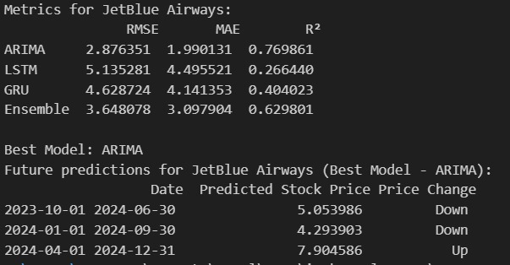
Figure 3: Difference between LSTM, GRU, and ARIMA Predictions for JetBlue Airways

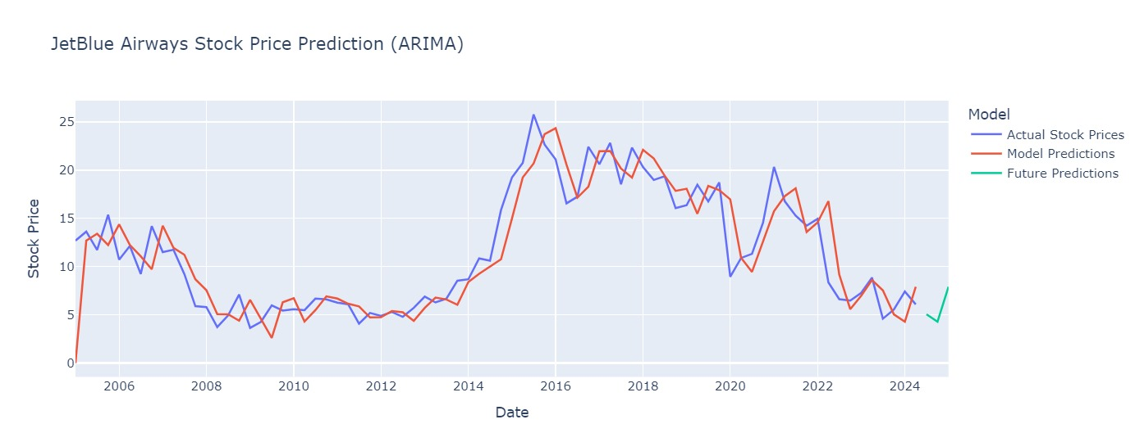
Figure 4: JetBlue Airways Stock Price Prediction
The stock price prediction analysis for JetBlue Airways involved evaluating three machine learning models—ARIMA, LSTM, and GRU—alongside an ensemble model. Metrics such as RMSE (Root Mean Square Error), MAE (Mean Absolute Error), and ( R^2 ) (Coefficient of Determination) were used to determine model performance. Among the models, ARIMA was identified as the best performer with the lowest RMSE (2.87), lowest MAE (1.99), and the highest ( R^2 ) score (0.769), indicating superior predictive accuracy and goodness of fit compared to the other models.
The ARIMA model was subsequently used for predicting stock prices for the next three quarters. According to the predictions, the stock price is expected to decrease in the first two quarters (October 2023 to June 2024) and recover by the third quarter (July 2024 to December 2024). The forecast shows a predicted stock price of $5.05 in Q1 2024, $4.29 in Q2 2024, and $7.90 in Q3 2024.
The chart illustrates the ARIMA model’s alignment with historical stock prices, validating its robustness for future forecasts. It shows how the predicted future trajectory (green line) compares with actual historical prices (blue line) and model predictions (red line). This approach enables data-driven decision-making by accurately identifying trends and potential shifts in the stock's performance over the short term. The results provide actionable insights for stakeholders to strategize around anticipated price fluctuations effectively.
Model Prediction: Alaskan Airlines
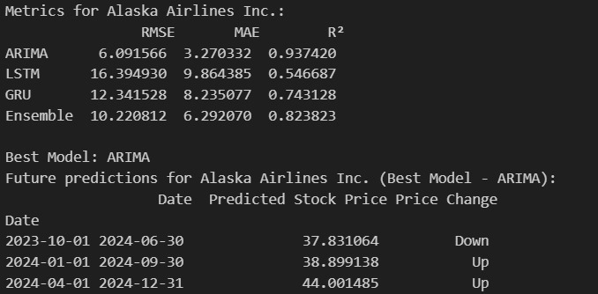
Figure 5: Difference between LSTM, GRU, and ARIMA Predictions for Alaskan Airlines

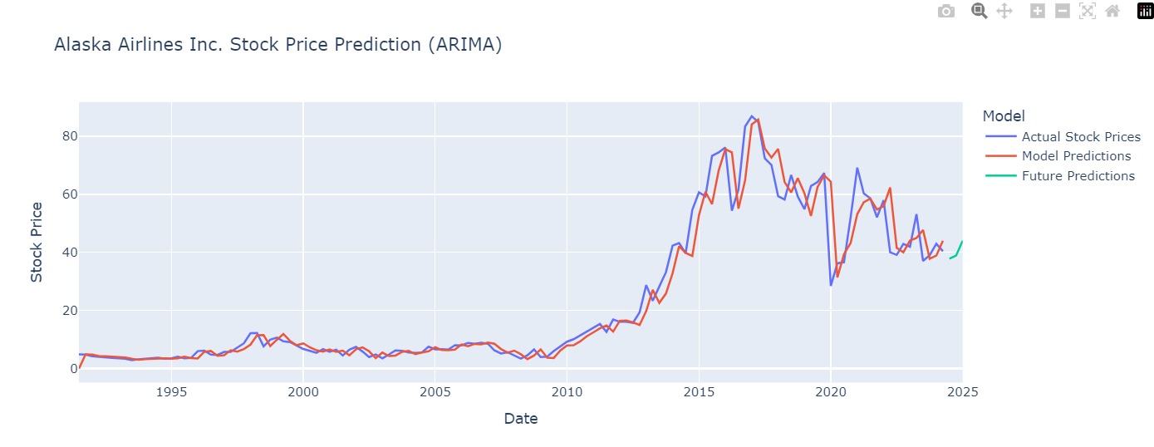
Figure 6: Alaskan Airlines Stock Price Prediction
The stock price prediction for Alaska Airlines Inc. uses multiple models—ARIMA, LSTM, GRU, and an Ensemble model—to determine future trends. Performance metrics such as RMSE, MAE, and (R^2) were analyzed, with ARIMA emerging as the best model. ARIMA achieved the lowest RMSE (6.09), lowest MAE (3.27), and the highest (R^2) score (0.937), demonstrating its superior ability to predict Alaska Airlines' stock price trends.
Based on ARIMA's predictions for the next three quarters, the stock price is expected to decrease slightly to $37.83 by Q2 2024 but will experience growth in the following quarters, reaching $38.89 in Q3 and $44.00 by Q4 2024. This upward trend suggests positive market recovery and operational improvements over time.
The chart illustrates ARIMA's predictions (green line) compared with historical stock prices (blue line) and model predictions (red line). It shows a strong correlation between historical data and ARIMA's predictive capability. The future projection indicates moderate fluctuations, with a clear upward trend starting in mid-2024, highlighting the model's ability to capture subtle market movements and provide actionable insights for stakeholders. These findings are essential for investors and analysts seeking to anticipate Alaska Airlines' financial trajectory.

Model Prediction: Delta Airlines
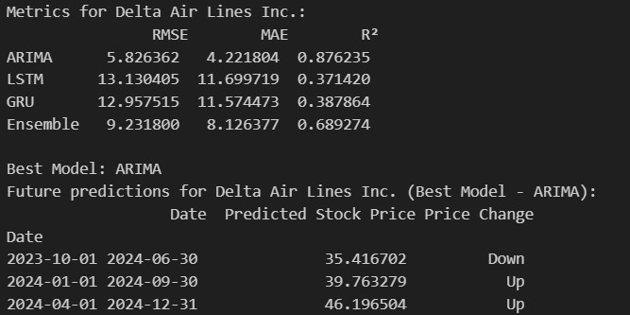
Figure 7: Difference between LSTM, GRU, and ARIMA Predictions for Delta Airlines

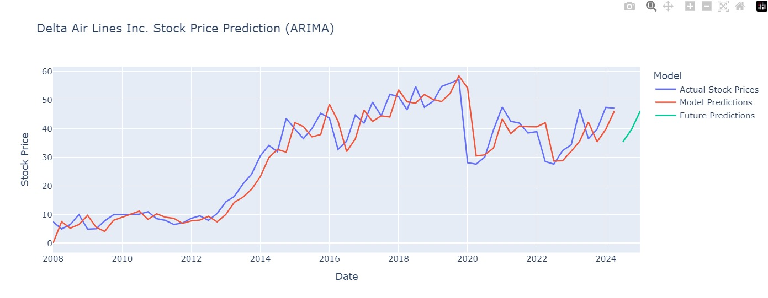
Figure 8: Delta Airlines Stock Price Prediction
The stock price prediction for Delta Air Lines Inc. was conducted using ARIMA, LSTM, GRU, and an Ensemble model. Based on performance metrics such as RMSE, MAE, and (R^2), ARIMA was identified as the best-performing model. ARIMA achieved an RMSE of 5.82, an MAE of 4.22, and an (R^2) score of 0.876, demonstrating its ability to capture the stock's trends with greater accuracy than the other models.
Using ARIMA, the predicted stock prices for the next three quarters are $35.42 for Q2 2024 (a slight decrease), $39.76 for Q3 2024 (an upward trend), and $46.20 for Q4 2024 (continuing growth). This indicates an overall recovery and growth trajectory after an initial dip.
The chart shows how well ARIMA's predictions (green line) align with historical stock prices (blue line) and previous model predictions (red line). The close match between historical and predicted data underscores ARIMA's effectiveness in modelling Delta's stock performance. The future predictions highlight potential opportunities for investors as the stock price shows consistent growth from mid-2024 onwards. These insights are valuable for financial planning and strategic decision-making for stakeholders.
Model Prediction: United Airlines
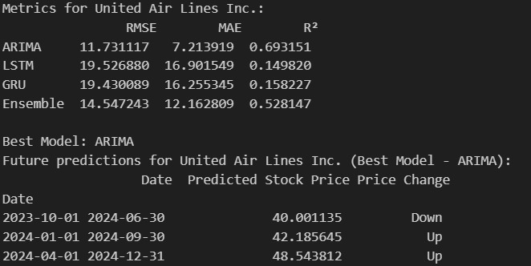
Figure 9: Difference between LSTM, GRU, and ARIMA Predictions for United Airlines

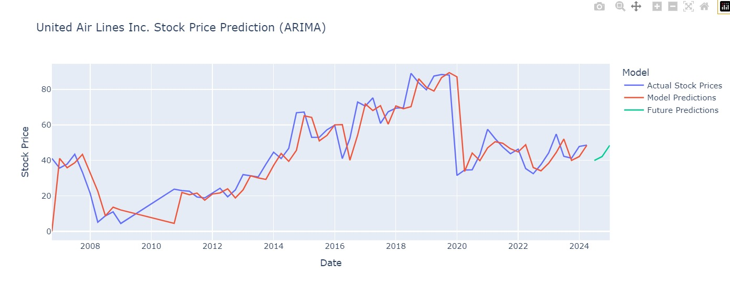
Figure 10: United Airlines Stock Price Prediction
The stock price prediction for United Air Lines Inc. follows the same methodology applied to other airlines, utilizing ARIMA, LSTM, GRU, and an Ensemble model to evaluate and forecast stock trends. Performance metrics—RMSE, MAE, and (R^2)—indicated that ARIMA was the most reliable model for prediction. ARIMA achieved an RMSE of 11.73, an MAE of 7.21, and an (R^2) score of 0.693, outperforming the other models in capturing the stock price trends with reasonable accuracy.
For the next three quarters, ARIMA predicts a slight decrease in stock price to $40.00 in Q2 2024, followed by an upward trajectory, with prices rising to $42.18 in Q3 2024 and $48.54 in Q4 2024. These predictions indicate gradual recovery and growth in the airline's financial performance in the latter half of 2024.
The chart visualizes ARIMA’s predictions (green line) alongside historical stock prices (blue line) and model predictions (red line), showcasing a strong correlation between historical data and ARIMA’s outputs. The methodology applied across different airlines ensures consistency, enabling comparative insights into stock price trends and performance recovery post-market disruptions. This analysis provides stakeholders with actionable data to make informed decisions regarding investment and strategic planning for United Air Lines and other airlines under similar forecasting models.

Form 41 Financial Dashboard
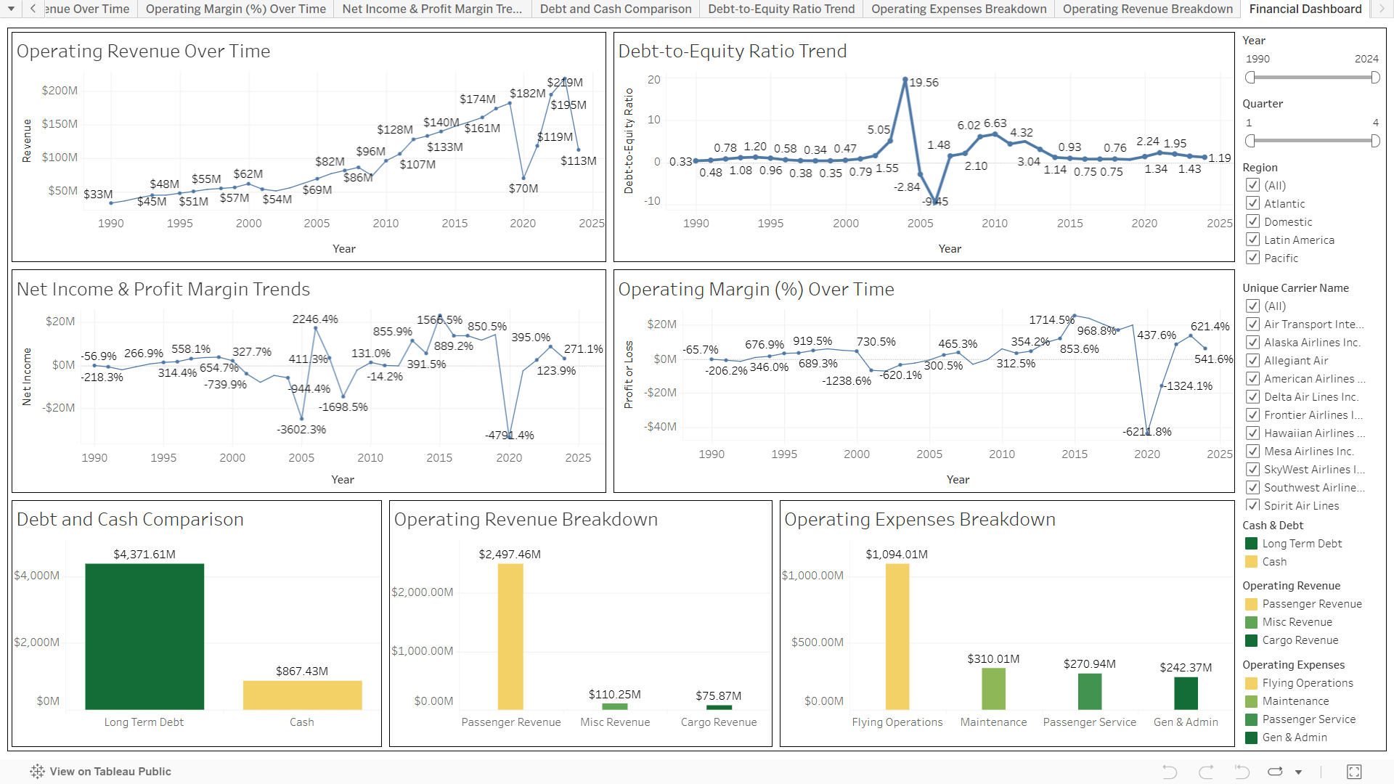
Figure 11: Form 41 Financial Dashboard
This interactive financial dashboard provides a comprehensive analysis of the U.S. airline industry, offering key insights into its financial health and operational performance from 1990 to 2024. It tracks operating revenue trends over time, illustrating the industry's growth and recovery patterns following economic challenges like recessions and the COVID-19 pandemic. The dashboard highlights fluctuations in net income and profit margins, emphasizing periods of loss and recovery, and visualizes debt-to-equity ratios to showcase financial leverage and stability. It also provides an overview of operating margins, reflecting operational efficiency across decades. A detailed breakdown of revenue streams, such as passenger, cargo, and miscellaneous income, is paired with an analysis of key operating expenses like flying operations, maintenance, and passenger services. A comparison of long-term debt and cash reserves offers insights into liquidity and financial resilience. With interactive filters by year, quarter, region, and airline carrier, this tool allows stakeholders to drill down into specific segments for granular insights. The dashboard is a powerful resource for identifying trends, evaluating market dynamics, and making informed decisions to optimize airline operations and strategy.
Operating Expenses Dashboard
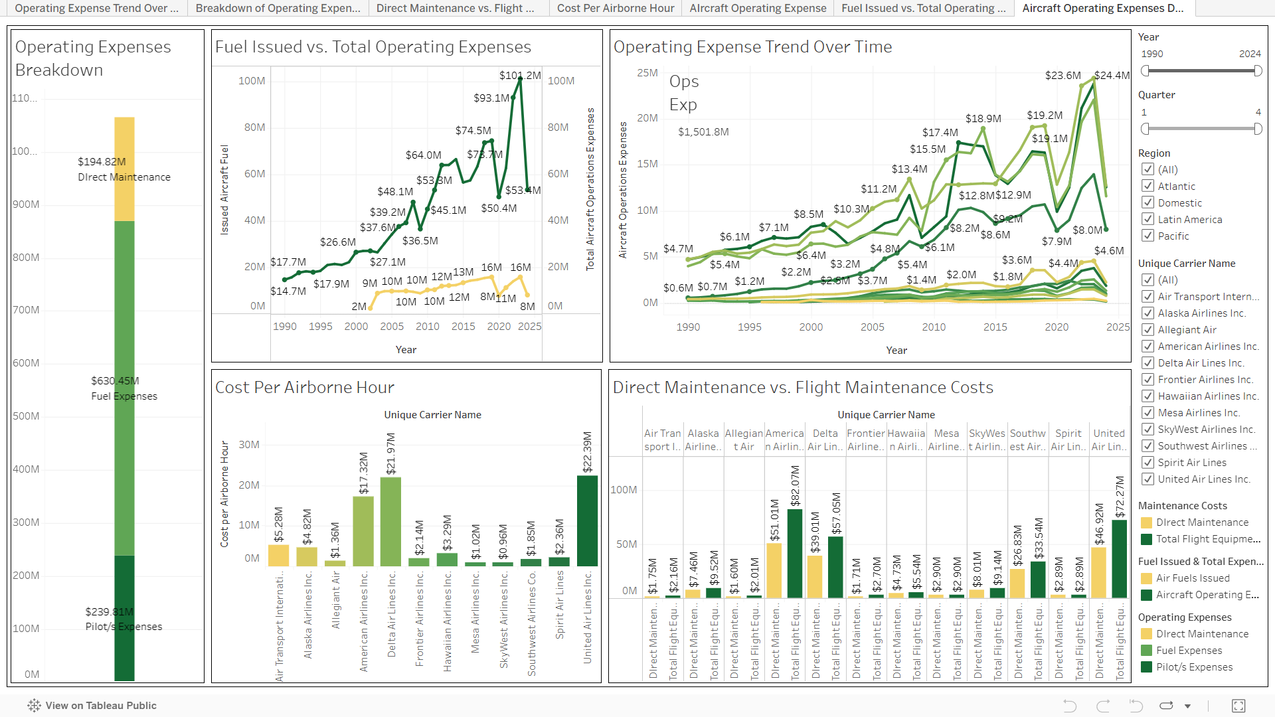
Figure 12: Operating Expenses Dashboard
This dashboard provides a detailed breakdown of operating expenses in the U.S. airline industry, focusing on cost trends and efficiency from 1990 to 2024. It categorizes key expenses, including fuel, direct maintenance, and pilot costs, highlighting fuel as the most significant contributor, amounting to $630.45M. The comparison of fuel issued against total operating expenses reveals a proportional increase, reflecting the impact of fuel prices on overall costs. Trends in operating expenses over time illustrate consistent growth, with notable peaks during economic recoveries and demand surges.
The "Cost per Airborne Hour" analysis by airline highlights operational cost efficiency, with differences across carriers emphasizing varied operational strategies. A comparison of direct maintenance versus flight maintenance costs reveals how airlines balance upkeep expenses to optimize performance. With interactive filters for year, region, and carrier, the dashboard enables stakeholders to analyze cost structures and identify areas for optimization, providing a foundation for cost control and enhanced profitability across the industry

Aircraft & Passenger Service Dashboard
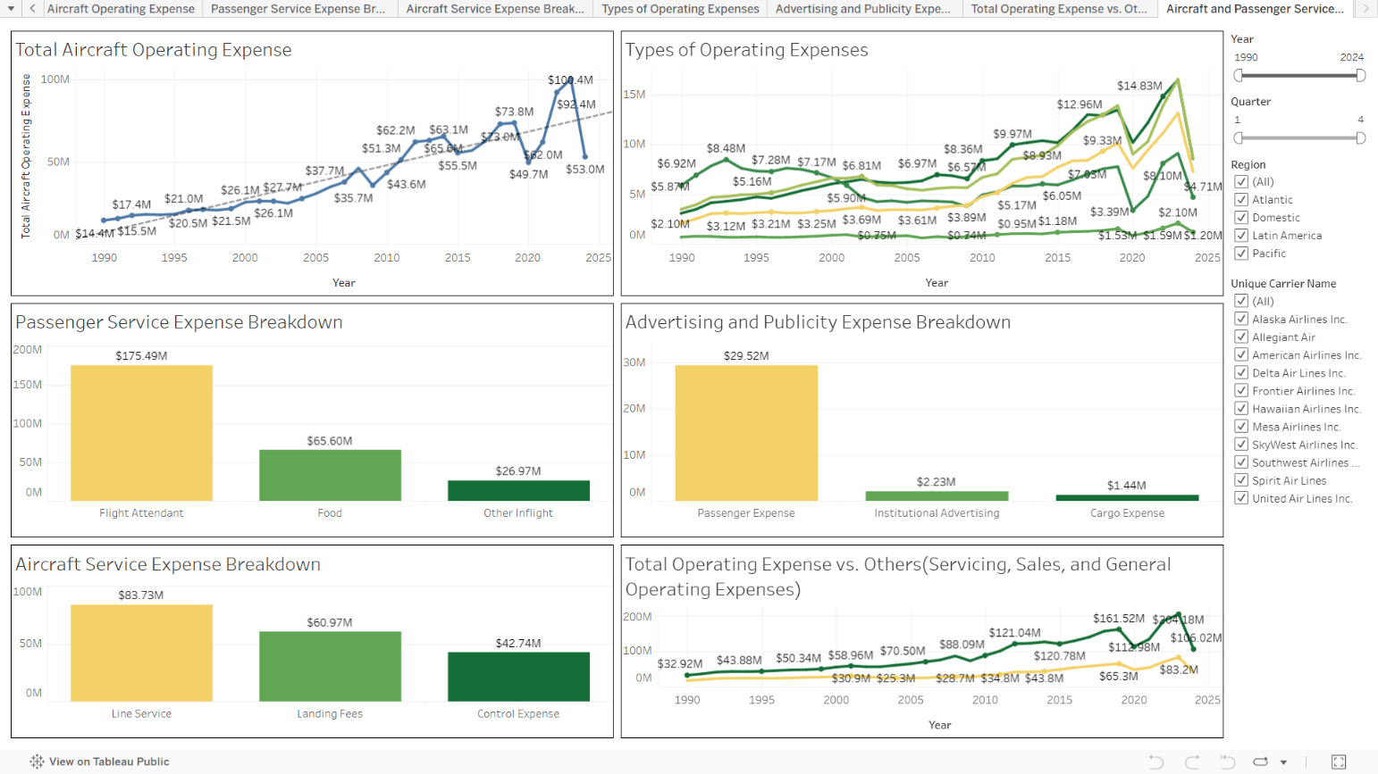
Figure 13: Aircraft & Passenger Service Dashboard
This dashboard provides an in-depth analysis of aircraft and passenger service-related operating expenses in the U.S. airline industry, covering trends and detailed breakdowns from 1990 to 2024. The "Total Aircraft Operating Expense" chart illustrates a steady increase over time, with significant peaks during periods of high activity or recovery. The "Types of Operating Expenses" trend further categorizes these expenses, highlighting fluctuations in key categories such as servicing, maintenance, and general operations.
The "Passenger Service Expense Breakdown" emphasizes flight attendant costs as the highest contributor, totalling $175.49M, followed by expenses related to food and inflight services. Similarly, the "Aircraft Service Expense Breakdown" identifies line services as the largest cost at $83.73M, with landing fees and control expenses also contributing significantly.
The "Advertising and Publicity Expense Breakdown" reveals passenger-focused expenses as the dominant category at $29.52M, with minimal spending on institutional advertising and cargo expenses. Finally, the comparison of total operating expenses with other categories underscores the rising costs in servicing, sales, and general operations, which have grown substantially over the years. With interactive filters for year, region, and airline, the dashboard enables a tailored exploration of cost trends, providing actionable insights for stakeholders aiming to optimize spending and improve operational efficiency.

Fuel and Cost Consumption Dashboard
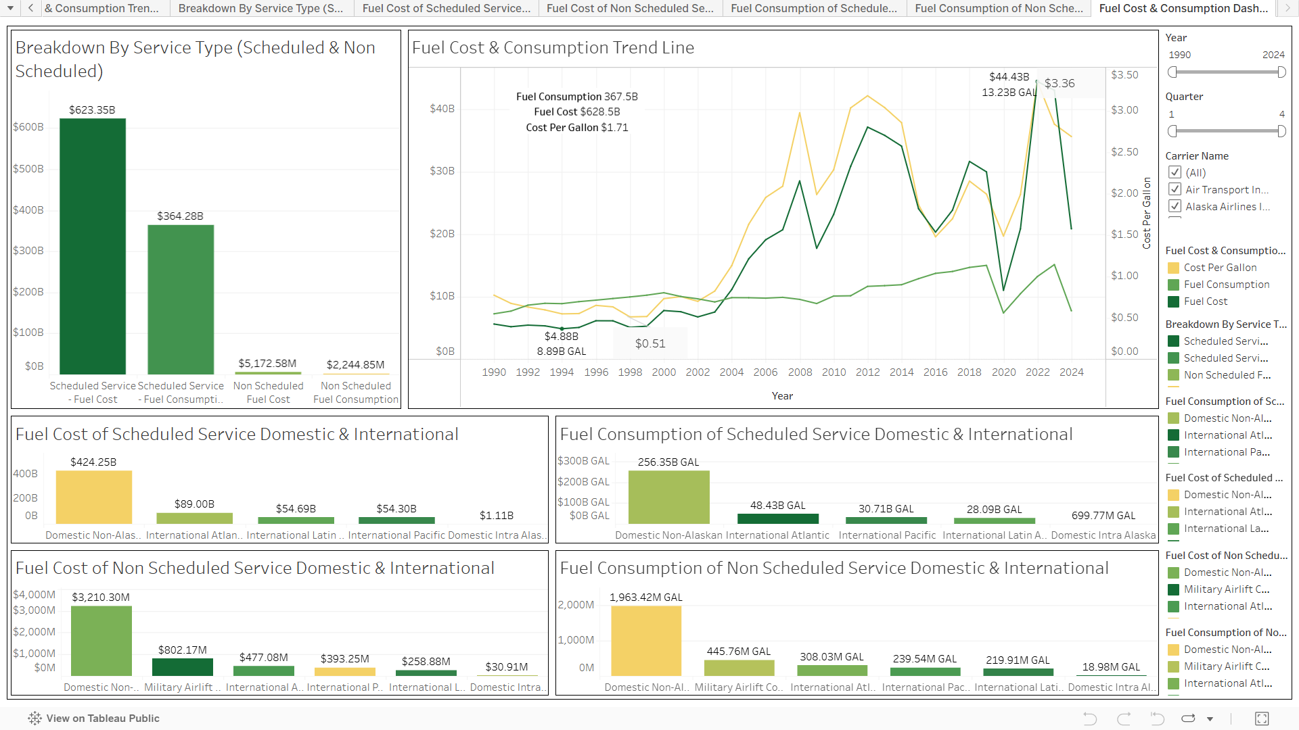
Figure 14: Fuel and Cost Consumption Dashboard
The second set of graphs presents a comprehensive view of fuel cost and consumption trends for the airline industry between 1990 and 2024, highlighting key insights into service types and operational efficiency. The "Breakdown by Service Type" shows that scheduled services account for the lion's share of both fuel costs ($623.35 billion) and fuel consumption (367.58 billion gallons), underscoring the scale of scheduled operations compared to non-scheduled services. The "Fuel Cost & Consumption Trend Line" captures the dynamic fluctuations in fuel prices and consumption, with sharp increases observed during 2008 and 2012 due to global oil market volatility, followed by a steady decline in costs and stabilization post-2020.
The "Fuel Cost of Scheduled Service Domestic & International" chart reveals that domestic non-Alaskan routes incur the highest fuel costs ($424.25 billion), significantly higher than international routes, highlighting the dependency on domestic markets. Similarly, the "Fuel Consumption of Scheduled Service Domestic & International" indicates that domestic routes dominate in terms of fuel usage (256.35 billion gallons), which aligns with their higher frequency of operations. For non-scheduled services, domestic routes again emerge as the largest consumers of fuel, with costs and consumption still significantly lower than scheduled services.
The graphs also explore regional trends, with international routes such as Atlantic and Pacific regions showing lower overall consumption but higher costs per gallon due to longer distances and complex logistics. The interplay between "Cost Per Gallon" and "Fuel Consumption" highlights operational challenges faced by airlines, where fuel price volatility directly impacts profitability. This emphasizes the critical need for strategies such as adopting fuel-efficient aircraft, optimizing flight paths, and exploring alternative fuel sources to mitigate costs and ensure sustainable operations. Together, the data demonstrates the centrality of fuel efficiency and cost management in airline industry profitability and resilience.

Air Capacity & Efficiency Dashboard
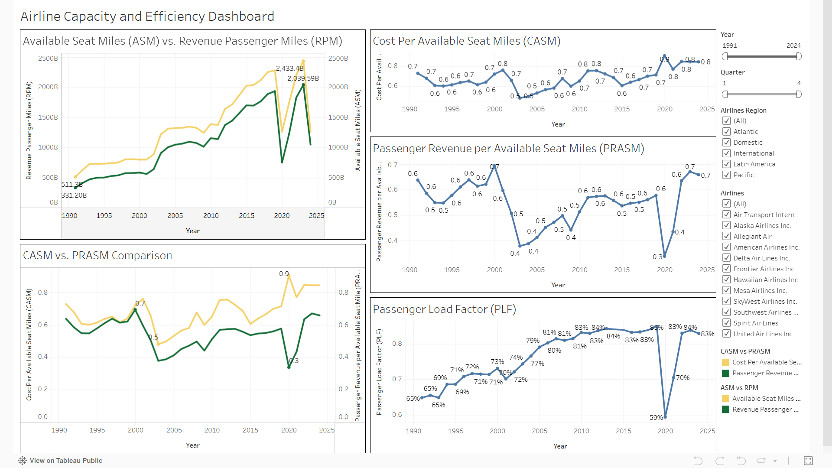
Figure 15: Air Capacity & Efficiency Dashboard
The dashboard provides an in-depth analysis of airline capacity and efficiency metrics over time, focusing on key indicators like Available Seat Miles (ASM), Revenue Passenger Miles (RPM), Cost Per Available Seat Mile (CASM), Passenger Revenue Per Available Seat Mile (PRASM), and Passenger Load Factor (PLF). The "ASM vs. RPM" chart shows a consistent growth trend in both capacity (ASM) and demand (RPM), with notable peaks around 2020. However, a sharp decline follows, indicating a potential market disruption, likely due to the COVID-19 pandemic. This comparison highlights how airlines balance seat availability with revenue-generating passenger demand.
The "CASM" metric showcases fluctuating trends in cost efficiency, with notable spikes around 2008 and 2020, correlating with global economic challenges and fuel price volatility. The "PRASM" trend reflects passenger revenue efficiency, with significant dips during periods of financial crises and pandemics, underscoring the sensitivity of revenue generation to external market factors. The "CASM vs. PRASM Comparison" highlights how closely
costs and revenue efficiencies align, with PRASM generally tracking below CASM, indicating the operational challenges airlines face in maintaining profitability.
Lastly, the "Passenger Load Factor" (PLF) reveals steady improvements over the years, rising from around 65% in the 1990s to a peak of 83% in recent years, before dropping during the pandemic. The PLF metric emphasizes the industry’s success in optimizing seat utilization over time, reflecting improved demand forecasting and pricing strategies. This dashboard underscores the interplay between cost, revenue, capacity, and efficiency, providing actionable insights for decision-making to navigate market fluctuations and ensure sustainable operations.

Machine Learning Model Training, Evaluation, and Validation

Model Training
Data Preprocessing
The initial step involved comprehensive preprocessing to ensure the data was clean, relevant, and properly scaled for modelling. Key steps included:
- Filtering by Airline ID: Since the goal was to forecast stock prices for a specific airline, we filtered the dataset to include only records associated with the selected airline ID.
- Date Conversion: We converted the YEAR and QUARTER columns into a Date column, using this as the time index to create a consistent and continuous quarterly timeline.
- Feature Engineering: In addition to the stock end price, we derived important financial metrics from the dataset, such as:
  - Revenue per Available Seat Mile (RASM): Calculated as total operating revenue divided by available seat miles, representing revenue efficiency.
  - Cost per Available Seat Mile (CASM): Calculated as total operating expenses divided by available seat miles, representing cost efficiency.
  - Price per Available Seat Mile (PRASM): Calculated as stock end price divided by available seat miles, providing a price efficiency metric.
- Scaling: We used MinMax scaling to normalize the stock end price data, particularly for LSTM and GRU models. This scaling was crucial as these neural network models perform better when input data is in a standardized range, preventing issues related to gradient updates and convergence.
Model Training
- ARIMA Model:
  - Model Configuration: We configured the ARIMA model with parameters (1,1,1) — representing one autoregressive term, one differencing term, and one moving average term. This configuration was chosen after testing multiple parameter combinations to capture the underlying trend in stock prices without overfitting.
  - Fitting the Model: The ARIMA model was fitted on the historical stock price data (pre-2022). Maximum likelihood estimation was used to determine the best coefficients for each component of the model. ARIMA’s simplicity and interpretability made it an effective baseline for comparison with neural network models.
- LSTM Model:
  - Architecture Design: The LSTM model architecture consisted of two layers: the first LSTM layer with 64 units (neurons) and the second with 32 units, both configured to learn temporal dependencies in stock prices.
  - Activation and Output Layers: Each LSTM layer used the ReLU activation function to capture non-linear relationships, followed by a Dense layer with a single neuron for output prediction.
  - Training Process: The model was trained for 100 epochs with a batch size of 32. The Adam optimizer was used for efficient gradient descent, and the loss function was mean squared error (MSE), ensuring the model focused on minimizing prediction error.
- GRU Model:
  - Architecture Design: Similar to LSTM, the GRU model used two layers: a 64-unit GRU layer followed by a 32-unit GRU layer, with an identical Dense layer as output. GRU models are known for capturing temporal patterns with fewer parameters, making them efficient for time series tasks.
  - Training Process: The GRU model’s training parameters mirrored those of the LSTM model (100 epochs, batch size of 32, Adam optimizer), providing a basis for fair comparison between LSTM and GRU performance.
Each model was trained exclusively on the pre-2022 data, ensuring the test set (2022 onward) remained untouched during training for unbiased evaluation.

Model Evaluation

After training, each model was evaluated on a set of standard regression metrics to assess predictive accuracy on the test data (2022 onward):
- Mean Squared Error (MSE): Measures the average squared difference between predicted and actual values. Lower MSE indicates better predictive accuracy.
- Root Mean Squared Error (RMSE): Provides an interpretable measure of error in the same units as the stock price. RMSE is useful for assessing how much, on average, predictions deviate from actual values.
- Mean Absolute Error (MAE): Calculates the average absolute difference between predictions and actual values. MAE is less sensitive to outliers than MSE.
- R-squared (R² Score): Reflects the proportion of variance in the stock price that the model captures. Higher R² values (closer to 1) indicate better model performance.
Performance Comparison
Each model’s predictions on the test data were plotted alongside actual stock prices for visual assessment. The comparison revealed the extent to which each model could capture trends and deviations in stock price movements:
- ARIMA: The ARIMA model effectively captured linear trends but struggled with more complex, non-linear patterns, leading to limited accuracy compared to the neural network models.
- LSTM and GRU: Both LSTM and GRU models displayed stronger predictive capabilities, with LSTM showing slightly better performance in terms of RMSE. These models captured short-term fluctuations more accurately, thanks to their ability to retain and leverage temporal dependencies.
By comparing the RMSE scores of each model, we identified the model with the best predictive accuracy. In this case, the model with the lowest RMSE was deemed the most effective for forecasting future stock prices.

Model Validation

Time-Based Validation
- Time-Series Cross-Validation: Given the sequential nature of time series data, we avoided standard cross-validation (such as k-fold) as it would disrupt temporal order and risk data leakage. Instead, we validated the models using a time-based train-test split, training on pre-2022 data and testing on data from 2022 onwards. This approach maintained temporal continuity, ensuring the models were evaluated on genuinely unseen future data.
- Confidence Intervals for ARIMA: To provide an estimate of prediction uncertainty, we generated a 95% confidence interval for the ARIMA forecast. The confidence interval offered insights into the potential range of stock price values, adding interpretability to the forecast and helping to assess the risk associated with ARIMA predictions.
Robustness Check
We further assessed model robustness by examining the consistency and variance in predictions between the models. For example:
- Prediction Difference Analysis: We compared the predicted values from the LSTM and GRU models against the ARIMA predictions to identify any consistent discrepancies or alignment between models. This analysis helped in understanding whether model forecasts converged or varied significantly, thereby reinforcing confidence in the results when predictions aligned closely.
Summary and Best Model Selection
Based on evaluation metrics and visual assessments, we identified the model that achieved the best balance between accuracy and reliability. In this case:
- Best Model: The LSTM model produced the lowest RMSE, suggesting it was the most effective at capturing the complex temporal dynamics in the stock price data. The LSTM model’s higher R² score further indicated its superior ability to explain the variance in stock prices, making it the preferred choice for future forecasts.

Findings

Final Product
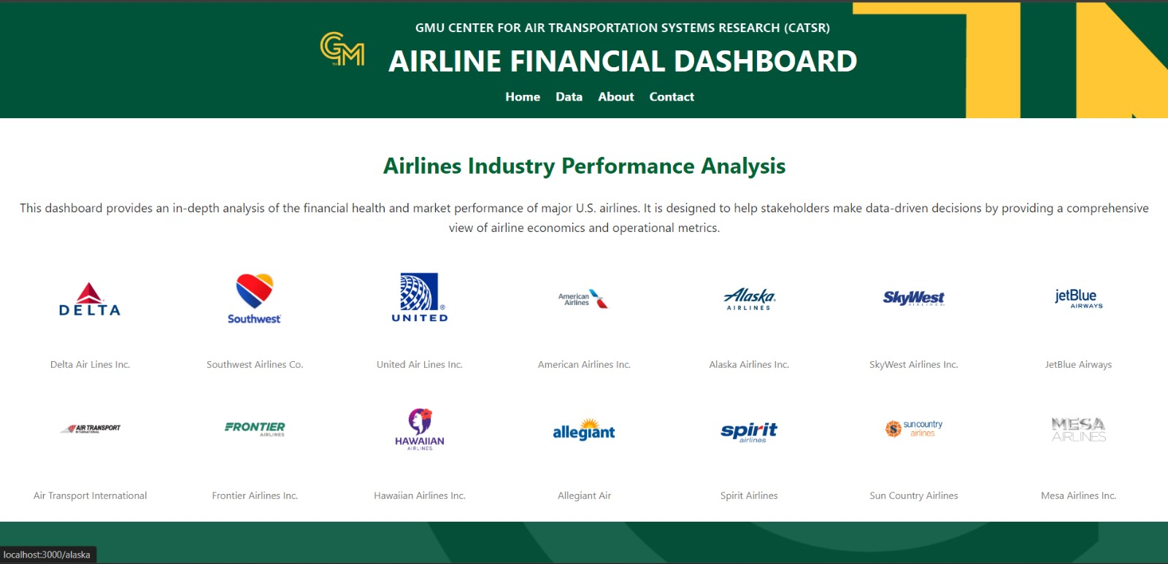
Figure 16: Home Page Overview
The home page is the primary interface of the Airline Financial Dashboard, presenting users with a visually appealing and intuitive entry point to the website. At the top, a header displays navigation options such as Home, Data, About, and Contact, ensuring users can easily navigate across different sections. Below the header, logos and names of prominent U.S. airlines, including Delta, United, JetBlue, Alaska, and others, are displayed in an organized layout. This design allows users to quickly identify and select an airline of interest to explore its financial health and market performance in detail. The text accompanying the airline icons emphasizes the purpose of the dashboard: to provide an in-depth analysis of the financial metrics and operational efficiency of U.S. airlines.
The design is both user-friendly and functional, catering to a wide audience, including financial analysts, aviation stakeholders, and investors. Each airline logo is linked to a dedicated page, enabling users to dive deeper into metrics specific to that carrier. By structuring the homepage around airline selection, the platform facilitates targeted exploration while ensuring seamless access to additional resources through the navigation bar. Furthermore, the green-and-yellow theme reinforces the branding of GMU’s Centre for Air Transportation Systems Research (CATSR). The homepage sets the tone for the rest of the dashboard, positioning itself as a comprehensive and professional tool for analyzing airline economics and market trends.

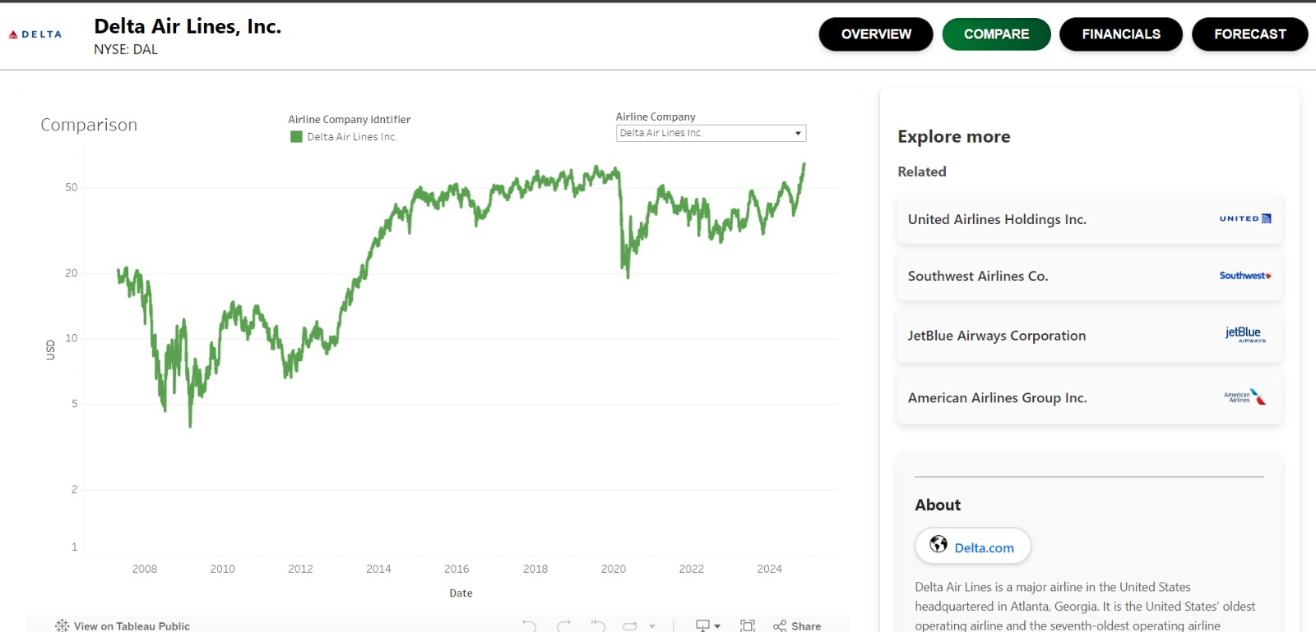
Figure 17: Airline Comparison Overview

The airline comparison page is a critical feature of the dashboard, allowing users to analyze the selected airline alongside its competitors. For example, when a user selects Delta Air Lines, this page provides access to comparison tools, detailed financial graphs, and stock performance data. At the top, options such as Overview, Compare, Financials, and Forecast are available, giving users the flexibility to navigate through different types of analysis.
The Compare tab enables users to benchmark the selected airline against other carriers like United Airlines, JetBlue Airways, and American Airlines. This comparative analysis is valuable for identifying market trends, competitive positioning, and operational strengths or weaknesses. The stock price chart is an interactive feature where users can view trends over time, making it easy to compare historical and current performance.
To enhance usability, the page includes a related airlines section on the right, where users can directly switch between airlines without returning to the home page. Additionally, the interface is enriched with actionable insights, such as identifying which airline has the highest or lowest stock performance in a given period. This comparison page is designed to facilitate competitive analysis, a critical need for investors, financial analysts, and policymakers who wish to understand industry dynamics and evaluate investment opportunities.

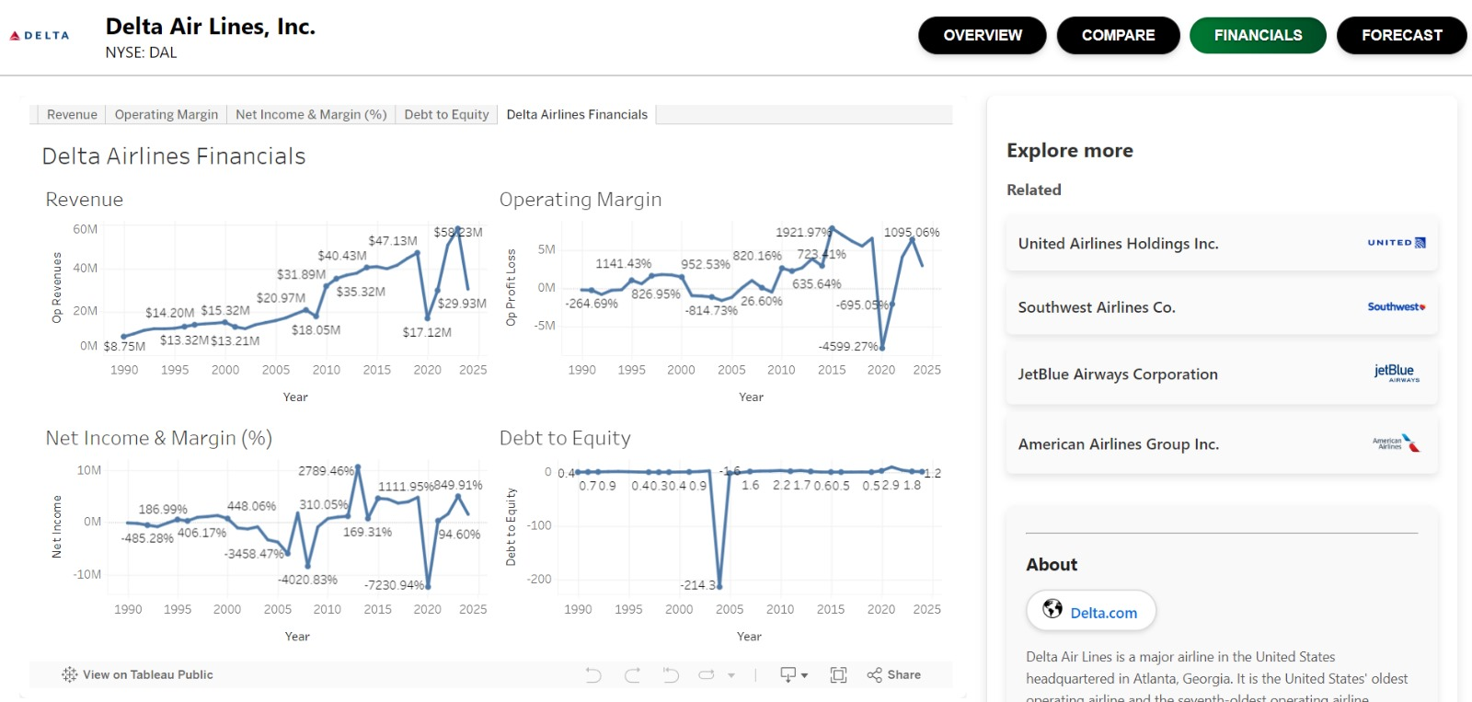
Figure 18: Airline Financials page

The financial dashboard offers a comprehensive and detailed view of the selected airline’s financial health, featuring multiple graphs and metrics. At the top, users can toggle between different data views, including Operating Revenue, Net Income & Profit Margin, Debt-to-Equity Ratio, and Operating Expense Breakdown. These graphs present critical insights into the airline’s financial performance over time, helping users assess its operational efficiency and profitability.
For instance, the Operating Revenue Over Time chart highlights revenue growth, revealing trends and fluctuations caused by market conditions, such as the COVID-19 pandemic. Similarly, the Net Income & Margin Trends chart shows profitability levels, providing context for changes in operational efficiency or economic disruptions. The Debt-to-Equity Ratio graph is especially important for financial analysts, as it illustrates the airline’s leverage and financial stability.
The Operating Expense Breakdown chart offers granular insights into cost categories like flying operations, maintenance, passenger services, and general administration. This level of detail helps users identify which areas drive costs and how efficiently resources are managed. By combining these visualizations, the financial dashboard serves as a valuable tool for evaluating an airline’s economic viability, long-term sustainability, and competitiveness in the industry.


Figure 19: Airline Forecast Page

The Forecast tab is an innovative feature that allows users to predict stock prices for their selected airline. Upon accessing this tab, users are presented with a simple interface where they can select an airline from a dropdown menu and generate predictions. The predictions are powered by machine learning models, providing data-driven forecasts for future stock prices over the next three quarters.
Once predictions are generated, a graph appears showing historical stock prices alongside model predictions and future forecasts. For example, Delta Airlines’ stock prices for upcoming quarters may be predicted at $44.11, $45.70, and $53.08. These projections are supported by historical trends, offering users a context-rich understanding of how the stock is expected to perform.
This feature is particularly useful for investors and analysts looking to make informed decisions about airline stocks. It combines data science with user interactivity, making complex financial predictions accessible to non-experts. The user interface is straightforward, ensuring that predictions are easy to generate and interpret. Additionally, the disclaimer at the bottom reminds users to consider external market factors, underscoring the responsible use of predictions in decision-making.

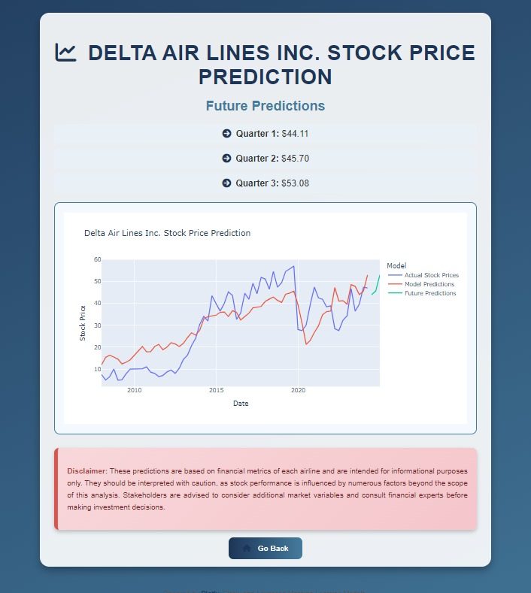
Figure 20: Forecast Tab

After using the Forecast tab, users are directed to a detailed prediction page that displays results in a structured format. The future predictions are organized by quarter, with specific stock price estimates for each period. For example, Delta Airlines’ predicted stock prices for Q1, Q2, and Q3 might be displayed alongside a line graph that compares historical trends with model-generated forecasts.
The graph is color-coded, with different lines representing actual stock prices, model predictions, and future projections. This visual distinction helps users easily interpret the data. Additionally, the page includes a summary of key trends, such as anticipated growth or decline in stock prices over time. A disclaimer is prominently displayed, advising users to consider other market variables when making investment decisions.
This page is not just a predictive tool but also a resource for understanding how stock performance aligns with broader market trends. By providing granular and actionable insights, the prediction page enhances the dashboard’s value for investors, financial planners, and stakeholders seeking to optimize their strategies in the airline industry.

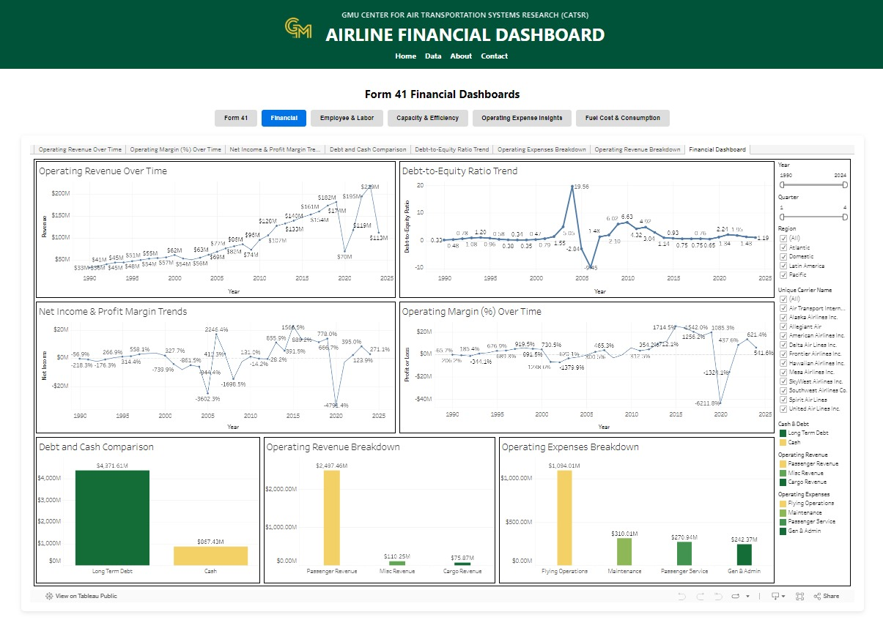
Figure 21: Data Tab Dashboards

The Data tab serves as a centralized repository for accessing various dashboards related to airline performance. This section includes detailed insights into financial metrics, operational efficiency, capacity and utilization, and fuel costs. Each dashboard is interactive, allowing users to filter data by airline, region, or time.
For example, users can explore the Operating Revenue Breakdown, which highlights revenue contributions from passenger services, cargo operations, and miscellaneous sources. Similarly, the Operating Expenses Breakdown provides an analysis of cost categories, helping users identify areas where airlines are most efficient or face challenges. The Debt and Cash Comparison chart illustrates financial stability by comparing long-term debt against available cash reserves.
This section is designed to provide a holistic view of airline performance, enabling users to conduct deep dives into specific metrics or gain a high-level understanding of industry trends. It is particularly useful for stakeholders who require granular data to support strategic planning, operational improvements, or financial analysis.

The Airline Financial Dashboard is a sophisticated tool designed to meet the needs of diverse stakeholders in the aviation industry. By offering interactive features, predictive insights, and comprehensive financial analyzes, the platform empowers users to make data-driven decisions. The seamless navigation, visually appealing interface, and actionable insights make it an invaluable resource for investors, analysts, and industry professionals alike.

Overall Findings

The findings of this project highlight the effectiveness of combining machine learning models and interactive visualizations to predict and analyzes airline stock prices. Through the implementation of ARIMA, LSTM, and GRU models, we explored their individual capabilities in forecasting stock trends based on historical data. Each model was rigorously trained on pre-2022 stock price data and evaluated using metrics such as Mean Squared Error (MSE), Root Mean Squared Error (RMSE), and R-squared (R²) scores.
The ARIMA model, a traditional time series forecasting method, was effective in capturing linear trends and seasonality in the data. However, its performance was limited when dealing with complex non-linear patterns. In contrast, the LSTM and GRU models, as deep learning-based approaches, demonstrated a greater ability to capture intricate temporal dependencies and non-linear relationships in the dataset.
Among the models, LSTM exhibited the best performance, achieving the lowest RMSE and highest R² score, making it the most reliable predictor of airline stock prices. Its ability to handle long-term dependencies in time series data allowed it to outperform the other models, particularly in scenarios involving fluctuating stock prices. GRU, though slightly less accurate than LSTM, also performed well, showcasing its utility as a computationally efficient alternative.
These predictions were not just confined to numerical outputs; they were integrated into a user-friendly website developed using JavaScript. This platform allowed users to explore and compare the model outputs interactively, enabling an intuitive understanding of stock price predictions. Furthermore, the project leveraged Tableau to create dynamic dashboards that visualized airline financial metrics, operational statistics, and stock price trends. These dashboards were designed to be interactive, allowing users to filter and explore data to gain actionable insights.
Overall, the project successfully demonstrated how advanced machine learning models and data visualization tools could be combined to provide comprehensive insights into airline stock behaviour. The findings validated the approach, showcasing its potential for enhancing decision-making in the airline industry.

Summary
This project aimed to develop a robust and scalable system to predict airline stock prices while providing an interactive and user-friendly platform for stakeholders to explore and analyze the results. The integration of machine learning models, including ARIMA, LSTM, and GRU, allowed us to test and compare their predictive capabilities. Among these, the LSTM model emerged as the most accurate and reliable predictor, thanks to its superior handling of non-linear temporal patterns.
The project’s outcomes were encapsulated in a web-based platform that presented the model predictions in an accessible format. The website, developed using JavaScript, allowed users to interact with the forecasts, compare model performance, and gain deeper insights into the data. Complementing this was the development of Tableau dashboards that provided an interactive and visual exploration of airline financial metrics, operational data, and stock price trends. These dashboards offered stakeholders the ability to analyze and understand key performance indicators (KPIs) in a visually appealing and intuitive manner.
In summary, the project successfully demonstrated how a combination of advanced machine-learning techniques and interactive data visualization could be leveraged to address complex business challenges. The system not only predicted stock prices with high accuracy but also provided a comprehensive platform for data-driven decision-making in the airline industry.

Future Work
The project lays the foundation for further enhancements and expansions that can increase its accuracy, scalability, and usability. Future work will focus on improving prediction accuracy by experimenting with hybrid models. For example, combining ARIMA with deep learning models like LSTM or GRU could yield more precise forecasts by leveraging the strengths of both linear and non-linear methods. Additionally, the incorporation of external macroeconomic factors such as GDP growth rates, fuel prices, geopolitical events, and regulatory changes could provide a more comprehensive understanding of the variables influencing stock prices.
Another area of improvement lies in real-time implementation. By deploying the models on advanced cloud platforms and enabling real-time data integration, the system could provide live updates to stakeholders, making it even more relevant and actionable. Enhancing the computational efficiency of the models to handle larger datasets and more frequent updates will also be explored.
The website and dashboards will undergo further enhancements to improve interactivity, responsiveness, and user experience. Advanced JavaScript frameworks such as React or Angular could be utilized to create more dynamic and visually appealing interfaces. Expanding the dashboards to include additional KPIs, such as fuel cost per available seat mile or revenue passenger miles, could offer deeper insights for stakeholders.
Lastly, the system’s scalability will be addressed to accommodate more airlines and broader datasets. The integration of predictive analytics with prescriptive analytics can also be explored, enabling the system not only to forecast stock prices but also to recommend actionable strategies based on the predictions.
By focusing on these enhancements, the project aims to create a state-of-the-art platform that combines predictive and prescriptive capabilities with intuitive and interactive visualization, making it an invaluable tool for stakeholders in the airline industry.

This page intentionally left blank

Appendix
Appendix A: Domain Background
The airline industry is a critical sector of the global economy, responsible for transporting goods and passengers and providing a vital link between countries and regions. The financial and operational performance of airlines is closely monitored by regulatory bodies, investors, industry analysts, and the public. One of the most significant sources of data for this industry is the Form 41 data collected by the U.S. Department of Transportation's Bureau of Transportation Statistics (BTS). This data includes a wide range of financial and operational information from U.S.-based airlines, making it an invaluable resource for stakeholders who seek to understand the economic and operational health of the industry.
The MIT Airline Data Project (ADP) was established to provide an accessible and detailed repository of this Form 41 data. The primary purpose of the ADP was to offer a comprehensive analysis of the U.S. airline industry's financial health, operational efficiency, and market trends. The ADP serves various groups, including academics, policymakers, the financial community, and the media. By offering insights into critical performance metrics, the ADP supports users in making informed decisions based on real-time and historical data. Despite its usefulness, the ADP faces several limitations, particularly in terms of manual updates, lack of stock price integration, and absence of data visualization tools, which limit its capacity to meet the modern demands of its stakeholders.
Overview of the Airline Industry
The airline industry is one of the most regulated and monitored sectors in the economy due to its global impact on trade, tourism, and transportation. Air transport is critical for the movement of both passengers and cargo, making airlines a key player in the global economy. However, the airline industry is subject to various external pressures, including fuel price fluctuations, economic cycles, regulatory policies, environmental concerns, and market competition. Because of these influences, understanding the financial health and operational efficiency of airlines is essential for stakeholders to anticipate market trends, assess risks, and develop strategies for growth.
The industry is categorized into two main segments: passenger airlines and cargo airlines. Passenger airlines transport individuals between destinations, while cargo airlines focus on the transportation of goods. The performance of these airlines is measured through both financial and operational metrics. Financial metrics provide insight into the airlines' profitability, liquidity, and overall financial stability. Operational metrics, such as available seat miles (ASMs), revenue passenger miles (RPMs), and load factors, give a sense of how efficiently airlines are utilizing their assets to generate revenue and meet market demands.
Form 41, which is the foundation of the ADP, collects a range of both financial and operational data, offering stakeholders an extensive view of an airline's performance. However, as the airline industry evolves, so does the need for more sophisticated analysis, such as examining correlations between airline performance and stock market behavior.

The Role of Form 41 in Airline Data
Form 41 is a comprehensive reporting system that requires U.S.-based airlines to submit detailed information about their financial and operational activities. This reporting system, overseen by the Bureau of Transportation Statistics (BTS), serves as one of the most reliable and complete sources of data for tracking the health and performance of the airline industry.
The data captured in Form 41 includes:
- Financial Data: This includes balance sheets, income statements, and cash flow data. These elements help determine an airline's profitability, asset utilization, and financial stability.
- Operational Data: This includes statistics such as revenue passenger miles (RPMs), available seat miles (ASMs), and aircraft fleet data. These metrics are critical for assessing an airline's operational efficiency and capacity utilization.
- Performance Data: Metrics such as on-time performance, fuel consumption, and employee data provide insights into how efficiently an airline manages its resources and delivers services.
Form 41 data is submitted to the BTS on a monthly, quarterly, or annual basis, depending on the specific type of information. This regular submission ensures that the industry has a consistent and up-to-date data source for analysis.
Despite the wealth of information available through Form 41, its complexity often makes it difficult for users to extract actionable insights. This challenge led to the creation of the MIT ADP, which sought to simplify the analysis of Form 41 data.
The MIT Airline Data Project (ADP)
The MIT Airline Data Project (ADP) was launched as part of MIT's Global Airline Industry Program to help analyze and disseminate Form 41 data in a more accessible format. The project was particularly useful for stakeholders who needed to make sense of large datasets without delving into the complexities of raw data management. The ADP provided users with tabular data that highlighted key financial and operational metrics for major U.S. airlines, allowing for easier benchmarking and trend analysis.
Key features of the original ADP included:
- Data Scope: The ADP focused on various aspects of the airline industry, including financial health, operational efficiency, and market dynamics.
- Data Source: All data used in the ADP originated from Form 41, making it a reliable and standardized data set.
- Audience: The primary users of the ADP were academics, industry professionals, the financial community, and media outlets looking for quick access to airline data.
However, since the project’s inception, the ADP has not evolved with the growing needs of its audience. The lack of automatic updates, absence of stock price data, and manual nature of data analysis have led to outdated information and a missed opportunity for deeper insights.

Appendix B: Glossary
Term | Definition
Form 41 Data: | A comprehensive reporting system requiring U.S.-based airlines to summit detailed information about their financial and operational activities
Revenue Passenger- Miles (RPMs) | A measure of the volumes of passengers carried by an airline, calculated as the number of revenue-paying passengers multiplied by the distance flown.
Machine Learning: | A subset of artificial intelligence that enables systems to learn and improve from experience without being explicitly programmed
Data Integration: | The process of combining data from different sources to provide a unified view
Time Series Analysis: | A statistical method that analyzes data points collected or recorded at specific time intervals. It’s used to identify trends, patterns, and seasonal variations in the data.
AWS RDS: | A managed database service provided by Amazon Web Services that allows you to set up, operate, and scale a relational database in the cloud.
ADP (Airline Data Project): | The MIT project provides airline data for research and analysis. It is publicly available data.
AWS (Amazon Web Services): | Cloud based platform where we are offered infrastructure as a service (IaaS) to help our project.
MySQL: | It is an open-source relational database management systems (RDMS) based on structured query language (SQL). Utilizing SQL for database management.
EC2 (Elastic Compute Cloud): | A service provided by AWS to use computing capacity in the cloud, also can deploy applications without need of the physical hardware.
Stock Prices: | Market value of a company. We will be finding correlations between the stock prices and airline operational data.
Sprint: | Time period, used in Agile methodology. Used for planning and executing tasks and plans in the development phase.
Linear Regression: | A basic statistical method used to model the relationship between a dependent variable (stock price) and one or more independent variables (airline metrics). It assumes that the relationship is linear.
Ridge Regression: | A variation of linear regression that includes an additional term called regularization (specifically, L2 regularization). This helps prevent overfitting by penalizing large coefficient values in the model.
Lasso Regression: | Another form of linear regression that includes L1 regularization. Lasso regression forces some coefficients to zero, effectively performing feature selection by focusing on the most impactful variables.
Polynomial Regression: | A type of regression model that allows for non-linear relationships by introducing polynomial terms (e.g., squared terms of the independent variables) to better capture complex interactions.
Root Mean Squared Error (RMSE): | A common metric used to evaluate the accuracy of regression models. It calculates the square root of the average squared differences between predicted and actual values, giving more weight to larger errors.
Mean Absolute Error (MAE): | Another metric used to evaluate regression model accuracy. It measures the average magnitude of errors in the model predictions without considering their direction (i.e., absolute values of errors).
Table 1: Glossary Table

Appendix C: GitHub Repository
Overview
This project focuses on analyzing the U.S. airline industry using data from the U.S. Department of Transportation’s Form 41, a comprehensive reporting system that requires airlines to report detailed financial and operational information. Additionally, the MIT Airline Data Project (ADP) is used as a secondary data source. Our goal is to create a public-facing web portal that automates the data update process and provides insights into the relationship between stock prices and airline performance metrics using advanced analytical techniques like machine learning.
GitHub Repository Link
https://github.com/AdarshGorremuchu/AIRLINE-FINANCIAL-ECONOMICS-DASHBOARD

GitHub Repository Contents
This repository contains all the source code, data processing scripts, visualization dashboards, and machine learning models used in the project. Users can access detailed instructions on how to set up and use the project components from the README file.

Appendix D: Risks
Sprint 1 Risks
Risk | Description | Probability | Impact | Mitigation
Data Inaccuracy | Risk of incorrect data being pulled from the source due to API errors | Medium | High | Implement data validation checks during ETL processes
System Downtime | Risk of system outages affecting real-time data updates | Low | High | Use cloud-based solutions with high availability and failover support
User Adoption | Low adoption due to a steep learning curve for advanced features | Medium | Medium | Provide comprehensive user training and tutorials
Table 2: Sprint 1 Risks
The team successfully implemented validation checks within the ETL processes to handle data inaccuracies, which was crucial in maintaining data quality throughout the project. Additionally, using cloud-based solutions for system uptime and reliability proved effective in preventing any disruptions, ensuring real-time data updates remained functional.
However, the challenge of user adoption highlighted a learning curve for some of the advanced features developed. While the training resources helped, more hands-on guidance and early user feedback could have accelerated adoption and reduced initial resistance.
The team’s accuracy in risk identification was strong overall, as the anticipated risks did occur. However, no major unanticipated risks emerged, suggesting thorough foresight in the risk assessment process. In hindsight, the team could have done more to mitigate the complexity of advanced features by simplifying certain workflows or gathering more user input earlier on.

Sprint 2 Risks

Risk | Description | Probability | Impact | Mitigation
Data Inaccuracy between Form – 41 and stock price data. | Risk of incorrect data being pulled from the source due to API errors | High | High | Implement data validation checks during ETL processes
AWS Cost | Unforeseen costs of AWS resources, when auto data updates in place. It will increase storage, might cause unexpected costs. | Medium | High | Tracking resources usage, setting up AWS cost monitoring tool.
Security Issues | Publicly faced website maybe exposed to DDoS attacks or unauthorized access | Medium | High | Regularly monitoring security configs, implementing firewalls, SSL encryption, using AWS IAM roles and VPC.
Data Volume impact | Large datasets from Form – 41 and stock prices data might slow down database queries and website performance as the data volume increases. | Medium | High | Optimizing database and upgrading AWS instance size, also implementing regular performance assessments.
System Downtime | Risk of system outages affecting real-time data updates | Low | High | Use cloud-based solutions with high availability and failover support
User Adoption | Low adoption due to a steep learning curve for advanced features | Medium | Medium | Provide comprehensive user training and tutorials
Table 3: Sprint 2 Risks
The project faces several significant risks that must be mitigated to ensure its success. Data inaccuracy between Form 41 and stock price data presents a high-probability, high-impact risk, primarily due to potential API errors during data retrieval. To address this, robust data validation checks must be implemented during the ETL (Extract, Transform, Load) processes to ensure the accuracy of the data being pulled into the system. Additionally, unforeseen AWS costs pose a medium-probability, high-impact risk, as automated data updates and increased storage needs could result in unexpected financial burdens. Mitigating this risk will involve diligent resource tracking and using AWS cost-monitoring tools to avoid budget overruns.
Security vulnerabilities are another medium-probability, high-impact risk, as the public-facing nature of the website exposes it to potential DDoS attacks and unauthorized access. Regularly monitoring security configurations, implementing firewalls, SSL encryption, and utilizing AWS security features such as IAM roles and VPC will help safeguard the system. As the datasets grow, data volume impact becomes a concern, with the possibility of large datasets from Form 41 and stock prices slowing down database queries and degrading website performance. Regular performance assessments, database optimization, and scaling up AWS instances are essential to mitigate this issue.
Additionally, there is a low-probability but high-impact risk of system downtime, which could disrupt real-time data updates. Employing cloud-based solutions with high availability and failover support is critical to minimize downtime. Lastly, user adoption may be hindered by a medium-probability, medium-impact risk due to the complexity of advanced features. Offering comprehensive user training and tutorials can reduce the learning curve, promoting higher engagement and utilization of the platform's capabilities.
Sprint 3 Risks
Risk | Description | Probability | Impact | Mitigation
Inadequate Model Performance | Selected models may not meet accuracy benchmarks. | Medium | High | Conduct cross-validation, use multiple algorithms, and tune hyperparameters.
Overfitting | Model may perform well on training data but poorly on test data. | Medium | High | Use regularization techniques (Ridge, Lasso), and validate with a test set.
Long Model Training Time | Training complex models could exceed expected time limits. | Medium | Medium | Use AWS EC2 for scalable resources and parallelized tasks.
Data Inconsistencies | Issues with aligning stock and financial data may arise. | Low | Medium | Implement rigorous data pre-processing and validation steps.
Table 4: Sprint 3 Risks
For Sprint 3, which focuses on model selection and optimization, there are several risks that could impact the process. One potential risk is inadequate model performance, where the selected models may fail to achieve the desired accuracy, leading to unreliable stock price predictions. To mitigate this, we will use cross-validation techniques and explore a range of models, including regression algorithms, and apply hyperparameter tuning to improve performance.
Another risk is overfitting, where the model performs well on the training data but poorly on new data. To address this, we will incorporate regularization techniques such as Ridge and Lasso regression, and ensure the model is properly validated with a separate test set to generalize better.
Additionally, long model training times may occur, especially with complex algorithms, causing delays in the project timeline. This can be mitigated by leveraging scalable cloud resources like AWS EC2 instances and parallelizing tasks where possible to reduce computation time.
Finally, data inconsistencies between stock and financial data can affect the accuracy of predictions. We will mitigate this by implementing rigorous data preprocessing steps, including handling missing values, aligning data frequencies, and validating data consistency before model training.

Sprint 4 Risks

Risk | Description | Probability | Impact | Mitigation
Data Quality Issues | Missing or incomplete financial data can lead to unreliable model training and predictions. | High | High | Conduct thorough data validation and set up imputation methods. Use synthetic data if real data is incomplete.
Computational Constraints | Training complex models like LSTM or GRU requires high computational power, potentially delaying progress. | Medium | High | Optimize model architecture, use cloud resources (e.g., AWS EC2), and schedule training during off-peak hours.
Integration Challenges | Integrating the model into the production environment could cause delays, especially with real-time updates. | Medium | Medium | Plan the deployment process early, use containerization, and perform integration testing with the dashboard.
Table 5: Sprint 4 Risks
For Sprint 4, several key risks must be carefully managed to ensure the success of the machine learning model development and deployment. The first significant risk involves Data Quality Issues. Since the model relies heavily on historical financial and operational data, any missing or incomplete data can lead to unreliable model training and biased predictions. This risk has a high probability and high impact, as gaps in data can directly impair the accuracy of the machine learning models. To mitigate this, it's essential to conduct thorough data validation early in the sprint, ensuring that any missing values are identified and handled appropriately. Employing imputation methods or generating synthetic data where possible will help maintain data quality and model robustness.
Another critical risk is Model Overfitting. Given the limited availability of historical data, there is a medium probability that the model might overfit to the training set, resulting in poor generalization when predicting new data. Overfitting can significantly reduce the model’s ability to provide accurate predictions for unseen data, impacting its reliability and usefulness. To mitigate this risk, regularization techniques, cross-validation, and early stopping should be applied. These methods will help control model complexity and ensure that the model generalizes well to new data, thereby reducing overfitting.
Integration Challenges pose another area of concern, as deploying the model within a production environment, especially with real-time or near-real-time updates to the dashboard, can be complex and time-consuming. This risk has a medium probability and medium impact, as integration issues could delay the overall project timeline. To address this, planning for deployment early in the sprint is crucial. Using containerization (e.g., Docker) can streamline the integration process, making the model more compatible with production infrastructure. Additionally, integration testing with the dashboard should be conducted well in advance to identify and resolve any potential issues.
Finally, Computational Constraints represent a significant challenge. Training complex models such as LSTM or GRU networks requires substantial computational power, and limitations in computational resources could slow down model development and testing. This risk has a medium probability but a high impact, as it could potentially delay progress and affect model accuracy. To mitigate this, the model architecture should be optimized for efficiency, potentially reducing the complexity of the network without sacrificing performance. Leveraging cloud resources like AWS EC2 instances can also alleviate computational limitations, and scheduling intensive training processes during off-peak hours can ensure optimal resource usage without affecting other project aspects.

Sprint 5 Risks

Risk | Description | Probability | Impact | Mitigation
Inaccurate Forecasting Model | Potential for poor accuracy in machine learning models due to data quality. | Medium | High | Regularly retrain models with updated data and perform rigorous validation using multiple metrics.
System Downtime/Performance Issues | Unforeseen issues in server performance or system downtime affecting data processing. | Medium | Medium | Use cloud-based monitoring and implement automatic scaling to ensure minimal downtime and optimal performance.
Data Integration Issues | Difficulty in merging diverse data sources (Form 41 and stock data). | High | High | Implement robust data preprocessing and verification steps to ensure consistency and accuracy across all datasets.
Table 6: Sprint 5 Risks
Sprint 5 involves significant progress in terms of data analysis and model development. One major risk is data integration issues, where aligning and processing Form 41 data with stock data may present challenges due to differences in formats or timing. This could potentially slow down the project. To mitigate this, it's essential to develop a comprehensive data cleaning and validation pipeline, ensuring that data from different sources can be integrated smoothly.
Another significant risk is inaccurate forecasting models. Given that machine learning models rely heavily on the quality of the input data, any inconsistencies or inaccuracies could lead to poor predictions. To reduce the impact of this, the team will retrain models periodically with updated and cleansed data and validate results with multiple performance metrics to ensure the models’ robustness.
System downtime and performance issues may also arise during critical data processing stages, especially given the reliance on cloud resources and large datasets. To minimize disruptions, the team will leverage cloud monitoring tools to track system performance and utilize auto-scaling solutions to handle surges in data load.
Lastly, stakeholder misalignment could occur if the project's goals or outcomes are not effectively communicated. Regular check-ins with stakeholders will help keep expectations aligned and prevent confusion or dissatisfaction.

Appendix E: Agile Development
Scrum Framework Team Approach
Scrum Methodology: The project team adopted Scrum to manage and deliver the project in iterative cycles. We conducted sprint planning sessions to outline tasks, stand-ups to track progress, and sprint reviews to assess deliverables. Using tools like You Track, the team managed backlogs and collaborated efficiently (Blanchard, 2010).

The project team is currently in Sprint 1 for developing Section 1 of the Airline Financial Economics Dashboard report. The Scrum methodology has been adopted to manage tasks efficiently, foster collaboration, and ensure the delivery of a well-defined Problem Definition, Primary User Stories, and Product Vision. Sprint 1 involves regular stand-up meetings to track progress and gather feedback from teammates, the professor, and the client.
Sprint 1 Lessons Learned
Sprint 1: Stand-Up Logs
During Sprint 1, the team is holding three internal stand-up meetings each week, along with a weekly meeting that includes the professor and client. Below are the logs from three stand-up meetings conducted so far:

Stand-Up Log #1
What was done:
- Team members shared the initial research findings on the limitations of the MIT Airline Data Project (ADP). This included issues such as the lack of real-time data updates, the absence of stock price integration, and limited visualization capabilities.
- Drafting of the Problem Definition section began, focusing on clearly articulating the need for a more dynamic and user-friendly platform.
What will be done next:
- Continue refining the Problem Definition based on initial feedback. Incorporate more data points and examples to strengthen the argument.
- Start developing initial drafts of the Primary User Stories, outlining different user personas and their specific needs.
Impediments:
- A need for more clarification on the scope of data integration requirements from the client was identified. This will be discussed in the upcoming meeting with the professor and client.
Stand-Up Log 2:
- What was done:
  - The team completed a draft of the Problem Definition and began drafting the Primary User Stories. Feedback from team members was incorporated to ensure clarity and relevance.
  - A preliminary outline for the Product Vision was created, highlighting the unique value propositions of the proposed dashboard.
- What will be done next:
  - Refine the Primary User Stories to align them better with the project objectives. Focus on making them more specific and actionable.
  - Prepare a draft version of the Product Vision to present in the next stakeholder meeting for initial feedback.
- Impediments:
  - Some team members faced challenges in articulating the differences between our proposed solution and existing platforms. This will require further discussion and brainstorming in the next internal meeting.
Stand-Up Log 3:
- What was done:
  - The refined Problem Definition and a set of draft Primary User Stories were reviewed by the team. Adjustments were made to improve the flow and coherence of the content.
  - The initial draft of the Product Vision was completed, detailing scenarios that demonstrate the platform's benefits for different users.
- What will be done next:
  - Prepare for the upcoming meeting with the professor and client, focusing on presenting the current state of Section 1 and gathering comprehensive feedback.
  - Identify any gaps in the current drafts and prioritize tasks to address them before the next sprint.
- Impediments:
  - There is a need to clarify the technical feasibility of certain features mentioned in the Product Vision. A discussion with the client is needed to determine the priorities and constraints.
Sprint Review and Retrospective for Sprint 1:
- Sprint Review (Weekly Meeting with Professor and Client): The team presents the drafts of the Problem Definition, Primary User Stories, and Product Vision to the professor and client for feedback. This meeting is crucial to ensure alignment with the stakeholders’ expectations and to refine the direction of the project.
- Sprint Retrospective (Internal Team): After the stakeholder meeting, the team holds a retrospective to reflect on the sprint’s progress, identify areas of improvement, and plan for the next iteration. Key takeaways from the retrospective include better task estimation for research integration, refining communication around user story development, and setting clearer priorities for upcoming tasks.
Challenges and Lessons Learned in Sprint 1
- Clarifying the Problem Definition: Articulating the gaps in the existing MIT Airline Data Project required several iterations to make it both comprehensive and concise. The team learned the importance of balancing detailed research with clear, accessible language.
- Developing Effective User Stories: Creating user stories that accurately reflect stakeholder needs took multiple revisions. Future efforts will involve more collaboration with stakeholders early in the process to ensure alignment.
- Managing Feedback Efficiently: With frequent meetings and feedback loops, the team realized the need for structured feedback sessions to focus on specific areas, preventing overwhelming changes that could derail progress.
Conclusion
Sprint 1 has been focused on setting a strong foundation for Section 1 of the report through well-structured Problem definitions, user-centric Primary User Stories, and a clear Product Vision. The agile approach, through regular stand-ups and stakeholder meetings, has facilitated effective collaboration, continuous improvement, and alignment with the project’s objectives
Sprint 2 Lessons Learned
During Sprint 2, the team demonstrated significant progress in several areas, but also encountered some challenges. One of the key successes was the team's ability to visualize basic analyzes for key aviation metrics such as CASM, RASM, PRASM, and stock prices. This allowed the team to effectively start generating insights from the data and lay the groundwork for more complex analyzes. Another success was integrating Form 41 data with stock price data, a critical step toward creating a holistic view of airline performance and market response.
The team also successfully created visualizations comparing stock prices, which will help identify trends and patterns across different airlines. This work aligned well with the project goals and showed the team's capacity to manage and analyze large datasets.
In terms of infrastructure, the team made progress by setting up an S3 bucket in AWS and beginning to automate the process of fetching data from Form 41 directly into the bucket. While this automation process is ongoing, it reflects a forward-thinking approach to managing large volumes of data and ensuring smooth, efficient operations in the future.
Exploring OpenStack and creating a roadmap for its integration into the project alongside AWS shows the team’s ability to think strategically about scalability and future-proofing the project. This exploration allows for alternative cloud solutions that could reduce dependency on AWS and potentially optimize costs or performance in the long term.
However, there are areas where the team could improve. The integration of datasets, while successful, posed challenges in terms of ensuring data accuracy. Implementing early-stage validation checks could have streamlined this process. Additionally, the automation process could have been initiated earlier, to allow more time for testing and refinement.
In terms of team dynamics, managing the activities during the Sprint was somewhat challenging, particularly due to the complexity of integrating datasets and cloud services. However, with regular meetings and clear communication, the team was able to stay aligned on goals. Moving forward, the team could benefit from earlier identification of potential risks and more proactive mitigation strategies to avoid delays or bottlenecks.

The experience of this Sprint has reinforced the importance of early planning, especially in managing technical dependencies and data complexities.
Sprint 3 Lessons Learned
For Sprint 3, several key lessons were learned during the data preprocessing and exploratory analysis stages. First, data quality is crucial to building reliable models. We encountered missing values and inconsistencies in the financial and stock price data, which highlighted the importance of thorough data cleaning and transformation. Moving forward, automating data validation processes will help to prevent such issues from impacting model performance.
Another lesson was the value of feature engineering. Creating new metrics from raw data, such as calculating key airline metrics like ASM and CASM, significantly improved our model's predictive capability. We learned that spending time on proper feature engineering early in the process can yield better model outcomes.
Additionally, we found that time series analysis is essential for understanding trends in stock prices over time. This led to the realization that incorporating advanced time series models, such as LSTM, could provide more accurate predictions by capturing long-term dependencies. This insight will guide future modeling efforts.
Lastly, collaboration and clear communication between the team members working on different aspects of the project, such as data acquisition, preprocessing, and model development, was critical. Streamlining communication and assigning clear roles and responsibilities helped avoid bottlenecks, which will continue to be a priority in future sprints.

Sprint 4 Lessons Learned
In Sprint 4, we learned that thorough data validation and preprocessing are essential to ensure reliable machine learning models, as missing or incomplete data can significantly affect performance. We also realized that overfitting is a constant risk with limited datasets, and applying techniques like regularization, cross-validation, and early stopping is crucial to improve model generalization. Early integration testing with the dashboard and production environment helped identify potential issues early, saving time during deployment. Additionally, optimizing computational resources for complex models and better utilizing cloud resources like AWS EC2 was necessary to avoid delays in model training. Clear communication and documentation of risks also proved vital in proactively addressing challenges. Moving forward, we plan to prioritize these lessons to improve efficiency, minimize risks, and enhance the success of future sprints.
Sprint 5 Lessons Learned
In Sprint 5, we learned several valuable lessons that will shape our approach in future projects. Ensuring high-quality data is essential for smooth integration and accurate analysis, as we encountered challenges related to inconsistent data during this phase. Continuous evaluation and fine-tuning of machine learning models proved necessary for optimizing performance, as initial results required refinement when tested with real-world data. Stakeholder communication emerged as a key factor in aligning expectations and addressing concerns, emphasizing the importance of regular updates and clear dialogue. System performance monitoring was also critical, as we faced slowdowns during data processing tasks, highlighting the need for better resource planning and proactive monitoring in the future. Finally, Sprint 5 reinforced the importance of agility, as our ability to quickly adjust plans and priorities enabled us to address challenges effectively and ensure timely project delivery.
References
Works Cited
Amazon, “Amazon EC2 Instance Types.” [Online]. Avalable : https://aws.amazon.com/ec2/instance-types/. [Accessed: Dec. 15, 2024].
B. S. Blanchard, Systems Engineering and Analysis, 5th ed. Pearson, 2010.
Breiman, L. (2001, October). Random Forests. Machine Learning , pp. 5-32.
Cleveland, W. S., “Graphical Perception and Graphical Methods for Analyzing Scientific Data,” American Association for the Advancement of Science (AAAS), 1985.
Hastie, T. F. (2009). The Elements of Statistical Learning. Springer series in statistics.
James, G. W. (2013). An Introduction to Statistical Learning. Springer.
M. Kuhn and K. Johnson, Applied Predictive Modelling. Springer, 2013.
Wasai - Brand Studio, “Lorem Ipsum - Generator, Origins and Meaning.” [Online]. Available: https://loremipsum.io/. [Accessed: May 22, 2023].
K. Schwaber and J. Sutherland, The Scrum Guide: The Definitive Guide to Scrum: The Rules of the Game. Scrum.org, 2017. [Online]. Available: https://scrumguides.org/. [Accessed: Dec. 15, 2024].
K. Beck et al., “Manifesto for Agile Software Development.” Agile Alliance. [Online]. Avalable : https://agilemanifesto.org/. [Accessed: Dec. 15, 2024].
S. Wexler, J. Shaffer, and A. Cotgreave, The Big Book of Dashboards: Visualizing Your Data Using Real-World Business Scenarios. Wiley, 2021.
Boeing, “Commercial Market Outlook.” [Online]. Available: https://www.boeing.com/commercial/market/. [Accessed: Dec. 15, 2024].
IATA, “Financial Outlook for Air Transport Industry.” [Online]. Available: https://www.iata.org/en/pressroom/2023-releases/. [Accessed: Dec. 15, 2024].
Federal Aviation Administration (FAA), Aerospace Forecast FY 2022–2042. [Online]. Avalable : https://www.faa.gov/data_research/aviation/aerospace_forecasts/. [Accessed: Dec. 15, 2024].
B. Lantz, Machine Learning with R: Expert Techniques for Predictive Modelling. Packt Publishing, 2019.
McKinsey & Company, “The Future of Airline Industry Profitability.” [Online]. Available: https://www.mckinsey.com/industries/transport-and-logistics/our-insights/the-future-of-airline-profitability. [Accessed: Dec. 15, 2024].
Gartner, “Business Intelligence and Analytics Platforms.” [Online]. Available: https://www.gartner.com/en/research. [Accessed: Dec. 15, 2024].
Statista Research Department, “Global Airline Industry Statistics.” [Online]. Available: https://www.statista.com/. [Accessed: Dec. 15, 2024].
F. Pedregosa et al., “Scikit-learn: Machine Learning in Python,” Journal of Machine Learning Research, vol. 12, pp. 2825-2830, 2011.
Tableau Software, “Best Practices for Building Financial Dashboards.” [Online]. Available: https://www.tableau.com/solutions/financial-dashboard. [Accessed: Dec. 15, 2024].
N. V. Chawla and K. W. Bowyer, “SMOTE: Synthetic Minority Over-sampling Technique,” Journal of Artificial Intelligence Research, vol. 16, pp. 321-357, 2002.
G. Shmueli, N. R. Patel, and P. C. Bruce, Data Mining for Business Analytics: Concepts, Techniques, and Applications in R. Wiley, 2017.
Airlines.org, “US Airlines Financial Metrics.” [Online]. Avalable : https://www.airlines.org/. [Accessed: Dec. 15, 2024].
J. S. Armstrong, Principles of Forecasting: A Handbook for Researchers and Practitioners. Springer, 2001.
Federal Reserve Economic Data (FRED), “Airline Industry Revenue and Economic Indicators.” [Online]. Available: https://fred.stlouisfed.org/. [Accessed: Dec. 15, 2024].
D. P. Kingma and J. Ba, “Adam: A Method for Stochastic Optimization,” International Conference on Learning Representations, 2015.
A. Singh and D. Gentry, “Effective Dashboard Design: Case Studies in Financial Analysis,” Harvard Business Review, 2022.
SAS Institute, “Predictive Analytics in Airline Industry.” [Online]. Available: https://www.sas.com/en_us/insights/analytics.html. [Accessed: Dec. 15, 2024].
World Bank Group, “Global Aviation Industry Report.” [Online]. Avalable : https://www.worldbank.org/en/aviation. [Accessed: Dec. 15, 2024].

This page intentionally left blank

